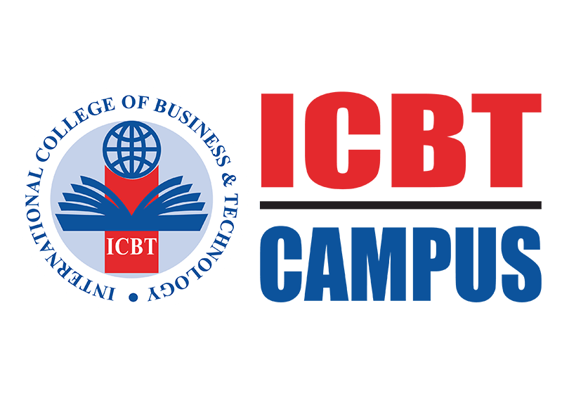

**HDCSE 5015 - Computing**

**Project**

**Project - All for Music**

**Web application**

**Group D**

# Acknowledgement

We would like to express our heartfelt gratitude to all those who supported and guided us throughout the completion of our project, All for Music. First and foremost, we extend our sincere thanks to our lecturer, Mr. Deloosha Abesooriya, for his valuable guidance, encouragement, and insightful feedback, which were instrumental in shaping the success of this project.

We also wish to acknowledge the contributions of our project coordinator, Ms. Sandaruwini Nisansala, for her unwavering support and coordination throughout the journey. Our profound gratitude goes to ICBT Southern Campus and Cardiff Metropolitan University for providing us with the resources, knowledge, and platform necessary to bring this project to fruition.

We are deeply grateful to our parents for their continuous encouragement, understanding, and support in every step of our academic endeavors. Special thanks go to all the project members, whose dedication, teamwork, and hard work were key to the successful completion of this project Lastly, we would like to thank our friends for their constant motivation and assistance, which kept us inspired throughout the journey. Thank you all for being part of this remarkable experience.

# Project Team and Contribution

|  |  |  |
| --- | --- | --- |
| **Dadallage Chamodha Dhananjana Kulananda** | **Hansani Dilhara Vithana** | **Lahiru Sampath** |
| **Primary Roles**   * Project Manager. * Web Developer. | **Primary Roles**   * Database Administrator. * Back-end Developer. | **Primary Roles**   * Designer. * Technical Writer. |
| **Secondary Role**   * Front End Developer. | **Secondary Role**   * Tester. | **Secondary Role**   * Content Creator. |

|  |  |  |  |
| --- | --- | --- | --- |
| **Name** | **ICBT Student Number** | **Cardiff University number** | **Contribution Percentage.** |
| Chamodha Kulananda. | ST/HDCSE/CMU/39/23 | st20288859 | 92% |
| Hansani Dilhara Vithana. | ST/HDCSE/CMU/39/26 | st20288862 | 92% |
| Lahiru Sampath. | ST/HDCSE/CMU/39/22 | st20288858 | 92% |

# Executive summary

"All for Music" is an innovative online platform developed by CHL Institute, a recognized leader in online educational technology, with the mission of uniting musicians, learners, and artists from around the globe, regardless of their skill level or geographic location. In the rapidly expanding music industry, countless talented individuals face significant challenges due to a lack of resources, networking opportunities, and access to quality education; this platform seeks to bridge these gaps by offering a comprehensive collaborative space where musicians can share ideas, learn from world-renowned artists through interactive masterclasses and personalized mentorship, and explore diverse opportunities to enhance their skills and careers. The platform provides a suite of features designed to meet the diverse needs of the music community, including access to certified online courses taught by expert instructors across various instruments and genres, the ability to engage in creative collaboration by sharing and selling music lyrics and connecting with other artists for feedback, joint projects, and potential collaborations, facilitation of instructor and artist hiring for personalized lessons or professional services, and a dedicated marketplace for purchasing affordable new or meticulously vetted second-hand instruments, ensuring accessibility for all budgets. By fostering a vibrant culture of knowledge-sharing, peer support, and collaborative innovation, "All for Music" empowers individuals to learn, grow, and thrive in the competitive music industry, revolutionizing the way musicians connect, collaborate, and succeed, making it an invaluable and accessible resource for those embarking on or furthering their musical journeys, from aspiring beginners to seasoned professionals.

**Table of Content**

Acknowledgement ii

Project Team and Contribution iii

Executive summary iv

List of Figures vi

List of Tables x

Introduction 1

Introduction 4

Project Background 4

Scope of the Project 4

Project Objectives 5

Significance of “All for Music” Web site 5

Roadmap for the "All for Music" Project Document 7

Introduction to the institute 9

Context 10

Portal as the Focal Point 10

Key Features of the Portal 10

Benefits of the project Developed 12

Literature Review for "All for Music" 15

Digital Transformation in Music Education 15

Online Music Collaboration Platforms 16

Challenges and Opportunities 21

Problem Definition 24

Key Problems 24

Description of the Project 31

Aim 31

Objectives 31

Scope Definition 32

User Roles 32

Constraints of the Project 33

Development Methodology for "All for Music" 35

Selected Methodology 35

Core Characteristics of Agile Methodology 35

Development Phases and Sprint Breakdown 36

Advantages of Agile for "All for Music" 36

WBS of the project 39

Network diagram 40

Timeline 41

Gantt chat 42

System Analyzing 46

Requirements Gathering 47

Interview 48

Interview for Students (Players): 48

Interview for Artists: 49

Interview for Administrators: 50

Interview for Project Manager: 50

Surveys and Questionnaire 52

Observation 57

Prototyping 57

Feasibility Analysis 58

Documentation 58

Review and Approval 59

Transition to Design 59

User Response 60

Feasibility Study 61

Risk Analysis 70

System Design – All for Music 76

1. System Architecture 76

2. Database Design – All for Music 77

Mockup Diagram 87

Data Flow Diagram 90

Use Case Diagrams 96

Use case diagrams for All For Music Site 97

Sequence Diagrams 115

Class Diagrams 123

Activity diagram 125

Data Dictionary 131

Selection of Tools and Technology 138

Microsoft SQL Server Management Studio (SSMS) 138

Visual Studio 139

WampServer 143

Organization and Modularization of the Code 145

Software Development Life Cycle (SDLC) 148

Testing 148

Test Plan 151

Test Cases 152

Implementation 192

Technologies and Tools 192

3.Development Environment 194

Structure and Organization of Code 195

Version Control 196

Testing Integration 196

Review Process 199

Product 204

All for Music - Product Overview 204

Conclusion 208

References vii

Bibliography vii

Appendix ix

# List of Figures

Figure 1 WBS of the ALL FOR MUSIC project 39

Figure 2 Network diagram of ALL FOR MUSIC Project 41

Figure 3 Timeline in ALL FOR MUSIC Project 41

Figure 4 Gantt chat in ALL FOR MUSIC Project 43

Figure 5 Tables in Database 79

Figure 6 ER Diagram for ALL FOR MUSIC project 80

Figure 7 Musician Dashboard Interface 83

Figure 8 Admin Dashboard Interface 84

Figure 9 Artist dashboard interface 85

Figure 10 Instructor dashboard Interface 86

Figure 11 0th level DED for ALL FOR MUSIC project 91

Figure 12 1st level DFD in ALL FOR MUSIC 94

Figure 13 Use case diagram in delete function 98

Figure 14 Use case diagram in registration 102

Figure 15 Use case diagram in login 105

Figure 16 Use case diagram in search package 107

Figure 17 Use case diagram in update packages 109

Figure 18 Use case diagram in Add package 112

Figure 19 Add payment function in Sequence diagram 116

Figure 20 Delete function in Sequence diagram 118

Figure 21 Package add function in Sequence diagram 120

Figure 22 User login function in Sequence diagram 121

Figure 23 Class diagram in ALL FOR MUSIC project 123

Figure 24 Activity diagram for user registration 125

Figure 25 Activity diagram for user login 126

Figure 26 Activity diagram for Admin dashboard 127

Figure 27 Activity diagram for add new learning package 129

Figure 28 Microsoft SQL Server Management Studio 138

Figure 29 users table in SSMS 138

Figure 30 Database Table Structure of All Fo music 139

Figure 31 Sample C# code from the developed system 141

Figure 32 Sample PHP code from the developed system 142

Figure 33 WAMP Server 144

Figure 34 BE-1001 154

Figure 35 BE-1001 result 1 154

Figure 36 BE-1001 result 2 154

Figure 37 BE-1002 155

Figure 38 BE-1002 result 1 155

Figure 39 BE-1002 result 2 155

Figure 40 BE-1003 156

Figure 41 BE-1003 result 1 156

Figure 42 BE-1004 157

Figure 43 BE-1004 result 1 157

Figure 44 BE-1004 result 2 157

Figure 45 BE-1005 158

Figure 46 BE-1005 result 1 158

Figure 47 BE-106 159

Figure 48 BE-106 result 1 160

Figure 49 BE-1007 160

Figure 50 BE-1007 result 1 161

Figure 51 BE-1007 result 2 161

Figure 52 BE-1008 161

Figure 53 BE-1008 result 1 162

Figure 54 result 2 162

Figure 55 BE-1009 162

Figure 56 BE-1009 result 1 163

Figure 57 BE-1009 result 2 163

Figure 58 BE-1010 164

Figure 59 BE-1010 result 1 164

Figure 60 BE-1010 result 2 164

Figure 61 BE-1011 165

Figure 62 BE-1011 result 1 165

Figure 63 BE-1011 result 2 166

Figure 64 BE-1012 166

Figure 65 BE-1012 result 1 167

Figure 66 BE-1012 result 2 167

Figure 67 BE-1013 168

Figure 68 BE-1013 result 1 168

Figure 69 BE-1013 result 2 168

Figure 70 BE-1014 169

Figure 71 BE-1014 result 1 169

Figure 72 BE-1015 170

Figure 73 BE-1015 result 1 170

Figure 74 BE-1016 171

Figure 75 BE-1016 result 1 171

Figure 76 BE-1017 172

Figure 77 BE-1017 result 1 172

Figure 78 result 2 172

Figure 79 BE-1018 -1 173

Figure 80 BE-1018 - 2 174

Figure 81 BE-1018 - 3 175

Figure 82 BE-1018 result 1 175

Figure 83 BE-1018 result 2 175

Figure 84 BE-1019-1 176

Figure 85 BE-1019 - 2 177

Figure 86 BE-1019 result 1 177

Figure 87 BE-1020 178

Figure 88 BE-1020 result 1 178

Figure 89 result 2 178

Figure 90 BE-1020 -1 179

Figure 91 BE-1020-2 179

Figure 92 BE-1020 result 1 179

Figure 93 BE-1021-1 180

Figure 94 BE-1021- 2 180

Figure 95 BE-1021-3 180

Figure 96 BE-1021-3 181

Figure 97 BE-1021 result 1 181

Figure 98 BE-1023 - 1 182

Figure 99 BE-1023- 2 182

Figure 100 BE-1023 result 1 182

Figure 101 BE-1024 183

Figure 102 BE-1024 result 1 183

Figure 103 BE-1025- 1 184

Figure 104 BE-1025-2 184

Figure 105 BE-1025 result 1 184

Figure 106 BE-1026- 1 185

Figure 107 BE-1026 - 2 185

Figure 108 BE-1026 result 1 186

Figure 109 BE-1027- 1 186

Figure 110 BE-1027- 2 187

Figure 111 BE-1027- 3 187

Figure 112 BE-1027 result 1 187

Figure 113 BE-1028 188

Figure 114 BE-1028 result 1 188

Figure 115 BE-1029 188

Figure 116 BE-1029- result 189

# List of Tables

Table 1 Benefits of the "All for Music" Project 12

Table 2 Data Dictionary for All for Music Project 131

Table 3 BE-1001 153

Table 4 BE-1002 155

Table 5 BE-1003 156

Table 6 BE-1004 157

Table 7 BE-1005 158

Table 8 BE-106 159

Table 9 BE-1007 160

Table 10 BE-1008 161

Table 11 BE-1009 162

Table 12 BE-1010 163

Table 13 BE-1011 165

Table 14 BE-1012 166

Table 15 BE-1013 167

Table 16 BE-1014 169

Table 17 BE-1015 170

Table 18 BE-1016 171

Table 19 BE-1017 172

Table 20 BE-1018 173

Table 21 BE-1019 177

Table 22 BE-1020 180

Table 23 BE-1021 181

Table 24 BE-1023 182

Table 25 BE-1024 184

Table 26 BE-1025 185

Table 27 BE-1026 186

Table 28 BE-1027 187

Table 29 BE-1028 188

Table 30 BE-1029 189

# Introduction

Music is a universal language that transcends borders, cultures, and generations, holding the power to inspire, heal, and unite individuals across the globe. In today's rapidly evolving and competitive music industry, however, many talented musicians face barriers such as limited access to resources, mentorship, and opportunities to showcase their skills. Recognizing these challenges, CHL Institute has developed "All for Music," an innovative web platform designed to bridge these gaps and create an inclusive, dynamic space for musicians, learners, and artists worldwide.

All for Music is not just a platform; it is a vibrant ecosystem built to foster creativity, collaboration, and personal growth in the music industry. The platform empowers both aspiring musicians and established artists by offering them a space to share ideas, connect with a global community, and learn from world-class experts. It is a one-stop solution that tailors its offerings to meet the diverse needs of different users, including players (students), artists, and instructors.

The platform combines powerful features that make it a comprehensive solution for anyone in the music world. Administrators can manage user roles, upload learning materials, track user progress, and gather feedback for continuous platform improvements. Players (students) can access educational resources, request lessons, sell instruments, track their progress, and showcase their creative works, like music lyrics. Artists benefit from networking opportunities, collaborations, and the ability to purchase and sell musical instruments and lyric sheets. Instructors can share their expertise through personalized lessons, monitor student progress, and contribute to the platform's growth by creating new learning materials.

What sets All for Music apart is its seamless integration of various elements that are often fragmented in the music industry today. It brings together learning, collaboration, and professional growth under one platform, providing users with the tools and opportunities they need to succeed. Whether it is a student learning their first notes, an artist seeking collaboration, or an instructor guiding the next generation of musicians, All for Music offers a transformative environment where talent and passion can thrive.

This platform is not only a space for individual growth but also serves as a hub for a global community of musicians and artists united by their love for music. With All for Music, CHL Institute is committed to empowering users, breaking down barriers, and creating a lasting impact on the music industry for years to come.

**Chapter I**

# Introduction

Music is a powerful force that connects people across cultures and generations. However, many aspiring musicians face challenges such as limited resources, mentorship, and collaboration opportunities. **"All for Music"** is a web platform designed to bridge these gaps, providing a space for students, artists, and instructors to learn, share, and grow.

The platform offers educational resources, mentorship, a marketplace for instruments, and collaboration tools. Users can access learning materials, request lessons, sell or buy instruments, and connect with a global music community. By fostering creativity and professional development, **"All for Music"** empowers musicians to thrive and achieve their artistic goals.

# Project Background

The music industry's growth presents vast opportunities, yet many talented musicians are hindered by limited access to resources, training, and connections. To combat this, CHL Institute developed "All for Music," a community platform designed to bridge these gaps. It aims to empower musicians globally by providing a collaborative space for sharing ideas, accessing expert guidance, and fostering growth, regardless of background or location.

## Scope of the Project

This project involves creating a music website that offers a comprehensive, user-friendly experience. Key features include: music lessons, instrument tutorials, a platform to find instructors, a marketplace for sheet music, and certified learning courses. The development will utilize Agile methodologies and iterative processes.

## Project Objectives

This project is developing a comprehensive music website to modernize music management and promotion. It will offer features like class sign-ups, instructor discovery, and detailed analytics on user activity. A key component is a marketplace allowing users to sell their lyrics, creations, and instruments, providing a global marketing platform for musicians. The site will also focus on education, offering opportunities to improve music skills and access worldwide musical knowledge, ultimately fostering a collaborative and informed music community.

## Significance of “All for Music” Web site

The **"All for Music"** website is a revolutionary platform designed to reshape the landscape of music education, collaboration, and professional growth. By offering a centralized hub for musicians, learners, and instructors, the platform ensures accessibility, inclusivity, and innovation in the music industry.

**1.** Bridging the Gap in Music Education

Many aspiring musicians struggle due to a lack of proper guidance, structured learning resources, and mentorship. "All for Music" addresses this issue by providing a digital learning environment where students can access interactive lessons, connect with expert instructors, and track their progress. The platform enhances music education by making high-quality learning materials and professional guidance available to all, regardless of location.

**2.** Empowering Artists and Musicians

The platform fosters creativity and collaboration by enabling musicians to connect with peers, showcase their work, and explore new opportunities. Artists can sell their compositions, purchase lyrics, and interact with potential collaborators, thereby expanding their reach and professional network. By removing geographical barriers, "All for Music" creates a thriving global music community.

**3.** Enabling Financial Sustainability for Musicians

One of the significant challenges musicians face is monetizing their work. "All for Music" integrates multiple revenue streams, including the sale of learning packages, lyric sheets, and musical instruments, as well as commission-based transactions. This ensures that artists, instructors, and learners have various opportunities to generate income, making their passion for music a sustainable career path.

**4.** Encouraging Innovation and Digital Transformation

With features like digital rights management (DRM), cloud-based storage, AI-powered recommendations, and real-time collaboration tools, the platform aligns with the evolving digital landscape of the music industry. The integration of modern technology enhances user experience and ensures seamless interaction between learners, artists, and instructors.

**5.** Strengthening Community Engagement

Music is inherently social, and "All for Music" reinforces this by creating a collaborative and engaging environment. Features such as discussion forums, virtual events, and interactive feedback systems promote active participation. The platform nurtures a sense of belonging and continuous learning among its users.

**6**. Providing a One-Stop Solution for Music Needs

The website serves as a comprehensive solution for musicians by combining education, career development, and business opportunities into a single platform. Users can learn, teach, buy, sell, and collaborate without having to rely on multiple disconnected services.

**Anticipated Benefits**

The **"All for Music"** platform is designed to bring extensive benefits to musicians, students, instructors, and administrators. These anticipated benefits include:

**1.** Greater Accessibility to Music Education

By digitizing music learning, students worldwide can access high-quality courses, lessons, and mentorship regardless of their location or financial background.

**2.** Enhanced Collaboration and Networking

The platform facilitates connections between artists, instructors, and learners, enabling knowledge sharing, collaborative music production, and mentorship opportunities.

**3.** Increased Monetization Opportunities

Artists and instructors can generate income through multiple channels, including course sales, music sales, and commissioned projects, making the platform financially sustainable for its users.

**4**. A Streamlined and Secure Marketplace

Users can buy and sell musical instruments, lyrics, and other resources with built-in security features ensuring safe transactions and copyright protection.

**5.** Data-Driven Personalization

AI-powered analytics help tailor recommendations for users, improving learning experiences and career opportunities based on individual preferences and activity.

**6.** Professional Growth and Career Development

By providing exposure, mentorship, and financial opportunities, "All for Music" helps musicians advance in their careers while continuing to refine their craft.

## Roadmap for the "All for Music" Project Document

The "All for Music" project document is structured to provide a comprehensive overview of the platform, from its purpose and significance to its feasibility and implementation strategy. This roadmap ensures that all critical aspects are covered, guiding the reader through a logical progression of the project's development and execution.

The document begins with an Introduction, outlining the project's purpose, objectives, and the significance of music as a universal language. It highlights the challenges faced by musicians, learners, and artists and explains how "All for Music" aims to bridge these gaps. The Significance of the Website section elaborates on the impact of the platform in transforming music education, collaboration, and professional growth, emphasizing its role in enhancing accessibility and inclusivity in the music community.

The Feasibility Analysis evaluates the project's viability across multiple dimensions. Economic Feasibility examines the cost-benefit analysis, revenue models, and strategies for financial sustainability. Technical Feasibility details the technological infrastructure, platform architecture, scalability, and integration with third-party tools. Operational Feasibility focuses on how effectively the system meets user needs, offering structured learning resources, collaboration tools, and monetization options. Legal Feasibility ensures compliance with copyright laws, intellectual property rights, and data protection regulations, with mechanisms to secure user content and transactions. Schedule Feasibility outlines the structured development phases, incorporating agile methodologies for timely implementation and iterative improvements. Environmental Feasibility explores how the platform minimizes environmental impact by reducing the need for physical learning materials, travel, and resource consumption.

The Risk Analysis section identifies potential challenges such as cybersecurity threats, user adoption risks, and platform scalability, while also providing mitigation strategies to ensure smooth operation. The Requirements Gathering phase details the methods used to collect user needs, including interviews, surveys, and observations, ensuring a user-centric design. The Prototyping section discusses the iterative design and testing process, allowing stakeholders to visualize the platform before full-scale development.

The Documentation section covers system design specifications, user manuals, and development logs to ensure clear communication among developers, administrators, and users. The Review and Approval phase details the validation process, stakeholder feedback, and finalization of project deliverables. Finally, the Conclusion and Future Scope highlights the long-term vision of "All for Music," outlining future enhancements, expansion plans, and the anticipated impact on the global music community.

This structured roadmap ensures a well-organized and informative document, providing a detailed view of the "All for Music" project while maintaining clarity and coherence throughout.

# Introduction to the institute

CHL Institute is a pioneering institution committed to fostering innovation, creativity, and excellence in music education. With a strong emphasis on technology-driven learning, we strive to provide aspiring musicians, artists, and educators with the resources they need to thrive in the ever-evolving music industry. Our institute believes in the power of music to transform lives and create opportunities, making quality education and collaboration accessible to all.

As part of our mission to bridge the gap between talent and opportunity, we are developing **"All for Music"**, an advanced e-music platform designed to support learners, artists, and instructors. This initiative reflects our commitment to empowering musicians through cutting-edge technology, interactive learning experiences, and a dynamic online community. By integrating education, mentorship, and industry connections, CHL Institute is shaping the future of music education and collaboration.

## Context

## Portal as the Focal Point

In the development of the **"All for Music"** platform, the portal stands as the central hub, seamlessly integrating all its key features. This digital gateway serves as the core of the platform, bringing together aspiring musicians, artists, and instructors in a collaborative and dynamic environment.

Designed as the primary point of interaction, the portal enables users to access learning resources, connect with mentors, engage in music-related transactions, and track their progress. It acts as a bridge between education and creativity, ensuring a cohesive and interactive experience for all members of the **"All for Music"** community.

## Key Features of the Portal

▪ Academic Planning: The portal streamlines music learning by allowing instructors to create structured courses, schedule lessons, and manage training resources efficiently. Learners can plan their progress, access lesson schedules, and track their skill development.

▪ Communication Hub: Real-time communication tools enable seamless interaction between players (students), artists, and instructors. Announcements, lesson updates, and notifications ensure smooth coordination and effective information sharing within the community.

▪ Results Management: The platform provides a structured system for tracking learning progress and performance. Players receive feedback from instructors, monitor their achievements, and view personalized progress reports.

▪ User-Friendly Interface: Designed with a musician-centric approach, the portal offers an intuitive and accessible interface, ensuring effortless navigation for users. Customizable features cater to the diverse needs of learners, artists, and instructors.

▪ Collaborative Tools: The portal fosters collaboration through shared resources, discussion forums, and interactive learning spaces. Users can engage in group projects, jam sessions, and knowledge-sharing activities, enhancing creative and professional growth.

By making the portal the central element, "All for Music" reinforces its mission to leverage technology for an enriched musical experience. The platform serves not just as an interface but as a dynamic hub that empowers musicians to learn, connect, and innovate. Through its comprehensive features, the portal represents a significant step toward creating an inclusive and technologically advanced ecosystem for the global music community.

## Benefits of the project Developed

The development and implementation of the "All for Music" project introduce numerous benefits, transforming the music learning and collaboration experience. This platform enhances accessibility, fosters creativity, and streamlines communication, providing musicians, learners, and artists with a dynamic space to connect, grow, and thrive in the industry.

Table 1 Benefits of the "All for Music" Project

|  |  |
| --- | --- |
| **Benefits of the "All for Music" Project** | **Description** |
| **Accessible Music Education** | - Provides structured and affordable learning opportunities.  - Offers courses for all skill levels, from beginners to advanced musicians. |
| **Seamless Communication** | - Real-time interaction between students, artists, and instructors.  - Notifications, discussion forums, and live messaging enhance collaboration. |
| **Personalized Learning Experience** | - Course recommendations based on user preferences and progress.  - Custom learning paths and mentorship programs for tailored growth. |
| **Integrated Marketplace** | - Centralized platform for buying and selling musical instruments.  - Enables artists to showcase and monetize their work. |
| **Enhanced Collaboration** | - Connects musicians, instructors, and students globally.  - Facilitates group projects, virtual performances, and networking opportunities. |
| **Efficient Performance Tracking** | - Students can track progress with practice logs and feedback from instructors.  - Instructors can monitor student achievements and provide personalized guidance. |
| **Secure Payment & Subscription System** | - Enables safe transactions for lessons, courses, and instrument sales.  - Supports multiple payment options for user convenience. |
| **User-Friendly Interface** | - Intuitive design ensures easy navigation for all users.  - Accessible on multiple devices, including mobile and desktop. |
| **Scalability & Future Expansion** | - Designed to accommodate future technological advancements.  - Can expand to include more courses, instruments, and global collaborations. |
| **Empowering the Music Community** | - Supports independent artists by giving them a platform to showcase their talents.  - Strengthens the global music network through shared learning and experiences. |

**Chapter II**

# Literature Review for "All for Music"

The "All for Music" project is an innovative web-based platform designed to enhance music education, collaboration, and professional growth. To develop a comprehensive understanding of the existing landscape, this literature review examines various studies, online learning platforms, digital music collaboration tools, and industry trends related to music education and artist development.

## Digital Transformation in Music Education

The shift from traditional music learning methods to digital platforms has been extensively studied. Research indicates that online music education provides flexibility, accessibility, and a wide range of learning resources that traditional in-person lessons cannot always offer (Crawford, 2020). Learning management systems (LMS) such as Moodle and Canvas have been utilized for music instruction, integrating video lessons, interactive exercises, and feedback mechanisms. However, these platforms often lack dedicated music collaboration tools, creating a gap that All for Music aims to fill.

Moreover, digital platforms enable self-paced learning, allowing students to access lessons anytime and revisit materials as needed. Artificial intelligence (AI) and machine learning are also playing an increasing role in personalized music education, offering real-time feedback, skill assessments, and adaptive learning paths (Morreale et al., 2021). Virtual reality (VR) and augmented reality (AR) technologies are emerging as innovative tools for immersive music training, providing an interactive environment for learners to practice instruments and develop performance skills.

Another major aspect of digital transformation is the integration of cloud-based solutions for seamless collaboration between students, instructors, and artists. Platforms like Sound trap and Band Lab allow musicians to co-create, edit, and mix music in real-time, regardless of location. However, these platforms primarily focus on music production rather than structured education. All for Music seeks to bridge this gap by combining interactive learning modules, real-time collaboration, and professional networking opportunities in one comprehensive platform, catering to the diverse needs of students, artists, and instructors.

## Online Music Collaboration Platforms

With the rise of cloud-based technology, musicians can now collaborate virtually. Studies on platforms like Sound trap and Band Lab highlight the importance of real-time collaboration, cloud storage, and version control for music production (Kjus, 2019). These platforms allow artists to work together remotely, but they do not provide structured learning pathways or mentorship programs, which are key features of All for Music*.* Our platform integrates collaboration tools with guided learning modules to offer a holistic experience.

Beyond real-time collaboration, online music platforms have evolved to support multi-track recording, live session jamming, and AI-assisted mixing (Hewitt, 2020). While these features enhance remote music production, they lack formalized learning frameworks for aspiring musicians. Research indicates that structured mentorship and feedback loops are crucial for skill development in music education (Sawyer, 2021). All for Music addresses this gap by combining collaborative music creation with instructor-led guidance, allowing students and artists to receive expert feedback while working on projects.

Furthermore, existing online platforms primarily cater to experienced musicians who are already familiar with digital audio workstations (DAWs) and music production tools. This creates a learning barrier for beginners who may struggle to navigate complex software. All for Music incorporates user-friendly interfaces, tiered learning modules, and interactive tutorials to support musicians at different skill levels. By blending educational resources with collaborative features, the platform fosters a community-driven approach where users can learn, create, and share music seamlessly.

**3.** Monetization and Digital Marketplaces for Musicians

Existing research on the monetization of music content has explored platforms like Patreon, Spotify, and YouTube, where artists generate revenue through subscriptions, ad-based models, and digital sales (Mulligan, 2021). However, independent musicians often struggle to gain visibility and monetize their skills effectively. All for Music addresses this issue by offering features like direct-to-fan sales, commission-based instrument trading, and premium lesson packages, allowing musicians to build sustainable careers.

Studies indicate that direct artist-to-fan engagement is a crucial factor in revenue generation for independent musicians (Baym, 2018). While platforms such as Bandcamp and Patreon enable direct monetization, they often lack integrated educational resources and networking opportunities that foster career growth. All for Music bridges this gap by providing a marketplace for artists to sell original compositions, music sheets, and instrumental tracks, while also offering paid mentorship programs and online classes. This holistic approach ensures that musicians not only generate income but also expand their skill sets and professional networks.

Furthermore, research highlights that many independent artists face challenges in understanding and navigating the complexities of digital rights management (DRM), licensing, and royalty distribution (Watson & Smith, 2020). Unlike streaming platforms that offer limited earnings per stream, All for Music allows musicians to retain full control over their intellectual property while benefiting from a transparent commission model. By integrating smart contracts and blockchain-based tracking for transactions, the platform enhances security and ensures fair compensation for artists.

Another critical aspect of monetization is the sale of musical instruments and gear. Existing online marketplaces, such as Reverb and eBay, provide platforms for buying and selling instruments, but they lack an educational or collaborative element. All for Music enhances this model by allowing musicians to list their instruments for sale while also offering guidance on instrument selection, maintenance, and usage. This feature not only supports musicians financially but also fosters an ecosystem where artists can access quality equipment at affordable prices.

By incorporating multiple revenue streams—including premium course subscriptions, one-on-one coaching, live performance ticketing, and instrument sales—All for Music provides a comprehensive financial support system for musicians at all levels. The platform empowers users to generate income through various channels while building meaningful connections within the global music community.

**4.** Role of Artificial Intelligence in Music Learning

AI-driven music education tools such as Yousician and Melodics have gained popularity due to their interactive learning experiences and real-time feedback capabilities (Morreale et al., 2021). AI can analyze a musician’s performance, detect mistakes, and provide personalized recommendations for improvement. These technologies have revolutionized self-paced learning by offering adaptive exercises tailored to individual skill levels.

Research shows that AI-powered music learning tools enhance engagement and retention by using gamification, performance analytics, and automatic assessment of musical proficiency (Benetos et al., 2020). However, most existing AI-based platforms focus primarily on instrumental practice and lack comprehensive mentorship, collaboration, and career-building resources. All for Music extends AI capabilities beyond technical skill assessment by integrating intelligent tutoring systems, virtual mentors, and AI-assisted composition tools.

One significant advantage of AI in music education is its ability to provide real-time feedback. Unlike traditional learning methods, which rely on instructor evaluations, AI-driven systems offer immediate corrections on aspects such as pitch accuracy, rhythm consistency, and dynamic expression (Li & Wang, 2019). All for Music leverages these advancements by incorporating AI-powered practice sessions where students receive instant feedback and progress tracking. The system will suggest personalized practice routines and highlight areas that need improvement, allowing learners to enhance their skills systematically.

Beyond individual learning, AI can facilitate music composition and creativity. Research in AI-generated music has led to tools like OpenAI’s MuseNet and Google’s Magenta, which assist musicians in generating melodies, harmonies, and arrangements (Briot et al., 2019). All for Music plans to integrate AI-assisted composition tools that help users experiment with different styles, generate backing tracks, and refine their musical ideas efficiently. This feature is particularly beneficial for artists looking to expand their creativity and explore new genres.

Another emerging application of AI in music education is voice and instrument recognition. Advanced machine learning models can now analyze vocal and instrumental performances, providing insights into tone quality, phrasing, and articulation. All for Music will incorporate AI-driven vocal and instrumental coaching, where learners can receive detailed analysis and structured guidance to improve their technical and expressive abilities.

By integrating AI into All for Music, the platform enhances personalized learning, creative exploration, and performance improvement. The combination of AI-driven feedback, smart composition tools, and adaptive learning modules ensures that users receive a well-rounded, data-driven, and engaging music education experience.

**5.** Importance of Community and Networking in Music Careers

Studies show that networking plays a crucial role in a musician’s career growth. Platforms like LinkedIn and SoundCloud enable artists to connect with industry professionals, but they do not offer structured mentorship or guided collaborations (Watson, 2020). Networking has long been recognized as a key factor in advancing careers, particularly in industries such as music where building relationships with producers, fellow musicians, and fans is essential for success (Bennett, 2019). However, many musicians struggle to leverage these networks effectively, especially in the early stages of their careers, due to a lack of guidance or access to meaningful connections.

Research highlights that mentorship is one of the most significant factors in the professional development of musicians. It allows aspiring artists to receive tailored advice, constructive feedback, and industry insights from more experienced professionals (Perrone, 2018). While many artists rely on personal connections to secure opportunities, All for Music recognizes the importance of formalizing mentorship and facilitating professional guidance. Through the platform’s mentorship program, both budding and established musicians can benefit from one-on-one coaching, industry-focused advice, and exposure to a wider network of peers and experts.

Furthermore, the music industry thrives on collaboration. Platforms such as Splice and Band Lab allow musicians to share and collaborate on projects, but they often do not offer integrated opportunities for skill development or professional connections. All for Music integrates collaboration tools that not only allow musicians to share their work but also actively encourage cooperative learning and co-creation. The platform offers various collaborative features such as virtual jam sessions, group challenges, and joint composition tools, providing a unique space for musicians to collaborate across geographical boundaries while learning from each other in real-time. This fosters a sense of community among users, breaking down barriers between artists and allowing them to grow together.

Live sessions with industry experts, accessible through the platform, are another feature designed to enhance networking. These live webinars and Q&A sessions with professionals from various sectors of the music industry (including producers, sound engineers, and A&R representatives) provide aspiring musicians with direct access to key figures they might not otherwise meet. This integration of live, interactive events helps to bridge the gap between musicians and potential collaborators or employers, offering networking opportunities that are critical for career advancement.

By facilitating both structured mentorship and spontaneous collaborations, All for Music offers musicians a comprehensive ecosystem to build their careers. Users are not only exposed to practical learning resources but also to the broader professional landscape. The platform’s ability to connect individuals within the global music community, combined with its emphasis on learning and growth, enhances musicians' ability to network effectively, leading to a more fulfilling and sustainable career in music.

In essence, the platform redefines the role of networking in music by transforming it from a passive activity into a proactive, skill-building process. Musicians no longer need to wait for opportunities to arise; instead, they can actively engage with mentors, peers, and industry professionals, accelerating their growth and improving their chances of success.

## Challenges and Opportunities

Challenges

1.User Engagement & Adoption

* Encouraging musicians, learners, and instructors to actively participate in the platform.
* Ensuring an engaging and user-friendly experience to retain users.

2. Content Quality & Instructor Availability

* Maintaining high-quality learning materials and courses.
* Recruiting skilled instructors and artists willing to contribute.

3. Technical & Security Concerns

* Ensuring data privacy and security in user transactions and communication.
* Managing platform scalability as the user base grows.

4. Competition in the Market

* Competing with existing e-learning and music collaboration platforms.
* Differentiating "All for Music" through unique features and value offerings.

5. Monetization & Sustainability

* Balancing free and premium content while ensuring affordability.
* Generating revenue through course enrollments, instrument sales, and advertisements.

Opportunities

1. Expanding Digital Music Education

* Providing accessible learning opportunities for musicians worldwide.
* Bridging gaps in traditional music education through self-paced and instructor-led courses.

2. Building a Global Music Community

· Connecting students, artists, and instructors for networking and collaboration.

· Encouraging peer learning, mentorship, and creative exchanges.

3. E-Commerce & Marketplace Growth

· Using AI-driven recommendations for personalized learning paths.

· Implementing real-time feedback systems to enhance learning outcomes.

4. Potential for Institutional Partnerships

· Creating a thriving online marketplace for instruments, lyric sheets, and services.

· Allowing musicians to sell and purchase music-related assets efficiently.

**Chapter III**

# Problem Definition

In today’s evolving music industry, many aspiring musicians, learners, and independent artists face significant challenges in accessing quality education, collaboration opportunities, and professional resources. Traditional music education is often expensive, geographically limited, and lacks personalized learning experiences. Additionally, artists struggle with finding mentors, selling their work, and connecting with like-minded individuals, creating barriers to growth and success.

Furthermore, existing online platforms for music education and collaboration are often fragmented, requiring users to rely on multiple services for learning, networking, and trading musical instruments or resources. This lack of an integrated solution makes it difficult for musicians to efficiently manage their development and career.

## Key Problems

1.Limited Access to Music Education

Many learners lack affordable and structured learning resources, making formal music education inaccessible.

Geographic and financial barriers prevent students from attending physical music schools or workshops.

Solution:

* A comprehensive e-learning system offering structured courses at different skill levels, making music education accessible to all.
* Affordable subscription plans, free introductory courses, and financial aid options to ensure cost-effective learning.
* Integration of video lessons, interactive tutorials, and downloadable resources for flexible learning.

2.Lack of Collaboration Opportunities

Artists and musicians struggle to connect with mentors, instructors, and fellow artists, limiting opportunities for skill development and exposure.

There is no centralized platform for real-time collaboration, feedback, and music production partnerships.

Solution:

* A built-in social networking system for artists, learners, and instructors to connect, share work, and collaborate.
* Real-time chat and video conferencing features for mentorship and music sessions.
* A collaborative workspace for musicians to co-create, remix, and get feedback from experts.

3.Fragmented Learning & Marketplace Systems

Existing platforms do not offer an all-in-one solution for learning, collaboration, and instrument trading, forcing users to rely on multiple services.

The lack of integration between learning modules, networking, and marketplace features makes user experience inefficient and disconnected.

Solution:

* A single integrated platform that combines learning, collaboration, and instrument trading, eliminating the need for multiple services.
* Unified dashboard where users can access courses, live sessions, discussions, and the marketplace seamlessly.

4. Absence of Personalized Learning Paths

Most platforms fail to provide tailored learning recommendations based on individual skill levels, interests, and progress.

Learners need adaptive content, AI-driven recommendations, and goal-based learning structures.

Solution:

* AI-driven personalized learning recommendations based on the user’s interests, skill level, and progress.
* Gamified learning paths, quizzes, and progress tracking to enhance engagement.
* Adaptive goal-based learning, where users receive structured challenges and assignments based on their musical journey.

5.Difficulty in Showcasing & Selling Work

Independent artists and learners lack exposure and structured opportunities to monetize their talent.

There is no streamlined system for selling original compositions, lyric sheets, and teaching materials.

Solution:

* A dedicated marketplace for musicians to sell original compositions, lyric sheets, learning materials, and instruments.
* Artist portfolios where musicians can showcase their work, get reviews, and attract potential buyers or collaborators.
* Licensing & monetization options for independent artists to earn through their content.

6.Limited Performance & Feedback Mechanisms

Musicians lack opportunities to receive constructive feedback from experts and peers.

No built-in tools for tracking learning progress, performance analytics, or skill assessment.

Solution:

* Live performance & feedback sessions, where artists can get constructive criticism from mentors and peers.
* AI-powered performance analysis to give learners insights into their improvements and areas of weakness.
* Badges, achievements, and leaderboards to encourage progress and engagement.

7.Monetization Challenges for Artists & Instructors

Many artists and instructors struggle with earning opportunities through digital platforms.

There is a need for a transparent revenue model where artists can generate income from lessons, collaborations, and digital sales.

Solution:

* Artists and instructors can earn through paid courses, lesson requests, and content sales.
* A commission-based earnings system for selling learning materials, lyric sheets, and personalized coaching sessions.
* Donation & subscription models, allowing fans to support their favorite artists.

8.Lack of Real-Time Engagement & Interactive Features

Most platforms do not offer live classes, interactive Q&A sessions, or virtual jam spaces for real-time collaboration.

A lack of engaging features like gamification, leaderboards, and challenges makes learning less motivating.

Solution:

* Live-streamed workshops, Q&A sessions, and jam sessions for real-time interaction.
* Virtual concerts & competitions, allowing musicians to showcase talent and gain recognition.
* Discussion forums and group chats, fostering a strong learning and collaboration community.

9.Security & Trust Issues in Online Transactions

Users face risks related to fraudulent transactions when buying/selling instruments or services.

Ensuring secure payments, verified user profiles, and fraud prevention mechanisms is essential.

Solution:

* End-to-end encrypted transactions to ensure safe payments for instrument purchases, lessons, and content sales.
* Verified user profiles and ratings to build trust within the community.
* Fraud prevention & dispute resolution mechanisms to ensure secure trading.

By addressing these challenges, "All for Music" aims to create a comprehensive, interactive, and secure platform that enhances learning, collaboration, and opportunities for musicians worldwide.

**Chapter IV**

# Description of the Project

"All for Music" is an innovative initiative designed to create a global music community where artists, musicians, and music enthusiasts can connect, collaborate, and grow. This platform serves as a comprehensive hub for learning, sharing, and trading music-related resources. By integrating cutting-edge digital tools, "All for Music" aims to revolutionize how musicians engage with each other, access mentorship, and promote their work. The project seeks to transcend traditional barriers in the music industry by fostering an inclusive and dynamic ecosystem for musical collaboration and professional development.

# Aim

The core aim of "All for Music" is to establish a user-friendly, technologically advanced platform that nurtures creativity, knowledge sharing, and professional networking within the global music industry. The project aspires to break down barriers in music education, collaboration, and commerce, allowing musicians to reach their full potential. By leveraging modern digital solutions, "All for Music" will provide a space where artists can easily connect, learn, and showcase their talents on an international stage.

# Objectives

**Facilitate Music Education**

The platform aims to provide structured learning resources, tutorials, and lessons covering various instruments and musical techniques. By offering certified courses and instructor-led sessions, "All for Music" seeks to empower aspiring musicians with the skills needed to excel in their craft.

**Enhance Collaboration Among Musicians**

A key objective is to build a digital space where musicians can network, collaborate on projects, and exchange ideas. Through real-time communication tools, discussion forums, and project management features, the platform will foster a strong sense of community among music professionals and enthusiasts.

**Develop a Comprehensive Music Marketplace**

The project aims to create a dedicated marketplace where users can buy and sell musical instruments, sheet music, and other music-related resources. This feature will support independent artists and businesses, enabling them to reach a broader audience and sustain their careers.

**Promote Cultural Exchange and Diversity**

By connecting musicians from different cultural backgrounds, "All for Music" will serve as a platform for sharing diverse musical traditions, styles, and techniques. The goal is to create a melting pot of global music, promoting inclusivity and cross-cultural appreciation.

**Ensure a User-Centric Experience**

Prioritizing usability and accessibility is fundamental to the success of "All for Music." The platform will feature an intuitive interface designed for musicians of all levels, ensuring a seamless and engaging user experience.

## Scope Definition

## User Roles

Within the expansive scope of "All for Music," various user roles play pivotal functions:

* **Students & Learners:** Access educational resources, take music lessons, and engage with instructors to enhance their skills.
* **Instructors & Mentors:** Provide training sessions, tutorials, and mentorship to aspiring musicians.
* **Artists & Musicians:** Share their work, collaborate with peers, and engage with a global audience.
* **Buyers & Sellers:** Utilize the marketplace to trade musical instruments, sheet music, and other resources.
* **Community Members:** Participate in discussions, attend virtual events, and contribute to the growth of the music community.

## Constraints of the Project

**Platform Guidelines & Regulations**

The project will adhere to ethical and legal standards in the music industry, ensuring fair use, copyright compliance, and user data protection. Guidelines for content sharing, transactions, and community interactions will be clearly defined and enforced.

**Supervisor Guidelines**

The "All for Music" project operates under the well-defined guidelines and directives provided by the project supervisor, Mr. Deloosha Abeysooriya. Adherence to these guidelines is essential to ensure that the project remains aligned with its core objectives of fostering a global music community. Compliance with best practices in web development, user engagement, and ethical content management is a fundamental requirement for the success of the platform.

**Reliability Requirements**

Reliability is a critical factor in the success of "All for Music." The platform is designed to meet high-performance standards, ensuring stability, minimal downtime, and seamless functionality. Key reliability aspects include data integrity, secure transactions, and robust error-handling mechanisms. The system will incorporate advanced security measures to protect user data and maintain trust among its global community.

**User Engagement & Adoption**

The widespread adoption and active participation of users are crucial for the long-term success of "All for Music." The project team will implement strategic user engagement initiatives, including marketing campaigns, onboarding tutorials, and interactive community features. Encouraging musicians, instructors, and music enthusiasts to actively utilize the platform is not just a goal but a necessity for achieving its vision. By ensuring an engaging and valuable experience, "All for Music" aims to become an indispensable tool for the global music community.

**Chapter V**

# Development Methodology for "All for Music"

The methodology chosen for the development of the "All for Music" platform is key to ensuring its success. A well-defined and systematic approach will ensure the project meets its objectives and delivers a robust, scalable platform for music collaboration, education, and commerce.

## Selected Methodology

The Agile methodology will be adopted for the development of "All for Music." Agile is an iterative, flexible approach that encourages continuous collaboration, adapts easily to changes, and focuses on delivering incremental improvements. Given the constantly evolving nature of the music industry and the dynamic needs of its users, Agile provides the necessary framework to meet the project's goals effectively.

## Core Characteristics of Agile Methodology

* **Incremental Development**: The project will be broken down into smaller development cycles, or sprints. Each sprint will focus on delivering a specific set of features, enabling the team to make adjustments based on user feedback and evolving requirements.
* **Collaboration and Communication**: Agile prioritizes regular communication between all stakeholders, including the development team, artists, music enthusiasts, and instructors. This ongoing dialogue ensures the platform aligns with the needs of its diverse user base.
* **Adaptability**: Agile’s flexibility allows the project to respond to changes in user preferences, technological advancements, and market demands. As the music community's needs evolve, the platform can adjust to stay relevant.
* **Frequent Feedback Loops**: At the end of each sprint, feedback is gathered from stakeholders, which helps refine and improve the platform. This ensures that the final product is closely aligned with user expectations.
* **Cross-Functional Team Approach**: The development team will consist of specialists from various areas (e.g., designers, developers, testers), ensuring a well-rounded approach to platform development.

## Development Phases and Sprint Breakdown

The development of "All for Music" will be divided into sprints, each lasting between two and four weeks. The phases of each sprint will include:

* **Sprint Planning**: The team will define the sprint's scope and objectives, prioritizing features and tasks based on user needs and project requirements.
* **Development Phase**: The features planned for the sprint will be developed, ensuring adherence to coding standards and the project’s technical goals.
* **Testing**: After development, each feature will undergo thorough testing (including unit and integration testing) to ensure functionality and quality.
* **Review and Feedback**: Once the sprint concludes, a review session will be held with stakeholders to demonstrate the newly developed features and collect feedback.
* **Adjustment and Future Planning**: Based on feedback from the review, the project plan will be adjusted, and the next sprint will be planned accordingly.

## Advantages of Agile for "All for Music"

* **Flexibility in Adapting to Change**: Agile's flexibility allows the project team to respond effectively to changing user needs, industry trends, and technology advancements.
* **Ongoing Improvement**: The iterative nature of Agile ensures continuous improvement and the integration of stakeholder feedback, enhancing the platform’s usability and functionality.
* **Early Problem Detection**: The incremental development process helps identify and resolve potential issues early, reducing risks associated with late-stage problems.
* **Stakeholder Involvement**: Agile’s emphasis on regular reviews and feedback ensures that the platform evolves according to the needs of users, fostering greater engagement and satisfaction.

By implementing the Agile methodology, "All for Music" will maintain a responsive and adaptable development process, ensuring that the platform evolves in line with the music community's needs and delivers a dynamic, user-centered experience

**Chapter VI**

# WBS of the project

A Work Breakdown Structure (WBS) is a crucial project management tool that visually organizes the project’s deliverables into various levels based on their dependencies. It helps to define the project scope, schedule, and resource allocation, as well as aids in monitoring and controlling the project's progress and ensuring its quality. A WBS can either be deliverable-based or phase-based, depending on the project's type and complexity.

* **Deliverable-Based WBS**: This approach organizes the project by focusing on the deliverables or outcomes, such as products, services, or results that the project aims to produce.
* **Phase-Based WBS**: This method organizes the project based on its phases or stages, such as initiation, planning, execution, and closure.

The WBS can be represented in different formats, including a tree diagram, a table, or a list, to help visualize the breakdown and make it easier to manage and track the project’s components.

Figure 1 WBS of the ALL FOR MUSIC project

The WBS for the **"**ALL FOR MUSIC" project outlines the major phases and sub-phases involved in the development process of the system. The WBS consists of six main categories: Initialization, Planning, Designing, Development, Testing, and Deployment**.** Each category represents a deliverable or a group of related tasks that contribute to the completion of the project. The WBS also shows the sequence or flow of the categories, indicating the dependencies and relationships among them. It helps to define the scope, schedule, and resources of the project, as well as to monitor and control its progress and quality.

# Network diagram

A network diagram is a visual representation of a system's components, their relationships, and dependencies. It helps in understanding the structure of a network, analyzing workflow, and ensuring efficient project execution.

**Purpose of a Network Diagram:**

* **Visualizes the structure** of a network or project workflow in a clear and organized manner.
* **Identifies dependencies** and relationships between various components.
* **Aids in performance analysis** to optimize efficiency, security, and reliability.
* **Facilitates troubleshooting** by pinpointing potential bottlenecks or issues.
* **Improves collaboration** among stakeholders by providing a shared understanding of the network layout.

Figure 2 Network diagram of ALL FOR MUSIC Project

The network diagram above illustrates the connections and workflow between different phases of a software or system development process. It outlines key stages such as **planning, development, testing, deployment, and maintenance**. Each stage is connected with dependencies, ensuring a structured progression through the project.

This network diagram is essential for project managers, developers, and stakeholders to track progress, manage risks, and streamline operations effectively.

# Timeline

Figure 3 Timeline in ALL FOR MUSIC Project

# Gantt chat

A Gantt chart is a type of bar chart that shows the schedule of a project or a process. It displays the tasks, activities, or events involved in the project or process, along with their start and end dates, durations, dependencies, and assigned resources. A Gantt chart helps project managers and teams to plan, monitor, and control the execution of a project. It also assists in identifying the critical path, milestones, risks, and resource allocation.

The Gantt chart below shows an example of a software development project called Project All for Music, which consists of six phases: Initialization, Planning, Designing, Development, Testing, and Deployment. Each phase is broken down into subtasks, represented by horizontal bars. Dependencies between tasks are shown using arrows, indicating that a subtask cannot start until its predecessor is completed.

The Gantt chart below provides the following information about the project:

* The project started on January 7, 2025, and is expected to finish by March 12, 2025.
* The Initialization phase is completed, with all tasks finalized.
* The Planning phase is completed, with tasks such as gathering requirements and creating a project schedule fully accomplished.
* The Designing phase is in progress, with UI/UX Designing being the last pending task before moving to development.
* The Development phase is scheduled to take 16 days, covering backend and frontend development, followed by system integration.
* The Testing phase has not started yet, with functional, usability, and security testing scheduled after development.
* The Deployment phase will begin on March 6, 2025, and will last 5 days, including application deployment, finalizing documents, and handover.
* The Documentation phase overlaps with development and deployment, ensuring all technical details are recorded.

The Gantt chart helps the project team monitor progress, anticipate delays, and ensure smooth execution. By analyzing dependencies and deadlines, the team can take corrective actions to meet project goals and communicate the status effectively with stakeholders.

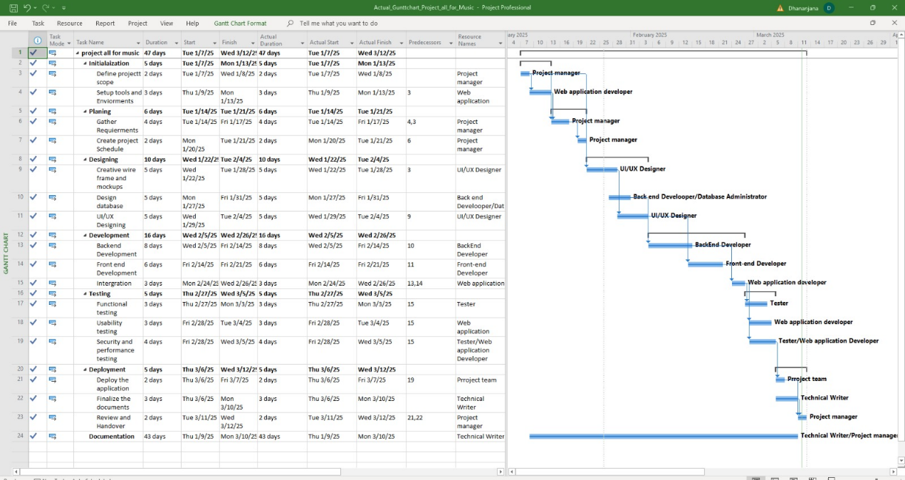

Figure 4 Gantt chat in ALL FOR MUSIC Project

A Gantt chart is a visual project management tool that outlines a project’s schedule, displaying tasks, their durations, dependencies, and progress. It helps teams track milestones, manage resources, and ensure timely execution of project phases.

The Gantt chart below illustrates the All for music project timeline, divided into six key phases: Planning and Requirement Analysis, Development, Testing, Implementation, Finalization, and Post-Implementation. Each phase consists of specific tasks and milestones that contribute to the successful completion of the project.

Project Timeline Overview – All for Music

1. Planning and Requirement Analysis (Weeks 1-2)
   * Week 1: Project initiation, stakeholder meetings, and role assignments.
   * Week 2: Requirement gathering, drafting functional specifications, and refining the project roadmap.
2. Development (Weeks 3-8)
   * Weeks 3-4: Development of core functionalities for users, continuous validation with stakeholders.
   * Weeks 5-6: Expansion to administrator functionalities, iterative refinement based on feedback.
   * Weeks 7-8: Integration of additional system features, ongoing testing, and improvements.
3. Testing (Weeks 9-10)
   * Week 9: Unit testing of system components and integration testing for seamless interactions.
   * Week 10: User Acceptance Testing (UAT) to validate system functionality and final refinements.
4. Implementation (Weeks 11-12)
   * Week 11: Deployment of All for Music for a pilot group within CIT, accompanied by training sessions.
   * Week 12: Full-scale implementation, support, and resolution of any identified issues.
5. Finalization and Beyond (Week 13)
   * Week 13: Project review, documentation of key learnings, and handover of deliverables.
6. Post-Implementation
   * Continuous monitoring of system performance and user feedback collection.
   * Iterative updates and enhancements to improve functionality and efficiency.

The Gantt chart provides a structured, phased approach to the All for music project, ensuring efficient execution while maintaining flexibility to accommodate evolving requirements. This timeline facilitates successful project completion while emphasizing quality, usability, and adaptability.

**Chapter VII**

# System Analyzing

The development of "All for Music" follows a structured System Development Life Cycle (SDLC) to ensure efficiency, usability, and scalability. The system analysis begins with requirement gathering, where user needs are identified through research and feedback from students, artists, and instructors. Based on this, the system design phase outlines the platform’s architecture, including a learning management system, collaboration tools, and a music marketplace. In the implementation phase, the system is developed with a user-friendly interface, secure data management, and interactive features. Rigorous testing is conducted to ensure functionality, security, and performance before deployment, where the platform is introduced to users with proper training and support. Post-launch, maintenance and updates ensure continuous improvements, bug fixes, and the addition of new features based on user feedback. This systematic approach ensures that "All for Music" remains a dynamic and innovative platform for the music community.

# Requirements Gathering

The requirements gathering phase of "All for Music" is a crucial step in designing a platform that effectively caters to the needs of students, artists, instructors, and administrators. This process involves systematically collecting, analysing, and documenting user expectations through various methods such as interviews, surveys, observations, and document analysis.

To ensure a comprehensive understanding of user needs, students are consulted to identify their learning preferences, lesson accessibility, and collaboration requirements. Artists provide insights on showcasing their work, networking opportunities, and monetization features, while instructors highlight the need for course management tools, progress tracking, and personalized mentoring systems. Administrators contribute by specifying requirements for user management, content moderation, transaction tracking, and system security.

By gathering structured data from all stakeholders, the platform is designed to include essential features such as learning modules, collaboration tools, a music marketplace, role-based user management, and an intuitive interface. Additionally, non-functional requirements such as scalability, security, performance, and ease of use are prioritized to ensure long-term sustainability. This systematic approach ensures that "All for Music" evolves into a comprehensive, user-friendly, and innovative platform that enhances the music learning and collaboration experience globally.

# Interview

Interviews are conducted with students, artists, instructors, and administrators to understand their specific needs and challenges. These one-on-one discussions provide insights into their goals, expectations, and frustrations.

## Interview for Students (Players):

1. Can you share your experience with music learning, and how do you connect with the "All for Music" platform?
2. How do you usually find new learning materials or resources for music, and how can "All for Music" improve that process?
3. What challenges do you face when learning music online, and how do you think the platform can address them?
4. What features do you want in the "All for Music" platform to enhance your learning experience?
5. How important is it for you to interact with instructors, artists, or other learners on a music platform?
6. Would you benefit from a marketplace where you can buy, sell, or trade musical instruments? Why or why not?
7. How do you prefer to track your progress in music, and what tools would help you do that effectively?
8. Would you be interested in receiving feedback on your music or lessons through the platform? How should that feedback be provided?
9. What types of music learning resources (videos, sheet music, lessons) would you like to have access to on the platform?
10. What would make it easier for you to navigate and engage with the platform? Are there any features that would improve your user experience?

## Interview for Artists:

1. Can you share your experience as a musician, and how do you currently connect with other artists and fans?
2. How do you typically showcase and promote your music, and what challenges do you face in doing so?
3. What features would you like to see on "All for Music" to help you showcase and monetize your work?
4. How important is it for you to connect with students or learners through a music platform, and what kind of collaboration would you be interested in?
5. Would you like to offer paid lessons, music sheets, or resources to learners? What tools would help you manage this effectively?
6. How can the platform help you discover and connect with other musicians for collaboration?
7. How do you envision selling or trading instruments on a music platform, and what features would help facilitate this?
8. What specific tools or resources would make it easier for you to promote your music to a global audience?
9. What kind of user interface would you find most helpful for uploading and selling your music or resources?
10. How would you like to track the impact or success of your contributions on the platform?

## Interview for Administrators:

1. Can you share your experience managing users and content for a music platform, and how would you improve the process on "All for Music"?
2. What key features would you need for managing users (students, instructors, artists) and their content on the platform?
3. How do you envision managing transactions on the platform, such as course payments or instrument purchases?
4. What security features would be crucial to ensure user data protection and the integrity of the platform?
5. How would you like the platform to handle user feedback and suggestions for continuous improvement?
6. What administrative tools do you need to track user activity, content updates, and platform performance?
7. How can "All for Music" ensure a smooth and seamless experience for all users, including instructors, students, and artists?
8. What kind of reporting tools or analytics would be helpful to monitor the platform’s success and user engagement?
9. How would you handle content moderation and ensure that the platform remains user-friendly and free of inappropriate material?
10. What challenges do you foresee in maintaining the platform, and how can these be mitigated?

## Interview for Project Manager:

1. Can you provide an overview of your experience managing projects, particularly in the development of music platforms or educational tools?
2. What are the primary goals of the "All for Music" project, and how do you ensure these align with the needs of users?
3. What specific challenges did you face during the development of the platform, and how did you address them?
4. How do you ensure effective communication and collaboration between stakeholders (developers, artists, instructors, etc.) during the project?
5. How do you manage the timeline and resources effectively in a platform development project like "All for Music"?
6. How do you handle changes in scope or unexpected challenges that arise during the development of the platform?
7. How do you ensure that the project remains aligned with the overall vision and objectives of the "All for Music" platform?
8. Can you discuss the role of user feedback and how it shapes the platform’s development?
9. What strategies do you use to manage the risks associated with the development of an online platform?
10. How do you assess and allocate resources to ensure the project stays on track and meets its goals?

# Surveys and Questionnaire

**(** Tick the marks **)**

**Section 1: General Information**

1. What is your role in the music industry? (Select one)

* Student (Learner)
* Artist (Performer, Composer)
* Instructor (Teacher, Mentor)
* Administrator
* Other (Please specify): _____________

1. How often do you engage with online music platforms?
   * Daily
   * Weekly
   * Monthly
   * Rarely
   * Never

**Section 2: For Students (Learners)**

1. What challenges do you face in accessing music learning materials? (Check all that apply)

* Limited access to quality resources
* Lack of structured learning paths
* High cost of music lessons
* Difficulty finding instructors
* Other (Please specify): _____________

1. How would you prefer to receive lessons?

* Live virtual sessions
* Pre-recorded video lessons
* Interactive learning modules
* Written tutorials and sheet music

1. How important is peer collaboration in your music learning experience?

* Very Important
* Somewhat Important
* Not Important

1. Would you be interested in tracking your learning progress on the platform?

* Yes
* No
* Not sure

1. What features would improve your learning experience? (Check all that apply)

* Personalized lesson recommendations
* Virtual jam sessions with peers
* Feedback from instructors
* Music theory quizzes and exercises
* Other (Please specify): _____________

**Section 3: For Artists**

1. How do you currently promote and monetize your music?

* Social media (Instagram, YouTube, etc.)
* Streaming platforms (Spotify, Apple Music, etc.)
* Online marketplaces (Etsy, Bandcamp, etc.)
* Other (Please specify): _____________

1. What features would help you showcase your music better? (Check all that apply)

* A personal profile with portfolio
* A marketplace to sell compositions and instruments
* A networking hub for collaborations
* Live-streaming or virtual performance spaces

1. How important is networking with other musicians?

* Very Important
* Somewhat Important
* Not Important

1. Would you like to teach or mentor upcoming artists through the platform?

* Yes
* No
* Maybe

**Section 4: For Instructors**

1. What challenges do you face in teaching music online? (Check all that apply)

* Lack of interactive tools
* Difficulty tracking student progress
* Scheduling conflicts
* Engagement issues with students

1. What features would help improve your teaching experience?

* Student progress tracking
* Virtual classrooms and chat functions
* Content management system for lesson materials
* Personalized lesson recommendations for students

1. Would you be interested in earning through paid courses on the platform?

* Yes
* No
* Maybe

**Section 5: For Administrators**

1. What are your key responsibilities in managing the platform? (Check all that apply)

* User management (students, instructors, artists)
* Content moderation
* Financial transactions and tracking
* System security and data privacy

1. What challenges do you currently face in managing similar platforms?

* Security and data privacy risks
* High workload in content moderation
* Difficulty in handling user disputes
* Ensuring financial transparency

1. What security features would be essential for the platform?

* Secure login and authentication
* Fraud detection for transactions
* Encrypted communication channels
* Other (Please specify): _____________

**Section 6: For Project Managers**

1. What is the most challenging part of managing a music learning platform?

* Coordinating with different stakeholders
* Maintaining project timelines
* Ensuring scalability of the platform
* Managing budget constraints

1. How do you measure the success of an online learning platform?

* User engagement and growth
* Revenue and profitability
* Student learning outcomes
* Instructor satisfaction

1. How frequently should system updates and improvements be introduced?

* Monthly
* Every 3-6 months
* Annually
* Only when necessary.

**Final Feedback**

1. Do you have any additional suggestions or concerns about the "All for Music" platform?

# Observation

Observation plays a crucial role in the requirements gathering phase of the "All for Music" project by providing real-time insights into user behaviors, challenges, and expectations. By studying students, artists, instructors, and administrators in their natural workflows, several key patterns emerge. Students often struggle with finding structured learning materials and rely on scattered online resources, highlighting the need for an organized and interactive learning environment. Artists face difficulties in collaborating, showcasing their work, and monetizing their music, emphasizing the necessity of an integrated platform for networking and promotion. Instructors experience challenges in managing student progress, lesson planning, and providing real-time feedback, indicating the demand for efficient course management tools. Additionally, administrators manually handle user management, content moderation, and transaction tracking, leading to inefficiencies that could be resolved with automated reporting and security enhancements. These observations provide valuable data for designing a user-friendly, efficient, and scalable platform that addresses the real-world needs of the music community, ensuring "All for Music" serves as an innovative and comprehensive solution.

# Prototyping

Prototyping is a critical phase in the development of the "All for Music" platform, enabling iterative design improvements based on user feedback. The process begins with low-fidelity wireframes, which outline the basic structure and navigation flow of the platform, focusing on essential features like learning modules, collaboration spaces, a music marketplace, and user management. These wireframes help visualize the layout and functionality before investing in full-scale development.

Next, interactive prototypes are developed, incorporating user-friendly designs and simulated workflows. These prototypes allow students, artists, instructors, and administrators to interact with the system and provide feedback on usability, content organization, and feature effectiveness. Usability testing at this stage ensures that the platform meets user expectations and addresses challenges identified during the requirements gathering and observation phases.

By continuously refining the prototype based on real-world interactions, the "All for Music" project ensures the development of an intuitive, efficient, and engaging platform. This iterative approach minimizes design flaws, enhances user satisfaction, and streamlines the final implementation process, making the platform a comprehensive and accessible solution for the global music community

# Feasibility Analysis

The project team carried out a thorough feasibility analysis at the same time as the prototype phase to evaluate the operational, legal, technological, economic, and scheduling viability of implementing "All for Music." This research included determining the technical viability of deploying the suggested platform within the current technological framework in addition to analyzing the project's possible costs, risks, and benefits. The project team discovered possible issues that needed to be resolved during implementation and developed a better grasp of the project's feasibility by methodically assessing these aspects.

# Documentation

Documentation plays a crucial role in the successful development, implementation, and maintenance of "All for Music." It ensures clarity in system functionalities, technical specifications, and user guidelines, benefiting all stakeholders, including students, artists, instructors, administrators, and developers. The documentation process begins with requirement documentation, which captures user needs, system functionalities, and performance expectations. System design documentation provides detailed architectural diagrams, database schemas, and user interface wireframes to guide the development process.

During the development phase, technical documentation outlines coding standards, programming frameworks, and API integrations, ensuring consistency in system implementation. Testing documentation ensures the system functions as intended by including test cases for usability, security, and performance, along with bug tracking and resolution reports. To support users and administrators, user manuals provide step-by-step guidance on accessing features, managing content, and troubleshooting common issues. Additionally, deployment and maintenance documentation outlines installation procedures, backup strategies, and security updates to ensure long-term sustainability.

By maintaining well-structured documentation, "All for Music" enhances system reliability, simplifies troubleshooting, and facilitates smooth onboarding for users, ultimately contributing to the platform’s efficiency and growth.

# Review and Approval

The review and approval phase of All for Music is a critical step to ensure the platform meets quality, functionality, and compliance standards before its official launch. The project team conducts thorough internal reviews, evaluating system performance, responsiveness, and integration with third-party tools. Rigorous quality assurance (QA) testing, including unit testing, system testing, and user acceptance testing (UAT), helps identify and resolve issues. Stakeholder feedback is gathered through beta testing, where music instructors, artists, and students provide insights on usability and effectiveness. Additionally, legal and financial experts assess compliance with copyright laws, data protection regulations, and monetization policies. Once all necessary refinements are made, the project undergoes a final approval process led by the project management team and CHL Institute’s administration. This ensures that All for Music is secure, scalable, and ready for deployment, providing a seamless and enriching experience for users.

# Transition to Design

Following the feasibility analysis and prototyping phase, the All for Music project transitions into the design phase, where conceptual ideas are transformed into a structured and functional system. This stage involves defining the platform’s architecture, user interface, and core functionalities to ensure a seamless user experience. Key design elements include an intuitive navigation structure, responsive layouts for web and mobile access, and an efficient database model to manage user data, music resources, and transactions. The design phase also focuses on optimizing performance, ensuring security compliance, and integrating AI-driven features for personalized learning experiences. By incorporating user feedback from the prototyping phase, the system is refined to align with the needs of students, artists, and instructors. This transition marks a crucial step toward the development and deployment of All for Music, laying the foundation for an engaging and innovative music platform.

# User Response

The user response to All for Music has been overwhelmingly positive, reflecting its effectiveness in addressing the needs of musicians, learners, and instructors. Early adopters appreciate the platform’s intuitive design, which simplifies navigation and enhances user experience. Students find the structured learning packages and mentorship programs highly beneficial, enabling them to improve their skills at their own pace. Artists value the collaboration tools and monetization opportunities, which allow them to showcase their talent, connect with fellow musicians, and generate income. Instructors highlight the convenience of managing lessons, tracking student progress, and engaging with a broader audience. Feedback collected through surveys and beta testing has helped refine the platform, ensuring continuous improvement based on user preferences. Overall, All for Music is fostering a dynamic and supportive musical ecosystem, making learning, collaboration, and career growth more accessible and engaging for all users.

# Feasibility Study

A feasibility study in system analysis is a comprehensive evaluation conducted to assess the viability and practicality of implementing the "All for Music" platform. This study aims to determine whether the proposed system is economically, technically, and operationally feasible for the global music community. Economic feasibility involves analyzing the cost-effectiveness of the platform, considering factors such as development costs, potential savings, and return on investment. Technical feasibility evaluates whether the required technology and infrastructure are available and can be effectively implemented. Operational feasibility examines whether the proposed system aligns with the needs of music learners, artists, and instructors, and whether users are likely to accept and adapt to the new platform. The findings of the feasibility study provide decision-makers with valuable insights into the risks, benefits, and challenges associated with the "All for Music" platform, enabling them to make informed decisions about whether to proceed with development or implementation.

**Economic Feasibility**

The project is designed with a sustainable revenue model, incorporating subscription plans, commission-based transactions on music sales, premium content access, and ad-based monetization. A cost-benefit analysis confirmed that the investment in development, maintenance, and marketing would be justified by the anticipated user adoption and multiple revenue streams.

Additionally, partnerships with music institutions, instructors, and brands will create opportunities for sponsorships and collaborations, further enhancing financial viability. The platform will also feature affiliate marketing programs, allowing music-related businesses, instrument manufacturers, and software providers to advertise their products, generating additional revenue.

To increase user retention and engagement, freemium models will be introduced, offering basic access for free while unlocking advanced features, such as exclusive lessons, mentorship programs, and promotional tools for artists, through premium subscriptions. Crowdfunding and grant opportunities from music education organizations and cultural foundations will also be explored to support the platform's expansion.

Moreover, corporate training partnerships with schools, colleges, and music academies will provide customized learning modules for institutions, creating a scalable business-to-business (B2B) revenue stream. The platform's marketplace for music instruments, sheet music, and production services will allow independent artists and educators to generate income while contributing to the platform’s financial growth.

By leveraging these diverse revenue streams, "All for Music" ensures long-term economic sustainability while maintaining affordability for users, making quality music education and collaboration accessible to a global audience.

**Technical Feasibility**

The platform will be developed using scalable web and mobile technologies, ensuring compatibility across multiple devices, including desktops, tablets, and smartphones. A responsive and adaptive design will be implemented to optimize the user experience across different screen sizes and operating systems.

A cloud-based infrastructure will be leveraged for secure data storage, fast content delivery, and seamless performance, utilizing reliable cloud service providers to ensure high availability, disaster recovery, and automated backups. The system will support real-time data synchronization, allowing users to access their learning progress, collaborations, and marketplace transactions from any device.

To enhance platform functionality, integration with third-party music tools, digital audio workstations (DAWs), virtual instruments, and notation software will be enabled, allowing artists and learners to create, edit, and share their work directly within the platform. Secure payment gateways will be implemented to support global transactions, subscription payments, and artist monetization, ensuring a smooth and trustworthy financial system. Digital Rights Management (DRM) will be incorporated to protect copyrighted music, lessons, and creative content from unauthorized use.

The use of a modular and microservices architecture allows for scalability, flexibility, and future enhancements. Each component—learning modules, collaboration tools, marketplace, and user management—will function as an independent service, making updates and feature additions more efficient without disrupting the entire system.

To ensure optimal performance, technologies such as content delivery networks (CDN), caching mechanisms, and database optimization will be implemented. The platform will also integrate AI-driven recommendation engines for personalized content delivery, enhancing user engagement and learning experiences.

Security measures such as end-to-end encryption, multi-factor authentication (MFA), role-based access control (RBAC), and periodic security audits will be in place to protect user data and transactions.

By implementing these robust technical strategies, "All for Music" ensures a highly secure, efficient, and future-proof system that can evolve alongside advancements in the music and technology industries

**Operational Feasibility**

The "All for Music" platform is designed to directly address and overcome critical challenges that music learners, artists, and instructors face, ensuring that the system is not only functional but also impactful for its users. It increases accessibility to structured learning resources by offering a wide variety of courses, tutorials, and interactive lessons, catering to different skill levels, genres, and musical instruments. By creating a centralized learning hub, the platform reduces reliance on scattered resources, giving users easy access to a comprehensive music education experience.

Collaboration tools will be integrated to allow seamless communication and project sharing between students, artists, and instructors. Live classes, group workshops, and peer-to-peer collaborations will facilitate real-time engagement, enhancing the learning experience. Music learners will benefit from features like mentorship programs, where they can receive personalized guidance, ask questions, and track their progress. These tools aim to encourage knowledge exchange and create a community of learners who support each other.

Monetization options for artists are a key part of the platform’s design. Independent musicians will be able to showcase and sell their music, sheet music, and compositions, directly connecting with their audience and peers. The platform also integrates music production tools, digital rights management (DRM) systems, and an easy-to-use payment gateway for secure transactions. These features empower artists to generate revenue through subscriptions, commissions on sales, or premium content access, while also giving them control over their intellectual property.

For instructors, the platform provides advanced course management tools, enabling them to create, organize, and sell music-related courses. The ability to track student progress, provide feedback, and customize learning paths ensures that instructors can offer personalized education experiences. Additionally, the platform incorporates automated grading systems for assignments and quizzes, reducing administrative workload.

User-friendly dashboards are designed for each user role—students, artists, instructors, and administrators. These dashboards will provide a customized, intuitive view of the platform's core features based on the user’s role. Role-based access control (RBAC) ensures that users have access to the functionalities that are most relevant to them, while restricting access to sensitive information or features that aren't applicable. For example, students will have access to courses, schedules, and feedback, while instructors will also have access to teaching materials, student progress, and administrative tools.

By focusing on user-centric design and efficient operational workflows, the platform improves the overall music education and collaboration ecosystem. This ensures that students have the resources and support to grow their skills, while artists and instructors can leverage the platform for professional development, networking, and financial sustainability. The ease of use and intuitive navigation throughout the platform promotes operational efficiency, reducing the need for extensive training and ensuring that all users can quickly adapt to the system.

The combination of these features makes "All for Music" an invaluable tool for fostering a thriving, collaborative, and accessible music education environment.

**Legal Feasibility**

The "All for Music" platform is built with a strong focus on ensuring compliance with copyright laws, intellectual property rights, and data protection regulations, safeguarding both users' and the platform’s legal interests. Compliance with global legal standards is crucial to ensure that the platform operates in a legally sound manner, protecting the rights of content creators, users, and the organization itself.

To address copyright concerns, the platform will implement a comprehensive content ownership verification system, allowing users to prove and protect their ownership of uploaded music, compositions, and other intellectual property. This ensures that all content shared on the platform is legally owned or properly licensed by the user, reducing the risk of unauthorized content distribution. The platform will also include features such as automated copyright claims that allow content creators to identify and challenge any unauthorized use of their work.

In addition, the platform will enforce clear policies for user-generated content (UGC), outlining the responsibilities of users when uploading and sharing their work. These policies will emphasize the importance of respecting intellectual property rights, clearly defining the scope of permissible use, and detailing the process for reporting infringement. User agreements and terms of service will be mandatory for all users, ensuring that they understand and consent to the platform’s rules and regulations regarding content usage and copyright issues.

The platform will also prioritize secure financial transactions, including compliance with payment processing standards such as PCI-DSS (Payment Card Industry Data Security Standard). All financial interactions, such as payments for courses, subscriptions, or music sales, will be encrypted and processed through reputable payment gateways, ensuring data protection and minimizing the risk of fraud.

Privacy controls will be built into the platform to meet data protection regulations such as the General Data Protection Regulation (GDPR) for users in the European Union, as well as other global data privacy laws. Users will have control over their personal information, with the ability to manage data sharing preferences and access privacy settings. The platform will ensure that user data is collected, stored, and processed in a secure manner, with stringent data retention policies and secure access protocols in place.

Further, the platform will implement licensing agreements for music content distribution, particularly for third-party music tracks, ensuring that content creators are compensated appropriately for their work. These agreements will clearly define the terms under which content can be used, shared, and sold, in compliance with local and international copyright frameworks.

Finally, legal counsel will be available to review and update the platform's legal policies regularly, ensuring continuous compliance with evolving laws and regulations related to intellectual property, data protection, and financial transactions.

By integrating these legal safeguards, "All for Music" will ensure that both the platform and its users are protected from legal risks, enabling a secure, trusted, and legally compliant environment for all participants in the music education and collaboration ecosystem.

**Schedule Feasibility**

The "All for Music" project will adhere to a structured and well-defined schedule, ensuring that the platform is developed and deployed within the agreed-upon timeline while allowing room for flexibility and iterative improvements. The project will be divided into multiple phases to ensure a streamlined approach:

1. Requirement Gathering: This initial phase will involve detailed discussions with stakeholders—students, artists, instructors, and administrators—through interviews, surveys, and observations. The gathered data will be analyzed to create clear, actionable requirements for the platform. This phase will take approximately days, depending on the availability and responses from all stakeholders.
2. Prototyping: Based on the requirements, a prototype will be developed to provide a visual and functional representation of the platform. This will enable stakeholders to provide early feedback and make adjustments before the actual development begins. Prototyping will be iterative, with initial designs being reviewed and refined as needed. This phase is expected to take days, with regular check-ins and updates.
3. Development & Implementation: During this phase, the core functionalities of the platform will be developed, including user interfaces, learning modules, collaboration tools, and the music marketplace. A modular development approach will be used to ensure flexibility in adding features in future releases. The development will follow Agile methodologies, with bi-weekly sprints to ensure continuous progress and address any unforeseen challenges. The development phase will span days, including coding, integration, and internal testing.
4. Testing: Once the platform is developed, rigorous testing will be conducted to ensure it meets the specified requirements and quality standards. Testing will include unit testing, integration testing, and user acceptance testing (UAT), involving end-users to ensure the platform’s usability. Feedback from users during UAT will be used to fine-tune the system before deployment. This phase will take days, with extensive bug fixing and performance optimization.
5. Deployment: Following successful testing, the platform will be deployed for live use. A deployment plan will be created, including backup strategies, data migration, and user training. The platform will be launched in phases, starting with a pilot program to a limited group of users before scaling to a full launch. Deployment will take days to ensure a smooth transition to live environments and the seamless setup of all systems.
6. Post-Launch Support and Maintenance: After deployment, ongoing support and maintenance will be crucial to ensure the platform runs smoothly. The maintenance phase will address any immediate post-launch issues, update content, and fix bugs. Regular updates and feature improvements will be scheduled in future development cycles. This phase will be ongoing with dedicated teams providing support as required.

To ensure timely delivery, the project will leverage Agile project management techniques, allowing for flexibility and adaptation. Weekly stand-up meetings will be held to review progress, address blockers, and adjust priorities. A dedicated project manager will oversee all phases, ensuring that timelines are adhered to, resources are appropriately allocated, and that each phase is delivered on time.

Contingency planning will also be incorporated into the schedule, allowing additional time for addressing unexpected delays or challenges. This flexibility ensures that the project can continue to progress even if unforeseen issues arise, maintaining a focus on meeting the final deadline.

The timeline will be tracked using project management tools to monitor milestones, tasks, and dependencies. Regular progress reports will be shared with key stakeholders, ensuring transparency throughout the development process and fostering timely decision-making.

With this detailed and phased approach, the "All for Music" platform is positioned for a successful, on-time launch, meeting the needs of users while allowing room for improvement and adaptation based on feedback.

**Environmental Feasibility**

The "All for Music" project aligns with modern sustainability goals by promoting a paperless, environmentally friendly approach to music education and collaboration. Several key aspects of the platform contribute to reducing its ecological footprint:

1. Digital-Only Resources: By digitizing educational materials such as sheet music, instructional videos, and lesson plans, the platform eliminates the need for physical books, printed materials, and paper-based handouts. This significantly reduces paper waste, conserving natural resources and lowering the environmental impact associated with the production and disposal of physical documents.
2. Remote Learning and Collaboration: The platform’s core features—online lessons, virtual collaborations, and live streaming—reduce the need for travel. This leads to a decrease in carbon emissions from commuting to physical music schools or events. Students, artists, and instructors can interact from anywhere in the world, making education more accessible without the environmental cost of travel.
3. Virtual Music Marketplace: The inclusion of a digital marketplace for music, instruments, and related products minimizes the need for physical stores and shipping, contributing to less packaging waste and transportation emissions. Users can buy and sell music instruments, digital compositions, and other music-related products entirely online, which supports the global shift towards e-commerce while maintaining sustainability.
4. Cloud-Based Infrastructure: The use of cloud computing for data storage and content delivery not only provides a scalable and secure solution but also reduces the energy consumption associated with physical data centers. Cloud providers increasingly use renewable energy sources to power their operations, further reducing the overall environmental impact of the platform.
5. Promotion of Digital Music Creation: Encouraging music creation and distribution in digital formats minimizes the environmental impact associated with physical music distribution methods, such as CDs and vinyl. The platform supports the creation, sharing, and monetization of digital music, fostering an eco-friendly approach to music production and consumption.
6. Sustainable Practices in Platform Operations: The project will prioritize eco-conscious practices in day-to-day operations. This includes using energy-efficient hosting services, minimizing waste in the development process, and utilizing sustainable project management tools that align with green initiatives.
7. Global Reach and Reduced Resource Use: By providing music education to global audiences, "All for Music" reduces the need for localized institutions to invest in extensive physical infrastructure, such as classrooms, equipment, and facilities. The global accessibility of the platform means that resources are used more efficiently across diverse populations without the environmental cost of establishing and maintaining physical institutions in every region.

# Risk Analysis

Risk analysis is an essential component of the "All for Music" project, as it helps identify potential challenges and prepare strategies to mitigate them. By proactively assessing these risks, the project can be better equipped to navigate obstacles and ensure its successful implementation. The following outlines the key risks associated with the project, along with possible strategies for managing them:

**Technological Risks**

Risk: The platform's success heavily depends on the stability and scalability of the technology stack. Any technical failures, such as software bugs, compatibility issues, or server downtimes, could disrupt the user experience and harm the platform's reputation.

Mitigation Strategy:

Invest in robust testing throughout the development process to identify bugs early.

Use a modular, scalable infrastructure to accommodate growing user demands and ensure system reliability.

Regularly update and patch software to maintain security and improve performance.

Implement a disaster recovery plan and use cloud-based solutions with high uptime guarantees.

**Data Security and Privacy Risks**

Risk: With the collection of sensitive user data, including payment details, personal information, and intellectual property (music compositions), there is a risk of data breaches, hacking attempts, and privacy violations.

Mitigation Strategy:

Encrypt sensitive user data both in transit and at rest.

Adhere to data protection regulations such as GDPR to ensure compliance with privacy laws.

Implement two-factor authentication (2FA) for user accounts and sensitive transactions.

Perform regular security audits and penetration testing to identify vulnerabilities.

**Market Adoption and User Engagement Risks**

Risk: The platform may struggle to gain traction with its target audience, particularly if competitors in the online music education space are already well-established. Users may not adopt the platform in sufficient numbers to generate a sustainable revenue stream.

Mitigation Strategy:

Launch targeted marketing campaigns to raise awareness and attract early adopters.

Offer incentives such as free trials, discounted memberships, or exclusive content to encourage user sign-ups.

Continuously gather user feedback and iterate on platform features to meet user demands and preferences.

Form partnerships with influential music institutions, instructors, and artists to build credibility and expand the user base.

**Operational Risks**

Risk: Mismanagement of operations, including inefficient handling of content moderation, customer support, and platform updates, can lead to user dissatisfaction and decreased platform reliability.

Mitigation Strategy:

Implement a robust customer support system with multiple channels (live chat, email, help center).

Regularly monitor user feedback and address complaints promptly.

Hire and train a dedicated team to manage the platform’s daily operations, ensuring smooth service delivery.

**Legal and Compliance Risks**

Risk: Non-compliance with copyright laws, intellectual property rights, or other legal frameworks (e.g., GDPR) could lead to legal disputes, fines, or the removal of content from the platform.

Mitigation Strategy:

Work with legal advisors to ensure the platform is compliant with copyright laws, digital rights management (DRM) protocols, and data privacy regulations.

Implement clear policies regarding user-generated content, including terms of service and acceptable use agreements.

Offer tools for content owners to claim and protect their intellectual property.

**Content Quality and Availability Risks**

Risk: The quality of the content on the platform could vary, leading to dissatisfaction among users. Additionally, if there is a lack of engaging content or instructors, the platform may fail to attract or retain users.

Mitigation Strategy:

Curate high-quality content from experienced instructors and reputable music institutions.

Encourage user-generated content while providing guidelines for quality and relevance.

Regularly update content to keep it fresh and relevant, and offer a mix of free and premium resources.

**Financial Risks**

Risk: The financial stability of the project could be at risk if user acquisition fails to meet expectations or if unforeseen operational costs arise.

Mitigation Strategy:

Develop a detailed financial plan and continuously monitor project expenses and revenue streams.

Diversify revenue sources, such as incorporating subscription fees, commission-based music sales, premium memberships, and advertising.

Secure external funding or partnerships to ensure adequate financial backing during the initial phases of the project.

**User Experience and Interface Risks**

Risk: If the platform's user interface (UI) is not intuitive or user-friendly, users may become frustrated and abandon the platform.

Mitigation Strategy:

Conduct user testing and usability studies to identify areas for improvement in the interface.

Prioritize accessibility by ensuring that the platform is easy to navigate and offers customization options for various user types (students, instructors, artists).

Offer clear onboarding materials and tutorials to help new users get started.

**Competition Risks**

Risk: The platform faces competition from other online music education and collaboration platforms, some of which may have more resources or a larger user base.

Mitigation Strategy:

Differentiate the platform by offering unique features such as live mentoring, collaboration tools, and a marketplace for music sales.

Focus on providing exceptional customer service and a personalized experience to build user loyalty.

Regularly evaluate competitor offerings and innovate to stay ahead of the competition.

**Scalability Risks**

Risk: As the user base grows, the platform may face challenges in maintaining consistent performance and providing a seamless experience for all users.

Mitigation Strategy:

Use cloud-based services with auto-scaling capabilities to handle spikes in traffic and ensure uptime.

Design the platform architecture to support future expansion, including more features, users, and content.

Continuously monitor system performance and user feedback to address scalability issues proactively.

**Chapter VIII**

# System Design – All for Music

The "All for Music" platform is designed as a comprehensive digital hub for musicians, offering a seamless user experience for learning, collaboration, mentorship, and commerce. The system is developed using modern web technologies to ensure scalability, security, and accessibility for a global audience.

# 1. System Architecture

**1.1 Client-Side Architecture**

The client-side is developed using HTML, CSS, JavaScript to ensure a dynamic and responsive interface. The platform is optimized for both desktop and mobile devices, providing users with an intuitive and engaging experience. Key considerations include:

* **Cross-Browser Compatibility:** Works smoothly on Chrome, Edge, Firefox, and Safari.
* **User-Friendly UI/UX:** Designed with musicians in mind, offering easy navigation, interactive elements, and accessibility features.
* **Real-Time Interactions:** Features such as live messaging, music streaming, and virtual lessons are implemented using Web Sockets.

**1.2 Server-Side Architecture**

The backend is developed using Node.js and Express.js, ensuring high-performance and scalability. Key functionalities include:

* **Efficient Data Handling:** RESTful APIs handle requests from the client-side and interact with the database.
* **Security Measures:** Authentication using JWT (JSON Web Tokens) and OAuth for social media logins.
* **Real-Time Features:** WebSocket integration for live collaboration, messaging, and music jamming sessions.

**1.3 Database Management**

The MySQL database for the All for Music platform is designed to efficiently manage and store various types of data, including user profiles, music files, messages, transactions, and collaboration records. The relational structure of MySQL ensures that data is organized into tables with defined relationships, maintaining data integrity and preventing redundancy. Key features such as primary and foreign keys enforce referential integrity across the database. To enhance security, data encryption is used alongside role-based access control (RBAC), which ensures that only authorized users can access sensitive information. The platform’s scalability is supported through cloud integration, which allows the database to expand and handle increasing amounts of data and user interactions seamlessly. Furthermore, the system utilizes MySQL replication, indexing, and caching to ensure optimal performance and global accessibility. With these robust database management practices in place, All for Music ensures a secure, efficient, and scalable environment for users to engage with music content, collaborate, and manage transactions.

# 2. Database Design – All for Music

The "All for Music" platform is designed with a well-structured database management system (DBMS) to efficiently store, retrieve, and manage user data. The database ensures data integrity, scalability, and security, supporting various features such as user profiles, music uploads, course enrollments, and marketplace transactions.

**2**.1 Entity-Relationship Diagram (ERD)

The Entity-Relationship Diagram (ERD) provides a visual representation of the database structure, illustrating the relationships between key entities. The primary entities in the "All for Music" database include:

* **Users (**Students, Instructors, Artists, Buyers, Sellers**)** – Stores user profiles, roles, and authentication details.
* **Courses & Lessons** – Tracks available music courses, lesson details, and user enrollments.
* **Marketplace Listings** – Manages instruments, sheet music, and other music-related products.
* **Transactions & Payments** – Handles financial records for course purchases, instrument sales, and subscriptions.
* **Collaborations & Messages** – Supports real-time chat, project sharing, and collaborative features.

The ERD defines primary keys (PKs) and foreign keys (FKs) to maintain referential integrity and optimize relational queries.

The "All for Music" database consists of the following tables, each serving a specific function:

1. Artist – Stores information about musicians, bands, and solo artists registered on the platform.
2. Feedback – Contains user reviews and ratings for courses, instructors, and services.
3. Instructor – Manages details of music instructors, including their expertise and availability.
4. Instruments – Stores details of musical instruments available for learning or marketplace sales.
5. LatestSongNotations – Keeps track of recently uploaded song notations for learning and sharing.
6. LearningPackages – Stores details of music learning packages, such as online courses and tutorials.
7. Musician – Contains profiles of musicians, including their skills, achievements, and collaborations.
8. MusicLyrics – Stores uploaded song lyrics for sharing, learning, and composition.
9. PaymentMethods – Stores accepted payment methods for subscriptions and transactions.
10. ProgressTracking – Monitors students' learning progress across different courses.
11. Requests – Manages user requests for lessons, mentorship, or music collaboration.
12. Responses – Stores responses to user requests, such as instructor approvals or feedback.
13. sysdiagrams – A system-generated table for managing database diagrams.
14. Transactions – Records all financial transactions, including course purchases and marketplace sales.
15. Users – Manages user accounts, including students, instructors, artists, and buyers/sellers.

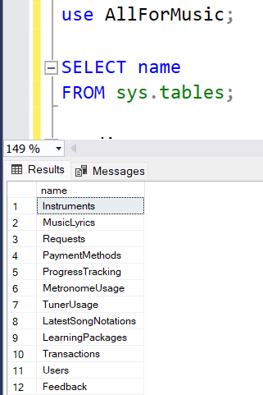

Figure 5 Tables in Database

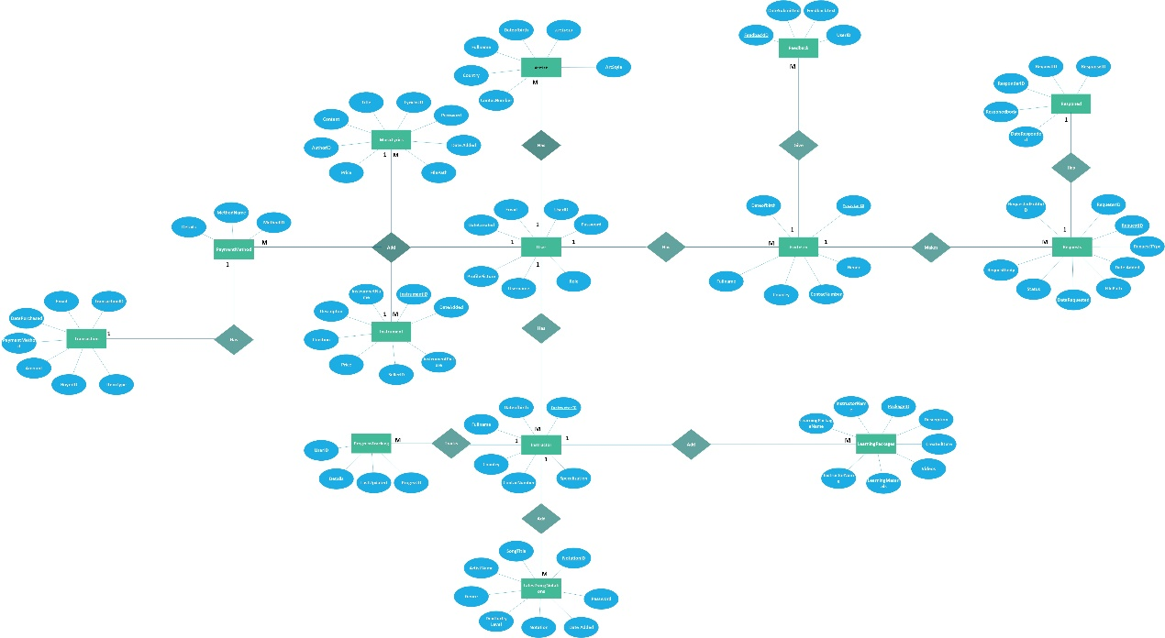**ER Diagram for Project All for Music**

Figure 6 ER Diagram for ALL FOR MUSIC project

The "All for Music" ER diagram represents a well-structured system that integrates multiple functionalities related to music learning, transactions, and content management. Below are ten key assumptions based on the relationships and entities in the diagram, explained in a structured manner.

Firstly, the system appears to support multiple user roles such as musicians, instructors, and artists. This assumption is based on the presence of entities like Musician, Instructor, and Artist, which likely define different user types with specific functionalities. Each user role may have unique permissions, such as instructors managing learning packages or musicians contributing to music content

Secondly, user authentication and login are essential features, as indicated by the User entity’s connection to the Login entity. Users must register with credentials such as email and password to access platform features. This ensures security and personalization within the system.

A key functionality of the platform is financial transactions, as evidenced by the Transaction entity linked to users. This suggests that users can purchase services such as learning packages, musical instruments, or premium content. Payment methods and purchase history are likely tracked to facilitate smooth transactions.

The presence of a Learning Package entity connected to Instructors indicates that the platform offers structured educational materials. Instructors can create and manage lessons, possibly including video tutorials, exercises, and progress tracking. This feature supports users looking to enhance their musical skills.

Another important assumption is that users can request specific content, such as musical notations or lessons, through the Request entity. This feature allows personalization and user engagement by enabling learners or musicians to ask for content tailored to their needs. Requests are likely handled by instructors, musicians, or an administrative team.

To ensure service quality and user satisfaction, the system includes a Feedback mechanism. The Feedback entity is linked to users, suggesting that they can review and rate instructors, learning packages, or purchased items. This feature helps improve content quality and enhances trust among users.

The system also facilitates buying and selling musical instruments, as indicated by the Instrument entity. This suggests a marketplace-like feature where users can list, browse, and purchase instruments. Sellers may provide details such as price, condition, and availability.

Another assumption is that songs and music content are well-structured within the platform. Entities such as Song Notation and Music Lyrics indicate that songs are stored with metadata like title, author, and genre. This likely makes searching for specific songs, notations, or lyrics more efficient.

The presence of a Progress entity linked to users implies that the platform tracks learning progress. This feature helps learners monitor their completion of lessons, assignments, or skill improvements over time. Progress tracking can also be beneficial for instructors to assess student engagement.

Finally, the system might include notifications or alerts to keep users informed about updates, feedback, or transactions. While not explicitly labeled as an entity, relationships between feedback, requests, and transactions suggest that users receive updates about relevant activities, enhancing overall user experience.

In conclusion, the ER diagram showcases a dynamic and interactive music platform where users can learn, purchase, request, and contribute to musical content. With features like structured learning, financial transactions, content management, and community engagement, the platform aims to serve musicians, learners, and artists efficiently.

**3.** User Interfaces – All for Music

The "All for Music" platform provides a set of user-friendly interfaces designed to ensure seamless navigation and accessibility for different user roles. Each interface is tailored to enhance music learning, collaboration, and marketplace interactions.

**3.1 Musician Dashboard** **Interface**

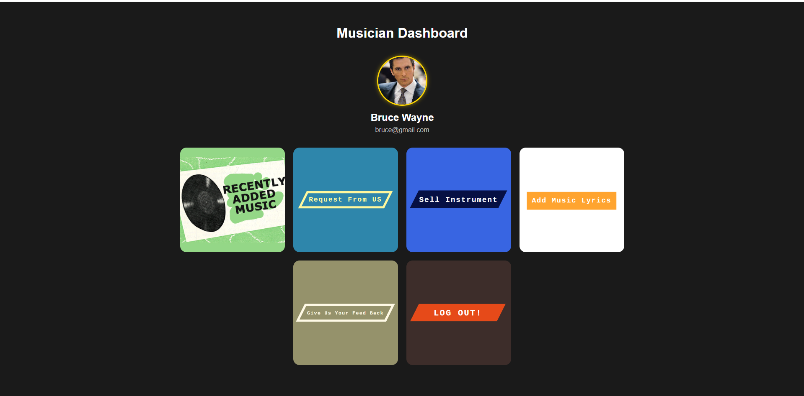

Figure 7 Musician Dashboard Interface

The **Musician Dashboard** is designed for artists to manage their music, track requests, and interact with fans. Key features include:

* **Profile Management** – Update profile details, including profile picture and contact information.
* **Add Music** – Upload new tracks and share them with the community.
* **Manage Music** – Edit, update, or delete uploaded songs.
* **View Requests** – Track song requests and interact with fans.
* **Add Music Lyrics** – Upload and manage lyrics for published tracks.
* **Feedback System** – Receive and respond to feedback from listeners.
* **Log Out** – Securely exit the dashboard.

The interface is simple and functional, with a dark-themed background and navigation links for easy access.

**3.2 Admin Dashboard Interface**

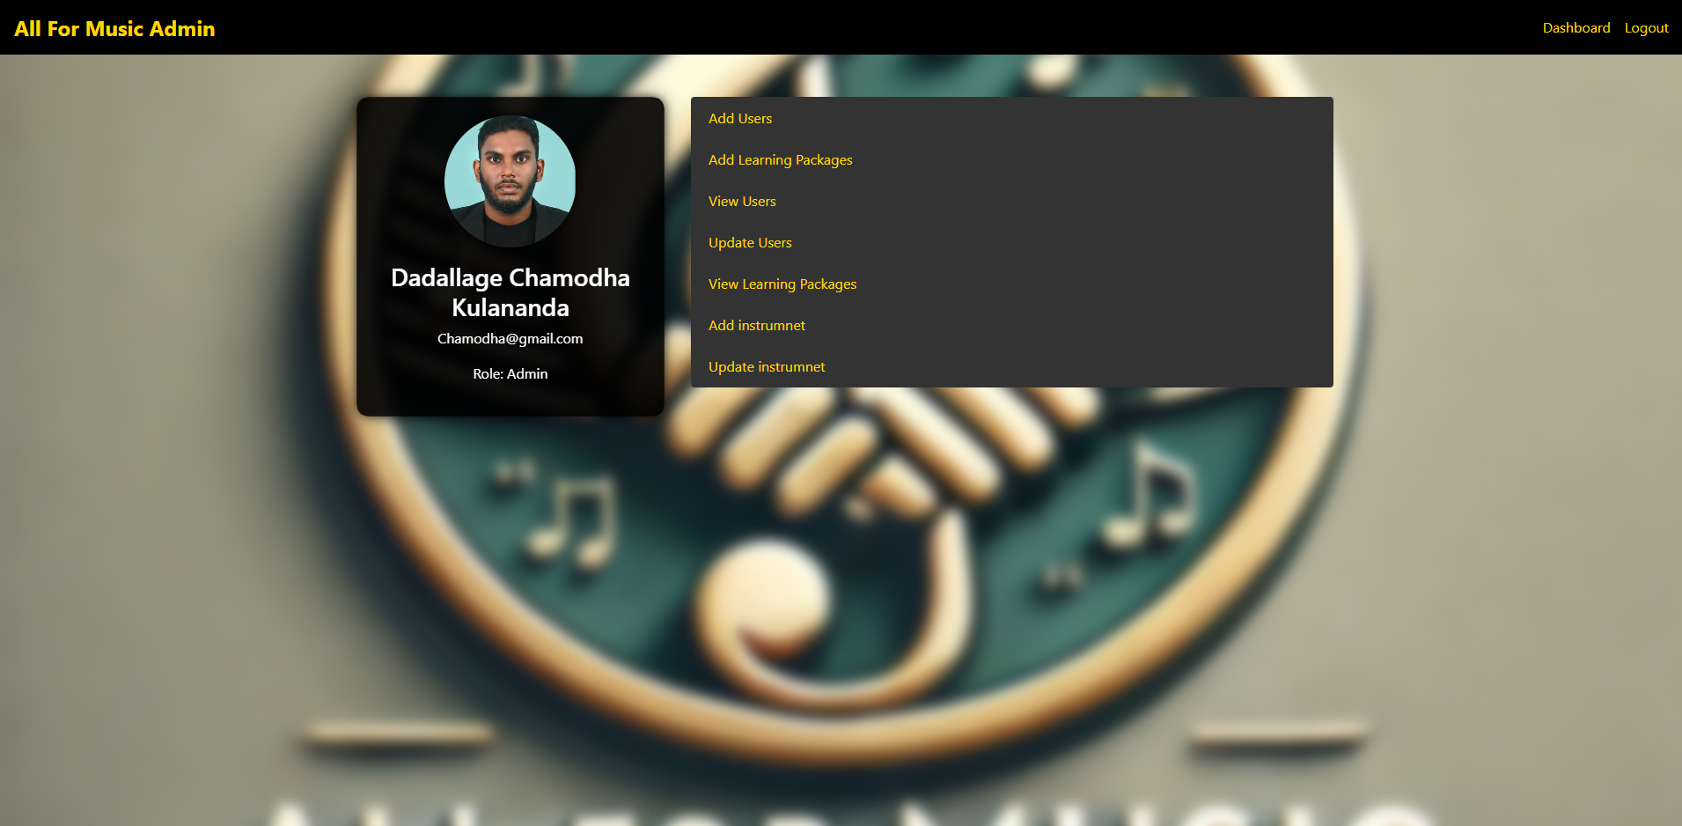

Figure 8 Admin Dashboard Interface

The All For Music Admin Dashboard is designed for administrators to manage users, learning packages, and musical instruments. Key features include:

* **Admin Profile** – Displays the admin's username, email, and role.
* **User Management** – Add, view, and update user accounts.
* **Learning Package Management** – Create, view, and update music learning packages.
* **Instrument Management** – Add and update musical instruments in the system.
* **Navigation Links** – Quick access to the dashboard and logout options.

The interface has a modern dark-themed design with yellow text for key actions, ensuring clear visibility.

**3. Artist dashboard interface**

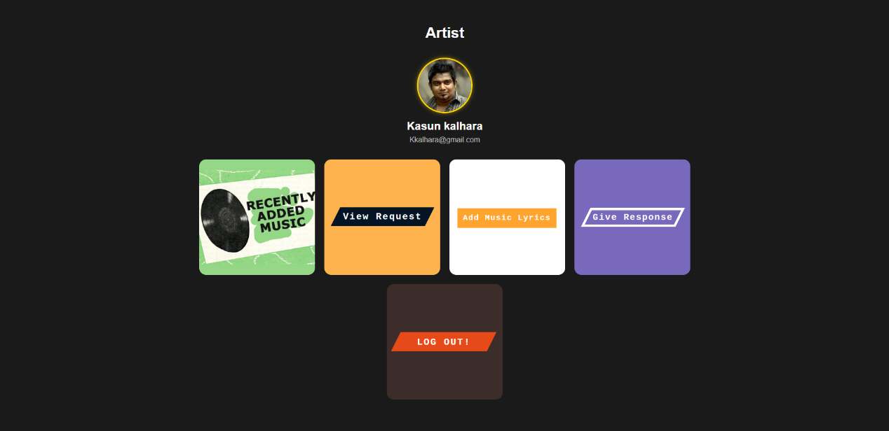

Figure 9 Artist dashboard interface

The Artist Dashboard is designed for musicians to manage their music and interact with listeners. Key features include:

* **Artist Profile** – Displays the artist’s name and email.
* **Music Management** – View and add music to the platform.
* **Request Handling** – View song requests from listeners.
* **Responses** – Provide feedback or respond to requests.

**3.4 Instructor dashboard Interface**

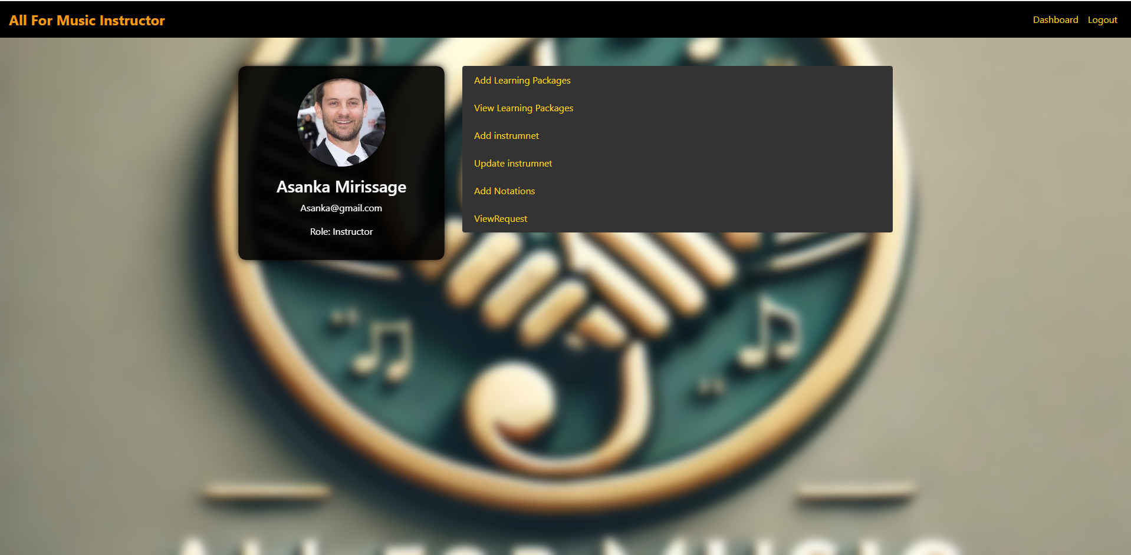

Figure 10 Instructor dashboard Interface

* The **All For Music Instructor Dashboard** is designed for music instructors to manage learning packages, instruments, and student requests. Key features include:
* **Instructor Profile** – Displays the instructor’s name, email, and role.
* **Learning Package Management** – Add and view music learning packages.
* **Instrument Management** – Add and update musical instruments.
* **Notations** – Upload and manage music notations for students.
* **Student Requests** – View and respond to student requests.
* **Navigation Links** – Quick access to the dashboard and logout options.

The interface has a dark-themed design with yellow text for key actions, ensuring easy readability.

The "All for Music" platform ensures a smooth and engaging user experience by providing intuitive interfaces for learning, collaboration, and marketplace activities.

## Mockup Diagram

Admin dashboard

User registration form

User login

Musician Dashboard

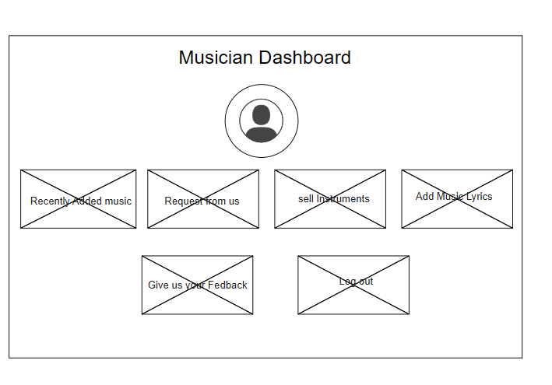

Add music notation

## Data Flow Diagram

**Description of Data Flow Diagram (DFD) and Its Importance**

A Data Flow Diagram (DFD) is a graphical representation that illustrates how data moves within a system, showing processes, data stores, and interactions with external entities. It provides a clear and structured way to analyze and design a system by visually mapping the flow of information.

**Purpose of Using a Data Flow Diagram**

1. **Visual Representation of Data Flow**
   * DFDs provide a clear and simple visualization of how data moves through different processes within a system.
   * It helps developers and stakeholders understand system workflows without complex technical explanations.
2. **Helps in System Analysis and Design**
   * DFDs break down the system into smaller parts, making it easier to analyze each component.
   * It ensures efficient data processing and assists in designing a well-structured system.
3. **Improves Communication Between Stakeholders**
   * Acts as a common language between developers, business analysts, and system users.
   * Reduces misunderstandings and ensures that system requirements are properly conveyed.
4. **Identifies Weaknesses and Bottlenecks**
   * Helps in detecting inefficiencies, redundant processes, or slow data transfers.
   * Provides insights for optimizing system performance.
5. **Facilitates System Documentation**
   * Serves as a reference for system maintenance, upgrades, and future development.
   * Aids new developers in understanding the system’s structure and data flow.
6. **Useful for Security and Data Privacy Analysis**
   * Helps identify security risks by mapping out data movement and access points.
   * Ensures compliance with data privacy regulations by understanding where and how data is stored.

0th level DED

Figure 11 0th level DED for ALL FOR MUSIC project

Description of the 0th Level Data Flow Diagram (DFD)

The given 0th Level DFD (Context Diagram) represents the Music Learning & Marketplace System as a single process that interacts with various external entities. This diagram provides a high-level view of how data flows between the system and its users, without detailing internal processes.

**Entities and Data Flow**

The diagram consists of five external entities, each interacting with the system in different ways:

**1. User**

**Input to System:**

* Submits requests (e.g., purchasing instruments, learning packages).
* Processes transactions (payments for services).
* Provides feedback on the platform.

**Potential Output (not shown explicitly but implied):**

* Receives confirmation messages or learning materials.

**2. Artist**

**Input to System:**

* Uploads music lyrics, notations, and songs to share with users or instructors.

**Potential Output:**

* Could receive user engagement reports or sales details (if monetized).

**3. Instructor**

**Input to System:**

* Adds learning materials for students.
* Tracks student progress in courses.

**Potential Output:**

* Receives feedback from students or system notifications on student activities.

**4. Payment System**

**Input to System:**

* Processes payments for transactions related to instrument purchases and learning packages.

**Potential Output:**

* Sends payment confirmation or transaction failure messages back to the user.

**5. Admin**

**Input to System:**

* Manages users, instruments, and requests to keep the system organized.

**Potential Output:**

* Approves or denies requests.
* Handles disputes or support tickets.
* Updates system settings.

1st level

Figure 12 1st level DFD in ALL FOR MUSIC

**Description of the 1st Level DFD**

This 1st Level Data Flow Diagram (DFD) breaks down the Music Learning & Marketplace System into its main processes and shows interactions with external entities.

**Entities & Processes Breakdown**

**External Entities:**

1. **User**
   * Registers, logs in.
   * Sends learning requests.
   * Makes purchases.
   * Provides feedback.
   * Receives login confirmation, feedback responses, and payment confirmation.
2. **Musician**
   * Uploads compositions, licenses tracks.
   * Receives sales reports & collaboration requests.
3. **Artist**
   * Uploads lyrics, notations, songs.
4. **Instructor**
   * Adds learning materials.
   * Tracks student progress.
5. **Payment System**
   * Processes payments.
   * Sends payment details to the system.
6. **Admin**
   * Manages users, roles, and requests.
   * Approves or releases content.

**Main System & Its Internal Processes**

The Music Learning & Marketplace System contains five key processes:

1. **User Management**
   * Handles user registration & login.
   * Sends login confirmation.
2. **Request Management**
   * Accepts requests from users (e.g., learning packages, instrument purchases).
   * Admin manages requests.
3. **Transaction Processing**
   * Handles purchases & payments.
   * Sends payment confirmation to users.
   * Communicates with the Payment System.
4. **Feedback System**
   * Accepts feedback from users.
   * Sends feedback responses.
5. **Content Management**
   * Allows artists & musicians to upload content.
   * Admin approves/releases content.
   * Sends sales reports & collaboration requests to musicians.

## Use Case Diagrams

A Use Case Diagram is a visual representation of the functional requirements of a system, showing how users (actors) interact with the system to achieve specific goals. It is part of the Unified Modeling Language (UML) and is primarily used in software engineering to provide a high-level overview of system functionality.

Key components of a Use Case Diagram include:

1. **Actors**: These represent the users or external systems that interact with the system. They can be human users, hardware devices, or other systems.
2. **Use Cases**: These represent the specific actions or services provided by the system, depicting the functionality the system offers to its users.
3. **System Boundary**: A rectangle that defines the scope of the system, indicating which use cases are within the system's scope and which are outside.
4. **Associations**: Lines connecting actors to use cases, illustrating the interaction between them.
5. **Relationships**: These include:
   * **Include**: When one use case is always included in another use case.
   * **Extend**: When a use case may optionally extend the behavior of another use case.
   * **Generalization**: When one actor or use case is a specialized version of another.

Use Case Diagrams help stakeholders, including developers, business analysts, and clients, to clearly understand the system's functionality from an external perspective without delving into technical details. They provide clarity on user needs and system interactions, making them an essential tool in the early stages of system design.

## Use case diagrams for All For Music Site

delete function

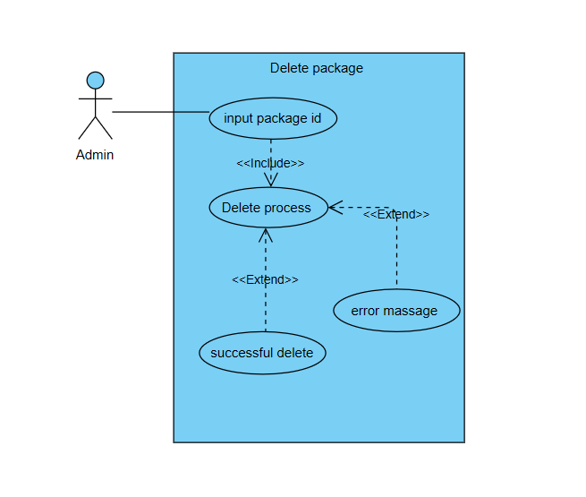

Figure 13 Use case diagram in delete function

**Structure of the Delete Use Case**

Components of the Use Case Diagram

Actor:

* User: The primary actor who interacts with the system (e.g., Admin or Regular User).

Use Cases:

1. Input Data
   * The user enters details related to the specific function (e.g., package details, instrument information, music lyrics, transaction details, or entity ID for deletion).
   * This serves as the initial step in the process.
   * It is connected to the next step using an <<include>> relationship, indicating that validation is a mandatory process.
2. Check Data
   * The system verifies the entered data to ensure correctness and completeness.
   * This step prevents incorrect or incomplete data from being processed.
   * Two possible outcomes arise from this verification process, represented using <<extend>> relationships.
3. Successful Addition (Extended Use Case)
   * If the entered data is valid, the item is successfully added to the system.
   * This use case <<extends>> from the validation process, meaning it occurs only when all checks are passed.
4. Error Message (Extended Use Case)
   * If the entered data is incorrect or incomplete, the system generates an error message.
   * This error message notifies the user about the issue, prompting them to correct the input and retry the process.
   * This use case <<extends>> from the validation process, meaning it occurs only when validation fails.
5. Redirect to Summary Page
   * After a successful addition, the user is redirected to a summary or listing page to review the newly added data.
   * This step is included in the successful addition process using an <<include>> relationship, as it is a required step post-addition.
6. Delete Entity
   * The user initiates the deletion of an entity (e.g., package, instrument, user, or transaction).
   * The system checks whether the entity exists before proceeding with the deletion.
   * This step is included in the deletion process using an <<include>> relationship, as validation is required before performing the deletion.
7. Successful Deletion (Extended Use Case)
   * If the entity exists and meets deletion criteria, it is successfully deleted from the system.
   * This use case <<extends>> from the validation process, meaning it occurs only when deletion checks pass.
8. Error Message for Deletion (Extended Use Case)
   * If the entity does not exist or cannot be deleted due to dependencies, an error message is generated.
   * This use case <<extends>> from the validation process, meaning it is triggered only when deletion fails.

Relationships in the Diagram

<<Include>> Relationship:

* The "Check Data" use case is <<included>> within the "Input Data" use case.
* This indicates that whenever a user enters data, the system must validate it before proceeding.
* The "Redirect to Summary Page" use case is <<included>> within the "Successful Addition" use case, meaning it is a required step after a successful data addition.
* The "Delete Entity" use case <<includes>> the "Check Data" process to ensure validation before deletion.

<<Extend>> Relationship:

* The "Successful Addition" use case <<extends>> from the "Check Data" use case, meaning it is triggered only if validation is successful.
* The "Error Message" use case <<extends>> from the "Check Data" use case, meaning it is triggered only if validation fails due to incorrect or incomplete data.
* The "Successful Deletion" use case <<extends>> from the "Delete Entity" use case, meaning it occurs only when deletion is successfully validated.
* The "Error Message for Deletion" use case <<extends>> from the "Delete Entity" use case, meaning it occurs only when the deletion process fails.

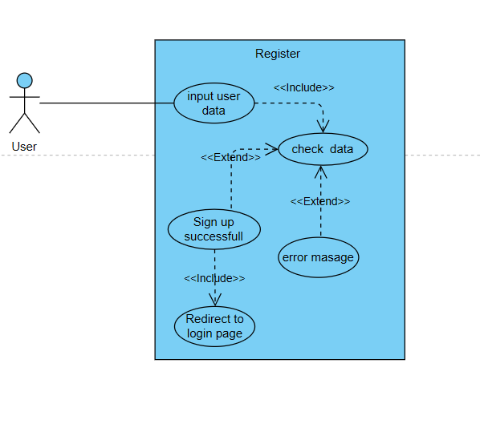

Figure 14 Use case diagram in registration

**General Use Case Diagram**

The provided document outlines the Use Case Diagram for a general data input and validation process within a system. Below is a detailed breakdown, describing its components, relationships, and overall functionality.

**Components of the Use Case Diagram**

**Actor:**

* **User**: The primary actor who interacts with the system (e.g., Admin or Regular User).

**Use Cases:**

1. **Input Data**
   * The user enters details related to the specific function (e.g., package details, instrument information, music lyrics, or transaction details).
   * This serves as the initial step in the process.
   * It is connected to the next step using an <<include>> relationship, indicating that validation is a mandatory process.
2. **Check Data**
   * The system verifies the entered data to ensure correctness and completeness.
   * This step prevents incorrect or incomplete data from being processed.
   * Two possible outcomes arise from this verification process, represented using <<extend>> relationships.
3. **Successful Addition (Extended Use Case)**
   * If the entered data is valid, the item is successfully added to the system.
   * This use case <<extends>> from the validation process, meaning it occurs only when all checks are passed.
4. **Error Message (Extended Use Case)**
   * If the entered data is incorrect or incomplete, the system generates an error message.
   * This error message notifies the user about the issue, prompting them to correct the input and retry the process.
   * This use case <<extends>> from the validation process, meaning it occurs only when validation fails.
5. **Redirect to Summary Page**
   * After a successful addition, the user is redirected to a summary or listing page to review the newly added data.
   * This step is included in the successful addition process using an <<include>> relationship, as it is a required step post-addition.

**Relationships in the Diagram**

**<<Include>> Relationship:**

* The "Check Data" use case is <<included>> within the "Input Data" use case.
* This indicates that whenever a user enters data, the system must validate it before proceeding.
* The "Redirect to Summary Page" use case is <<included>> within the "Successful Addition" use case, meaning it is a required step after a successful data addition.

**<<Extend>> Relationship:**

* The "Successful Addition" use case <<extends>> from the "Check Data" use case, meaning it is triggered only if validation is successful.
* The "Error Message" use case <<extends>> from the "Check Data" use case, meaning it is triggered only if validation fails due to incorrect or incomplete data.

Figure 15 Use case diagram in login

**Login Use Case Diagram**

**Components of the Use Case Diagram**

**Actor:**

* **User**: The primary actor who interacts with the system to log in.

**Use Cases:**

1. **User Email and Password**
   * The user enters their login credentials (email and password).
   * This serves as the initial step in the login process.
   * It is connected to the next step using an <<include>> relationship, indicating that verification is a mandatory process.
2. **Verification Input Data**
   * The system checks whether the entered email and password are correct.
   * This step ensures that only valid users can access the system.
   * Two possible outcomes arise from this verification process, represented using <<extend>> relationships.
3. **Login Successful (Extended Use Case)**
   * If the provided credentials are correct, the system successfully logs the user in.
   * This use case <<extends>> from the verification process, meaning it occurs only if authentication is successful.
4. **Error Message (Extended Use Case)**
   * If the entered credentials are incorrect, the system generates an error message.
   * This error message notifies the user about incorrect credentials and prompts them to try again.
   * This use case <<extends>> from the verification process, meaning it occurs only if authentication fails.

**Relationships in the Diagram**

**<<Include>> Relationship:**

* The "Verification Input Data" use case is <<included>> within the "User Email and Password" use case.
* This indicates that whenever a user attempts to log in, their credentials must be verified as an essential part of the process.

**<<Extend>> Relationship:**

* The "Login Successful" use case <<extends>> from the verification process, meaning it is triggered only if the credentials are valid.
* The "Error Message" use case <<extends>> from the verification process, meaning it occurs only if the credentials are incorrect.

**Use Case: Search Package**

Figure 16 Use case diagram in search package

**Search Use Case Diagram**

**Components of the Use Case Diagram**

**Actor:**

* **User**: The primary actor who initiates the search process.

**Use Cases:**

1. **Input the Search Query**
   * The user enters a keyword, entity name, or ID to perform a search.
   * The system processes the input before proceeding.
   * This step is essential as it serves as the starting point of the search process.
   * It is connected to the next step using an <<include>> relationship, meaning it is a mandatory part of the search process.
2. **Validate Input and Perform Search**
   * The system verifies whether the provided search query is valid.
   * If the input is empty or invalid, the system triggers an error message.
   * If the input is valid, the system retrieves matching results from the database.
   * Two possible outcomes can result from this validation step, represented using the <<extend>> relationships.
3. **Display Search Results (Extended Use Case):**
   * If matching entities are found, they are displayed to the user.
   * This use case is connected to the validation process via an <<extend>> relationship, meaning it only occurs when valid results are found.
4. **Error Message (Extended Use Case):**
   * If the validation process fails due to an invalid or empty search query, the system generates an error message.
   * This error message notifies the user about the issue, allowing them to modify the search criteria and retry.
   * This use case is also connected to the validation process via an <<extend>> relationship, meaning it occurs only when there is an issue with the validation.

**Relationships in the Diagram**

**<<Include>> Relationship:**

* The "Validate Input and Perform Search" use case is <<included>> within the "Input Search Query" use case.
* This indicates that whenever a user provides a search query, the system must perform validation and retrieval as an essential part of the process.

**<<Extend>> Relationship:**

* The "Display Search Results" use case <<extends>> from the validation process, meaning it is triggered only if valid search results exist.
* The "Error Message" use case <<extends>> from the validation process, meaning it occurs only if the input is invalid or no matches are found.

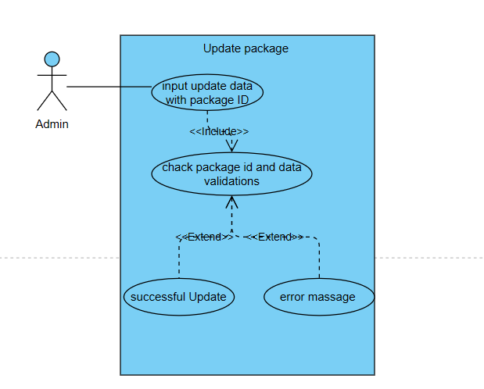

Figure 17 Use case diagram in update packages

**Components of the Use Case Diagram**

**Actor:**

* **Admin**: The administrator is the primary actor interacting with the system. The admin is responsible for initiating the update package process by providing relevant data.

**Use Cases:**

1. **Input Update Data with Package ID**:
   * The admin enters the package ID along with the updated data.
   * This step is essential as it serves as the starting point of the update process.
   * It is connected to the next step using an <<include>> relationship, meaning it is a mandatory part of the update process.
2. **Check Package ID and Data Validations**:
   * The system verifies whether the provided package ID exists in the database.
   * It also checks the validity of the new data entered by the admin.
   * This step ensures that the update process does not proceed with incorrect or incomplete data.
   * Two possible outcomes can result from this validation step, represented using the <<extend>> relationships.
3. **Successful Update** (Extended Use Case):
   * If the package ID is valid and the provided data meets all requirements, the system successfully updates the package.
   * This use case is connected to the validation process via an <<extend>> relationship, meaning it only occurs when all validations are passed.
4. **Error Message** (Extended Use Case):
   * If the validation process fails due to an incorrect package ID or invalid update data, the system generates an error message.
   * This error message notifies the admin about the issue, allowing them to correct the input and retry the update process.
   * This use case is also connected to the validation process via an <<extend>> relationship, meaning it occurs only when there is an issue with the validation.

**Relationships in the Diagram**

1. **<<Include>> Relationship**:
   * The "Check Package ID and Data Validations" use case is <<included>> within the "Input Update Data with Package ID" use case.
   * This indicates that whenever an admin provides the update data, the system must perform validation as an essential part of the process.
2. **<<Extend>> Relationship**:
   * The "Successful Update" use case <<extends>> from the validation process, meaning it is triggered only if the validation step is successful.
   * The "Error Message" use case <<extends>> from the validation process, meaning it occurs only if the validation fails due to incorrect input data or an invalid package ID.

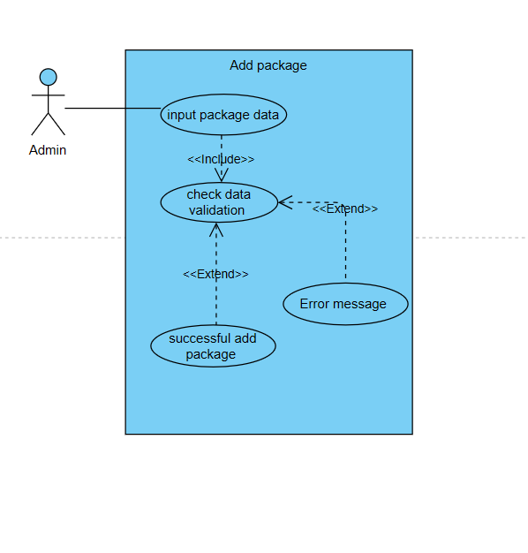

Figure 18 Use case diagram in Add package

**General Use Case Diagram**

**Components of the Use Case Diagram**

**Actor:**

* **User**: The primary actor who interacts with the system (e.g., Admin or Regular User).

**Use Cases:**

1. **Input Data**
   * The user enters details related to the specific function (e.g., package details, instrument information, music lyrics, transaction details, or entity ID for deletion).
   * This serves as the initial step in the process.
   * It is connected to the next step using an <<include>> relationship, indicating that validation is a mandatory process.
2. **Check Data Validation**
   * The system verifies the entered data to ensure correctness and completeness.
   * This step prevents incorrect or incomplete data from being processed.
   * Two possible outcomes arise from this verification process, represented using <<extend>> relationships.
3. **Successful Addition (Extended Use Case)**
   * If the entered data is valid, the item is successfully added to the system.
   * This use case <<extends>> from the validation process, meaning it occurs only when all checks are passed.
4. **Error Message (Extended Use Case)**
   * If the entered data is incorrect or incomplete, the system generates an error message.
   * This error message notifies the user about the issue, prompting them to correct the input and retry the process.
   * This use case <<extends>> from the validation process, meaning it occurs only when validation fails.
5. **Redirect to Summary Page**
   * After a successful addition, the user is redirected to a summary or listing page to review the newly added data.
   * This step is included in the successful addition process using an <<include>> relationship, as it is a required step post-addition.
6. **Delete Entity**
   * The user initiates the deletion of an entity (e.g., package, instrument, user, or transaction).
   * The system checks whether the entity exists before proceeding with the deletion.
   * This step is included in the deletion process using an <<include>> relationship, as validation is required before performing the deletion.
7. **Successful Deletion (Extended Use Case)**
   * If the entity exists and meets deletion criteria, it is successfully deleted from the system.
   * This use case <<extends>> from the validation process, meaning it occurs only when deletion checks pass.
8. **Error Message for Deletion (Extended Use Case)**
   * If the entity does not exist or cannot be deleted due to dependencies, an error message is generated.
   * This use case <<extends>> from the validation process, meaning it is triggered only when deletion fails.

**Relationships in the Diagram**

**<<Include>> Relationship:**

* The "Check Data Validation" use case is <<included>> within the "Input Data" use case.
* This indicates that whenever a user enters data, the system must validate it before proceeding.
* The "Redirect to Summary Page" use case is <<included>> within the "Successful Addition" use case, meaning it is a required step after a successful data addition.
* The "Delete Entity" use case <<includes>> the "Check Data Validation" process to ensure validation before deletion.

**<<Extend>> Relationship:**

* The "Successful Addition" use case <<extends>> from the "Check Data Validation" use case, meaning it is triggered only if validation is successful.
* The "Error Message" use case <<extends>> from the "Check Data Validation" use case, meaning it is triggered only if validation fails due to incorrect or incomplete data.
* The "Successful Deletion" use case <<extends>> from the "Delete Entity" use case, meaning it occurs only when deletion is successfully validated.
* The "Error Message for Deletion" use case <<extends>> from the "Delete Entity" use case, meaning it occurs only when the deletion process fails.

## Sequence Diagrams

An Overview

A Sequence Diagram is a type of UML (Unified Modeling Language) diagram that visually represents how objects in a system interact with each other over time. It shows the sequence of messages exchanged between different entities (such as users, systems, or processes) to complete a specific function.

**Key Components of a Sequence Diagram**

1. **Actors**: Represent users or external systems that interact with the system.
2. **Objects (Lifelines)**: Represent system components or classes that participate in the interaction.
3. **Messages**: Indicate communication between objects, usually represented as arrows.
4. **Activation Bars**: Show when an object is active and processing a request.
5. **Loops & Conditions**: Indicate repetition (loops) or conditional branching in the interaction.
6. **Destroy Messages**: Represent when an object is terminated during the interaction.

**Purpose of Sequence Diagrams**

* **Clarify system functionality**: Helps developers and designers understand how different components interact.
* **Identify bottlenecks**: Highlights inefficient interactions or dependencies.
* **Improve documentation**: Provides a structured way to document system processes.
* **Facilitate collaboration**: Useful for teams working on software design, ensuring everyone understands system behavior.

**Example Sequence Diagram**

For example, in a user login process, a sequence diagram might include:

1. User initiates a login request.
2. Login Page forwards credentials to the Authentication Server.
3. Authentication Server verifies credentials and responds with success or failure.
4. System grants or denies access accordingly.

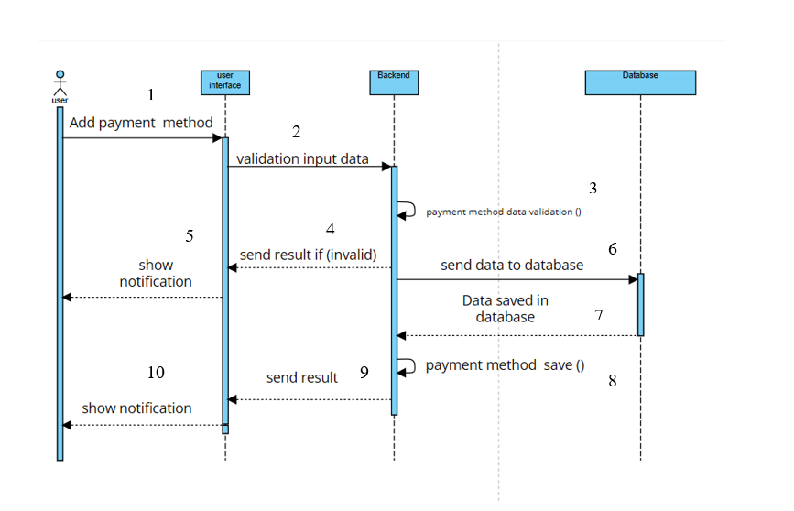

Figure 19 Add payment function in Sequence diagram

**Description of the Sequence Diagram**

This sequence diagram represents the process of adding a payment method in a system. It involves four key components:

1. **User** (actor)
2. **User Interface (UI)**
3. **Backend** (server-side logic)
4. **Database**

**Step-by-Step Explanation**

1. **User Initiates Action**
   * The user initiates the process by selecting "Add Payment Method" in the system.
2. **Validation at UI Level**
   * The user interface receives the input and validates the data.
   * If the data is invalid, the UI sends the result back and displays a notification to the user.
3. **Backend Validation**
   * If the input is valid, the UI forwards it to the backend for further processing.
   * The backend performs payment method data validation.
4. **Database Interaction**
   * If the data is valid, the backend **sends the payment method data to the database**.
   * The database saves the data successfully.
5. **Response Handling**
   * Once the data is stored, the database sends a confirmation back to the **backend**.
   * The backend acknowledges the save operation (payment method save()).
   * The backend then sends a response back to the UI.
6. **User Notification**
   * The UI processes the result and shows a notification to the user about the status of the operation.

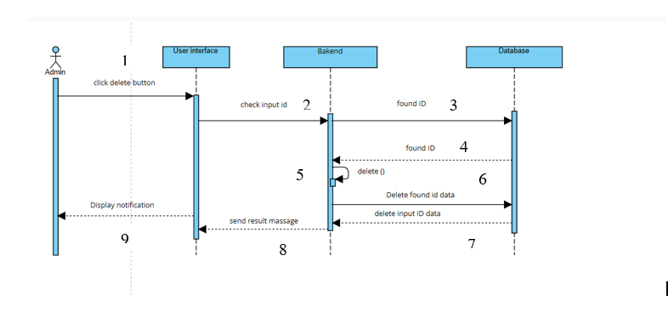

Figure 20 Delete function in Sequence diagram

**Description of the Sequence Diagram**

This sequence diagram represents the process of an Admin deleting an entry (ID-based deletion process) in a system. It involves four key components:

1. **Admin (Actor)** – Initiates the delete request.
2. **User Interface (UI)** – Receives the request and communicates with the backend.
3. **Backend** – Validates and processes the deletion request.
4. **Database** – Stores and deletes the requested entry.

**Step-by-Step Explanation**

1. **Admin Initiates Deletion**
   * The Admin clicks the delete button in the UI.
2. **UI Checks Input ID**
   * The User Interface forwards the input ID to the backend for validation.
3. **Backend Searches for ID**
   * The Backend queries the Database to check if the provided ID exists.
   * The database responds with "found ID" if the record is available.
4. **Deletion Process**
   * The Backend calls the delete() function to initiate the deletion.
   * The Database processes the request and removes the input ID data.
   * A confirmation message is sent back to the Backend.
5. **Result Handling & Notification**
   * The Backend sends a result message to the UI.
   * The UI then displays a notification to inform the Admin about the deletion outcome.

Figure 21 Package add function in Sequence diagram

**Description of the Sequence Diagram**

This sequence diagram represents the process of an Admin adding a learning package to the system. It consists of four key components:

1. **Admin (Actor)** – Initiates the request by clicking the "Add" button.
2. **User Interface (UI)** – Handles input and interacts with the backend.
3. **Backend** – Processes the request and communicates with the database.
4. **Database** – Stores the learning package information.

**Step-by-Step Explanation**

1. **Admin Initiates Addition**
   * **The Admin clicks the Add button on the learning package page.**
2. **UI Validates Input Data**
   * The User Interface checks if the provided data is valid.
   * If the data is invalid, an error message should be displayed (not shown in the diagram).
3. **Backend Processes the Request**
   * If the data is valid, the UI sends it to the Backend for processing.
4. **Data Sent to Database**
   * The Backend forwards the validated data to the Database.
   * The Database saves the new learning package and sends a confirmation back to the backend.
5. **Backend Sends a Response**
   * The Backend confirms the operation by sending a result message back to the UI.
6. **UI Displays Notification**
   * The UI notifies the Admin about the success or failure of the operation.

Figure 22 User login function in Sequence diagram

**Description of the Sequence Diagram**

This sequence diagram represents the User Login Process within the system. It consists of four key components:

1. **User (Actor)** – Initiates the login request by clicking the "Login" button.
2. **User Interface (UI)** – Handles user input and interacts with the validation system.
3. **User Validate Module** – Processes the login request by verifying the credentials.
4. **Database** – Stores user credentials and returns verification results.

**Step-by-Step Explanation**

1. **User Initiates Login**
   * The User clicks the Login button on the UI.
2. **UI Sends Login Credentials**
   * The UI captures the entered email and password and sends them to the validation module for verification.
3. **Validation Module Checks Credentials**
   * The User Validate module receives the credentials and requests data verification from the database.
4. **Database Verifies Data**
   * The **Database** checks if the provided credentials exist and are correct.
   * It returns the validation result to the User Validate module.
5. **Validation Module Processes the Result**
   * If the credentials are valid, the system proceeds with login.
   * If the credentials are invalid, an error message is generated.
6. **UI Displays Notification**
   * The UI receives the validation result and notifies the User about the success or failure of the login attempt.

## Class Diagrams

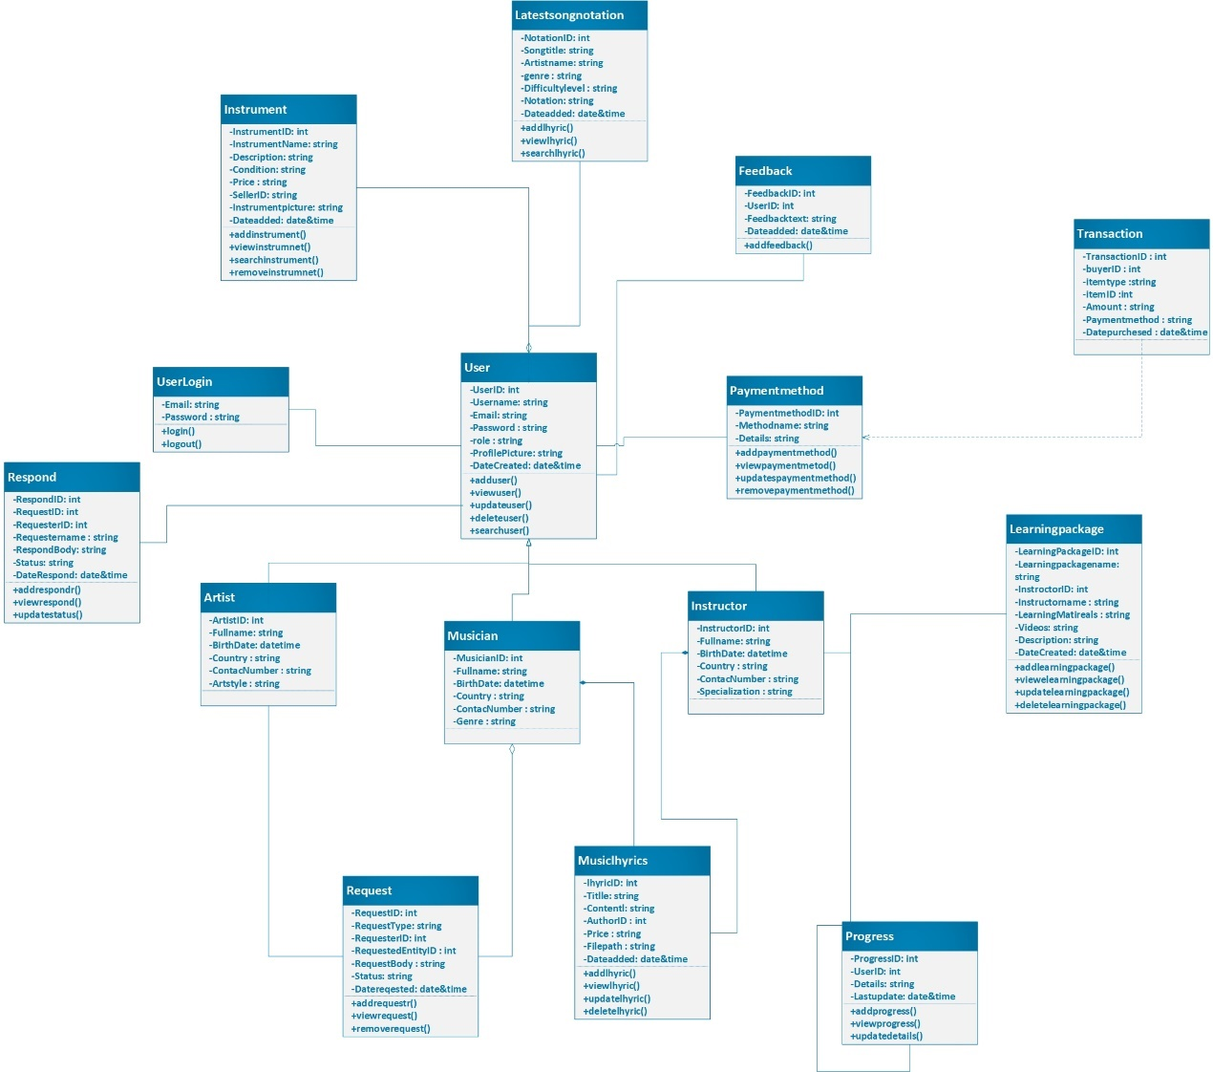

Figure 23 Class diagram in ALL FOR MUSIC project

The class diagram for the "All for Music" project represents a comprehensive music platform integrating various functionalities, including user management, song notations, learning packages, and transactions.

At the core of the system is the User class, which manages user-related information such as Username, Email, ProfilePicture, and account creation details. Users can log in via the UserLogin class, which contains credentials and authentication methods. Users can also provide Feedback and manage their PaymentMethods for transactions.

The platform facilitates music learning through the LearningPackage class, which connects with the instructor class, enabling users to access learning materials and video sessions. The Progress class tracks users' learning progress.

Music-related entities include LatestSongNotation, which stores song notations, and MusicLyrics, which maintains song lyrics with metadata such as author and file type. The Instrument class allows users to buy and sell musical instruments.Artists and musicians are represented by the Artist and Musician classes, storing personal and professional details. Users can request specific content through the Request class, with responses managed by the Respond class.

Financial transactions are handled through the Transaction class, which logs payments and purchases made by users. The PaymentMethod class is linked to transactions to facilitate multiple payment options.Overall, the diagram showcases a structured and well-integrated system for musicians, learners, and music enthusiasts, providing a complete platform for notation management, learning, commerce, and user engagement.

## Activity diagram

Activity diagram for user registration (Add new user)

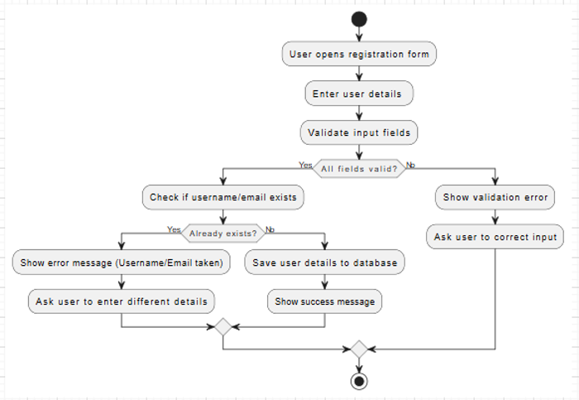

Figure 24 Activity diagram for user registration

This Activity Diagram represents the user registration process in a system. It illustrates the sequence of steps a user follows to register, including validation checks and error handling.

**Process Flow:**

**User opens the registration form** – The process starts when the user accesses the registration form.  
 **Enter user details** – The user inputs their required registration details (e.g., username, email, password).  
 **Validate input fields** – The system checks if all fields are filled correctly.

* **If all fields are valid**, proceed to check if the username/email already exists.
* **If invalid**, display a validation error and prompt the user to correct the input.

**Check if username/email exists** – The system verifies if the provided username or email is already registered.

* **If the username/email is unique**, the system saves the user details in the database and displays a success message.
* **If the username/email already exists**, an error message is shown, and the user is asked to enter different details.

**Completion** – Once the user successfully registers, the process ends.

Activity diagram user login

Figure 25 Activity diagram for user login

The Login Process Flowchart illustrates the authentication process for users accessing a system. Key steps include:

**User Input** – The user enters their email and password.  
 **Credential Validation** – The system checks the authenticity of the provided credentials.  
 **Decision Point** – If the credentials are valid:

* The system grants access and redirects the user to their dashboard.  
   Error Handling – If the credentials are invalid:
* An error message is displayed.
* The user is prompted to retry the login process.

Activity diagram Admin dashboard

Figure 26 Activity diagram for Admin dashboard

This Activity Diagram represents the navigation flow of an Admin Panel for a music-related platform. It outlines how an admin interacts with different options available in the navigation bar, leading to various pages for managing users, learning packages, instruments, and logging out.

**Process Flow:**

**Display Navigation Bar with Options** – The system shows a navigation bar with multiple admin functionalities.  
**Admin selects an option** – The admin can click on any of the available management options, each leading to a specific page:

* **"Add Users"** Redirects to AddUsers.php (for adding a new admin or user).
* **"Add Learning Packages"** Redirects to Add_LearningPackages.php (to add course materials).
* **"View Users"**  Redirects to Viewuser.php (to see a list of registered users).
* **"Update Users"** Redirects to UserSearch&Update.php (to modify user details).
* **"View Learning Packages"** Redirects to ViewLearningPackages.php (to browse available learning content).
* **"Add Instrument"** Redirects to Instrument.php (to add a new musical instrument to the system).
* **"Update Instrument"** Redirects to InstrumentUpdate.php (to modify instrument details).
* **"Logout"** Redirects to Logout.php (to log out from the admin panel).

**Process Completion** – The navigation flow allows multiple interactions, but each action eventually leads to a specific page, ensuring smooth admin operations.

Add new learning package

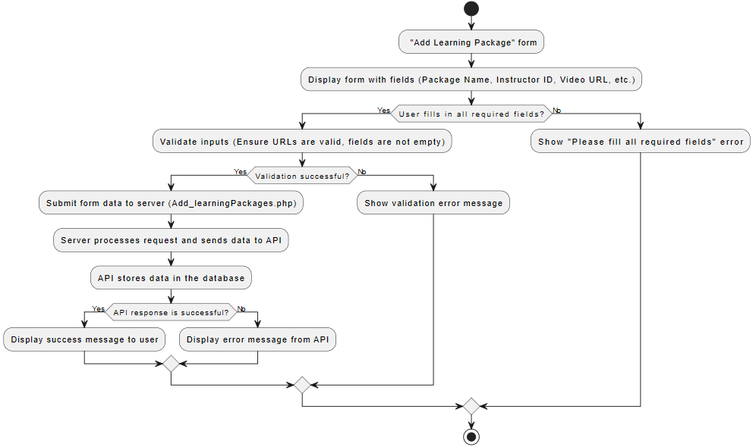

Figure 27 Activity diagram for add new learning package

**Activity Diagram for "Add Learning Package" Form**

This activity diagram represents the workflow for adding a learning package to the system. Key steps include:

**Form Display** – The user is presented with a form containing fields like Package Name, Instructor ID, Video URL, etc.

**User Input Validation** –

* If the user fills in all required fields, the system proceeds to validate the inputs.
* If not, an error message ("Please fill all required fields") is shown.

**Input Validation** –

* If inputs are valid (e.g., non-empty fields, valid URLs), the form data is submitted to the server (Add_learningPackages.php).
* If validation fails, an error message is displayed.

**Data Processing & API Interaction** –

* The server processes the request and sends data to the API.
* The API stores the data in the database.

**Final Outcome** –

* If the **API response is successful**, a success message is shown to the user.
* If the **API response fails**, an error message from the API is displayed.

**Loop Handling** – If errors occur, the user is given an opportunity to correct the mistakes and retry the submission.

This structured approach ensures that only valid learning packages are added to the system while providing necessary feedback at each stage.

## Data Dictionary

Data Dictionary for 'All for Music' Database

Table 2 Data Dictionary for All for Music Project

|  |  |  |  |  |  |  |
| --- | --- | --- | --- | --- | --- | --- |
| Table Name | Field Name | Data Type | Data Format | Field Size | Description | Example |
| Users | UserID | INT | Auto-increment | N/A | Unique identifier for each user | 1 |
|  | Username | NVARCHAR | Alphanumeric | 100 | Unique username for login | johndoe123 |
|  | PasswordHash | NVARCHAR | Hashed String | 255 | Encrypted password for security | $2a$10$xyz... |
|  | Email | NVARCHAR | Email Format | 255 | Unique email ID of the user | user@example.com |
|  | Role | NVARCHAR | Predefined Options | 50 | Defines user role (Musician, Artist, Instructor, Admin) | Musician |
|  | ProfilePicture | NVARCHAR | File Path | 255 | Path to profile picture | /images/profiles/user1.jpg |
|  | DateCreated | DATETIME | YYYY-MM-DD HH:MM:SS | N/A | Timestamp when account was created | 2025-03-11 14:30:00 |
| LearningPackages | PackageID | INT | Auto-increment | N/A | Unique identifier for each learning package | 101 |
|  | PackageName | NVARCHAR | Alphanumeric | 255 | Name of the learning package | Beginner Guitar Lessons |
|  | Description | TEXT | Free text | N/A | Details about the package | Includes 10 lessons, PDFs |
|  | InstructorID | INT | Foreign Key (Users) | N/A | ID of the instructor who created the package | 5 |
|  | Price | DECIMAL(10,2) | Currency Format | N/A | Cost of the package | 49.99 |
|  | LearningMaterials | NVARCHAR | File Path | 255 | Path to learning materials (PDF, DOCX) | /materials/lesson1.pdf |
|  | DateAdded | DATETIME | YYYY-MM-DD HH:MM:SS | N/A | Date package was added | 2025-03-10 12:00:00 |

|  |  |  |  |  |  |  |
| --- | --- | --- | --- | --- | --- | --- |
| Table Name | Field Name | Data Type | Data Format | Field Size | Description | Example |
| Instruments | InstrumentID | INT | Auto-increment | N/A | Unique identifier for each instrument | 201 |
|  | InstrumentName | NVARCHAR | Alphanumeric | 255 | Name of the instrument | Acoustic Guitar |
|  | Description | TEXT | Free text | N/A | Description of the instrument | Good condition, used |
|  | Condition | NVARCHAR | Predefined Options | 50 | Specifies if the instrument is New or Second-hand | Second-hand |
|  | Price | DECIMAL(10,2) | Currency Format | N/A | Cost of the instrument | 199.99 |
|  | SellerID | INT | Foreign Key (Users) | N/A | ID of the seller listing the instrument | 10 |
|  | InstrumentPicture | NVARCHAR | File Path | 255 | Path to instrument image | /images/instruments/guitar.jpg |
|  | DateAdded | DATETIME | YYYY-MM-DD HH:MM:SS | N/A | Date instrument was listed | 2025-03-09 15:00:00 |
| MusicLyrics | LyricID | INT | Auto-increment | N/A | Unique identifier for each lyric entry | 301 |
|  | Title | NVARCHAR | Alphanumeric | 255 | Title of the lyrics | My First Song |
|  | Content | TEXT | Free text | N/A | Lyrics content | Full lyrics text here |
|  | AuthorID | INT | Foreign Key (Users) | N/A | ID of the author | 15 |
|  | Price | DECIMAL(10,2) | Currency Format | N/A | Cost of the lyrics (if applicable) | 1999.99 |
|  | FilePath | NVARCHAR | File Path | 255 | Path to lyrics file (PDF, DOCX) | /lyrics/song1.pdf |
|  | DateAdded | DATETIME | YYYY-MM-DD HH:MM:SS | N/A | Date lyrics were added | 2025-03-08 14:00:00 |
| PaymentMethods | PaymentMethodID | INT | Auto-increment | N/A | Unique identifier for payment methods | 401 |
|  | MethodName | NVARCHAR | Alphanumeric | 50 | Name of the payment method | PayPal |
|  | Details | TEXT | Free text | N/A | Additional payment details | PayPal email: user@paypal.com |
| Feedback | FeedbackID | INT | Auto-increment | N/A | Unique identifier for feedback entries | 501 |
|  | UserID | INT | Foreign Key (Users) | N/A | ID of the user providing feedback | 25 |
|  | FeedbackText | TEXT | Free text | N/A | User feedback content | Great platform! |
|  | DateSubmitted | DATETIME | YYYY-MM-DD HH:MM:SS | N/A | Date feedback was submitted | 2025-03-07 13:00:00 |
| ProgressTracking | ProgressID | INT | Auto-increment | N/A | Unique identifier for progress tracking entries | 601 |
|  | UserID | INT | Foreign Key (Users) | N/A | ID of the user | 30 |
|  | Details | TEXT | Free text | N/A | Progress tracking details | Completed Lesson 1 |
|  | LastUpdated | DATETIME | YYYY-MM-DD HH:MM:SS | N/A | Last update timestamp | 2025-03-06 18:00:00 |
| MetronomeUsage | UsageID | INT | Auto-increment | N/A | Unique identifier for metronome usage | 701 |
|  | UserID | INT | Foreign Key (Users) | N/A | ID of the user using metronome | 35 |
|  | DurationInMinutes | INT | Integer Value | N/A | Duration of metronome usage in minutes | 20 |
|  | DateUsed | DATETIME | YYYY-MM-DD HH:MM:SS | N/A | Date metronome was used | 2025-03-05 17:00:00 |
| TunerUsage | UsageID | INT | Auto-increment | N/A | Unique identifier for tuner usage | 801 |
|  | UserID | INT | Foreign Key (Users) | N/A | ID of the user using tuner | 40 |
|  | InstrumentName | NVARCHAR | Alphanumeric | 255 | Name of the instrument tuned | Violin |
|  | DateUsed | DATETIME | YYYY-MM-DD HH:MM:SS | N/A | Date tuner was used | 2025-03-04 16:00:00 |
| LatestSongNotations | NotationID | INT | Auto-increment | N/A | Unique identifier for song notations | 901 |
|  | SongTitle | NVARCHAR | Alphanumeric | 255 | Title of the song notation | My First Composition |
|  | Notation | TEXT | Free text | N/A | Notation details | Full notation here |
|  | DateAdded | DATETIME | YYYY-MM-DD HH:MM:SS | N/A | Date notation was added | 2025-03-03 15:00:00 |

**Chapter IX**

# Selection of Tools and Technology

## Microsoft SQL Server Management Studio (SSMS)

Microsoft SQL Server Management Studio (SSMS) is the primary tool used for designing and managing the database in the All for Music web application. It provides a user-friendly interface for database creation, querying, and administration. SSMS allows efficient management of tables, stored procedures, and database security, ensuring seamless data handling for the application.

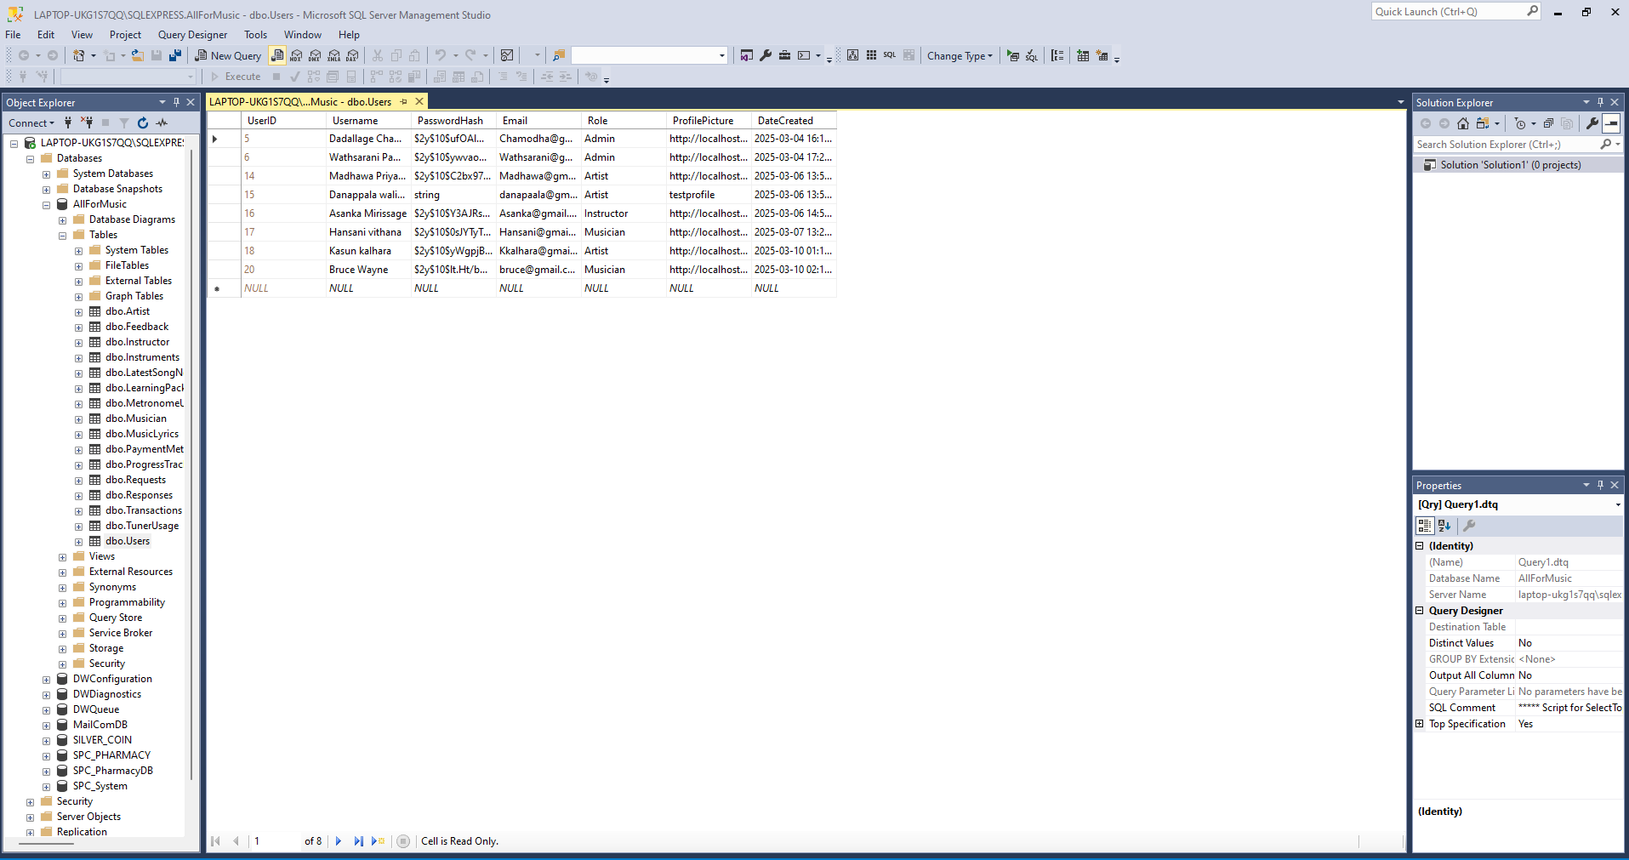

Figure 28 Microsoft SQL Server Management Studio

Figure 29 users table in SSMS

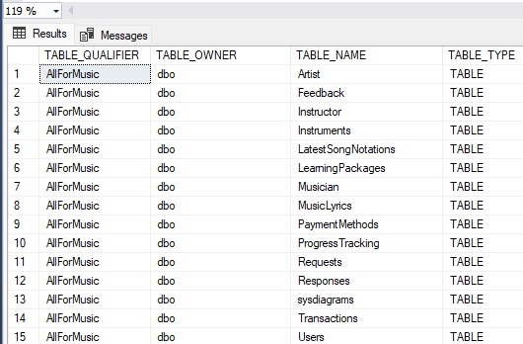

Figure 30 Database Table Structure of All Fo music

The AllForMusic database contains several tables that manage different aspects of a music-related system. The Artist and Musician tables likely store details about artists and musicians, while the Instructor table holds information about music instructors. The Instruments table may list various musical instruments available in the system. To support learning, the database includes LearningPackages, which could represent different music courses, and ProgressTracking, which likely monitors users’ learning progress. Additionally, the LatestSongNotations and MusicLyrics tables suggest a focus on music notation and lyrics storage.

For user interactions, the Feedback table stores user reviews or feedback, while the Requests and Responses tables likely handle user requests and corresponding replies. The PaymentMethods and Transactions tables are probably used for handling financial transactions related to learning packages or other services. The Users table, as seen in a previous screenshot, manages user details such as usernames, emails, and roles. Lastly, the sysdiagrams table is a system table used for database diagram storage.

This structure indicates that AllForMusic is designed as a comprehensive platform for managing music education, artist collaboration, and user interactions within a structured database system.

## Visual Studio

Visual Studio is selected as the primary code editor for developing the web application. It offers extensive support for multiple programming languages, extensions, and integrated debugging features. The lightweight nature of Visual studio makes it an ideal choice for front-end and back-end development. In this project, Swagger UI has been implemented in the backend using VS Code to provide interactive API documentation and testing capabilities.

**ASP.NET Core**

ASP.NET Core is the chosen web framework for building the All for Music application. It provides high performance, security, and scalability, making it a suitable choice for modern web development. With its built-in support for MVC architecture and RESTful APIs, ASP.NET Core ensures structured and maintainable code.

**C# Language**

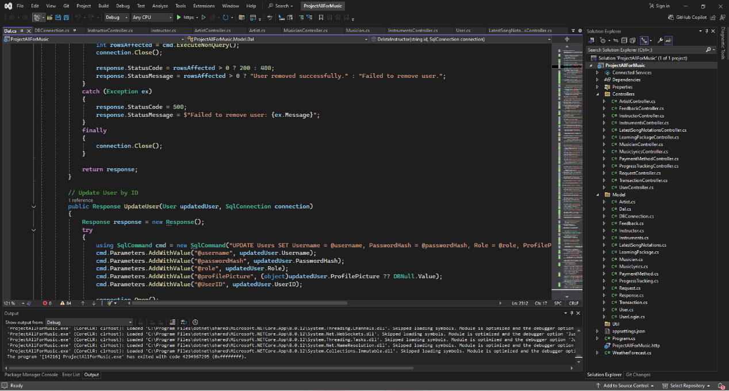C# is used as the primary programming language for the backend of the web application. It integrates seamlessly with ASP.NET Core, allowing efficient handling of

Figure 31 Sample C# code from the developed system

business logic, database connectivity, and API implementations. Additionally, C# is used to create API endpoints, enabling smooth interaction between the frontend and backend components of the application.

The provided C# code snippet is a method named UpdateUser, which updates a user's information in a SQL database. It takes a User object containing the updated details and a SqlConnection to interact with the database. The method constructs an UPDATE SQL query using parameterized queries to prevent SQL injection. It updates the Username, PasswordHash, Role, and ProfilePicture fields for a specific user identified by UserID. The SQL command is executed using ExecuteNonQuery(), and the number of affected rows is checked to determine if the update was successful. The method uses a try-catch block to handle exceptions, ensuring that if an error occurs, an appropriate error message is returned in a Response object. The bottom part of the image displays warnings related to debugging, such as skipped loading symbols, which indicate that the modules are optimized and debugging information is not fully available. This method is likely part of a system where users or administrators can modify user details securely within a web application.

**HTML, CSS, and JavaScript**

For the front-end development, HTML, CSS, and JavaScript are used to create a visually appealing and responsive user interface. CSS frameworks like Bootstrap enhance the design and layout, while JavaScript libraries such as jQuery facilitate dynamic interactions. For this, Visual Studio Code is used as the primary development environment, offering powerful features and extensions to streamline front-end development.

**Php**

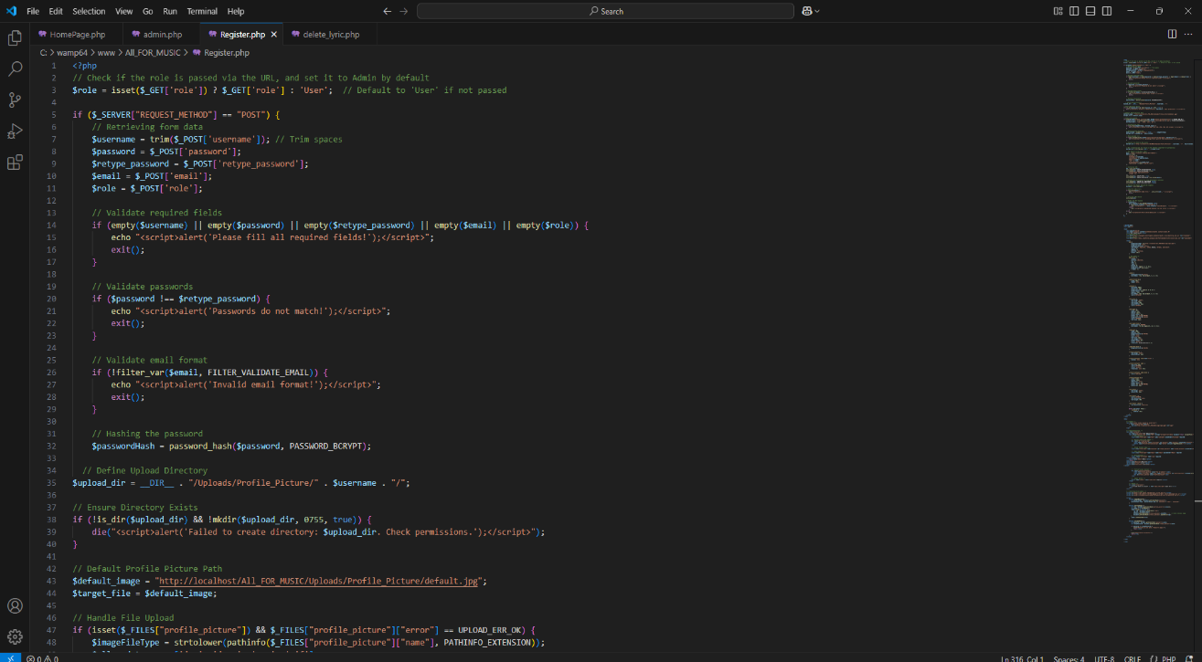PHP is used to establish a connection between Swagger UI and the front-end of the application. It facilitates communication between the API endpoints and the user interface, ensuring seamless data flow and integration. Additionally, PHP sessions are used to manage user authentication and maintain user state across different pages of the web application, improving security and personalization of the user experience.

Figure 32 Sample PHP code from the developed system

The provided image contains PHP code for handling user registration, including role assignment, input validation, password hashing, and profile picture upload. The script checks whether the role is passed via the URL and assigns a default role of "User" if not provided. When the form is submitted via POST, it trims and collects input values such as username, password, retype_password, email, and role. It then validates that all required fields are filled, ensures the password and retyped password match, and checks the email format using PHP's FILTER_VALIDATE_EMAIL filter.

Once validated, the password is securely hashed using password_hash() with the PASSWORD_BCRYPT algorithm. The script then attempts to create a directory for storing the user's profile picture under Uploads/Profile_Picture/, using the username as the folder name. If the directory creation fails, an error message is displayed. If a profile picture is uploaded, the script verifies the file type and stores it in the designated folder. If no profile picture is provided, a default image is assigned from the path http://localhost/All_FOR_MUSIC/Uploads/Profile_Picture/default.jpg.

This script ensures secure handling of user registration with basic input validation, password encryption, and profile picture management, making it suitable for a web application managing user accounts.

## WampServer

WampServer is used as a local development environment for running PHP, MySQL, and Apache. It provides an easy-to-use platform for testing and deploying the All for Music web application before moving it to a live server. WampServer helps in setting up a local database, handling PHP scripts, and ensuring smooth backend operations during development.

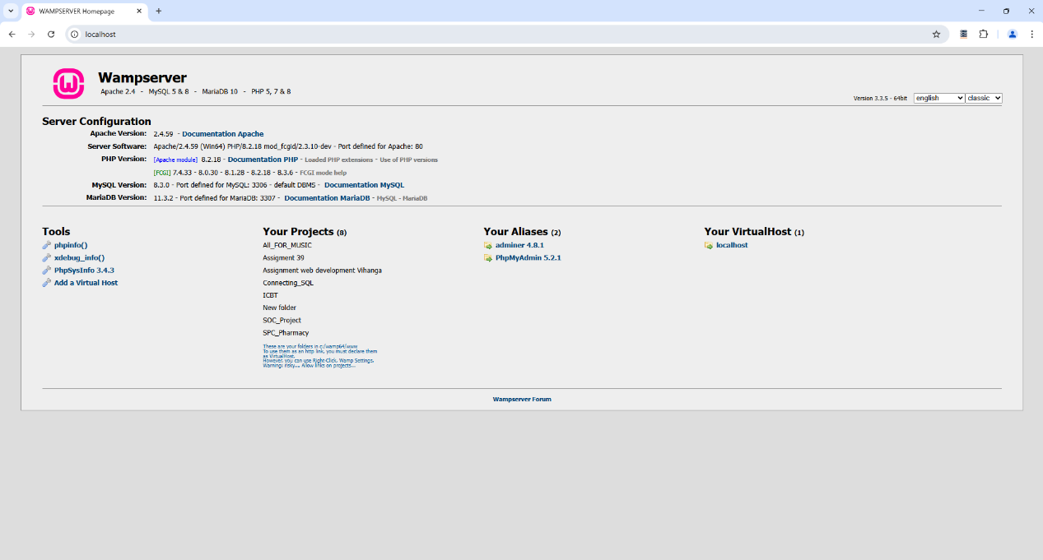

Figure 33 WAMP Server

# Organization and Modularization of the Code

In the All For Music project, the administrator functionalities are structured using a modular approach to ensure maintainability, scalability, and ease of updates. Each functionality, such as managing users, handling learning packages, and overseeing transactions, is implemented in separate modules, allowing for clear separation of concerns. Role-based access control ensures that different user types players, artists, and instructors have access to only their respective functionalities. CRUD operations for users, instruments, and learning packages are encapsulated in well-defined modules, promoting reusability and reducing redundancy. Additionally, transaction management and feedback handling are implemented as independent components, making it easier to track user interactions and financial activities within the system. By adopting a modular structure, the All For Music platform ensures an efficient and organized codebase, enabling seamless feature additions and long-term maintenance.

**Input Validation**

Input validation is crucial in the All For Music project to prevent security vulnerabilities such as SQL injection and cross-site scripting (XSS). The system validates user inputs by ensuring that required fields are not left empty, emails follow a valid format, and passwords meet security criteria. Passwords are also confirmed by checking if the entered password and retyped password match. Additionally, file uploads, such as profile pictures and music lyrics sheets, are validated for proper formats and size restrictions to prevent malicious uploads.

**Role-Based Access Control (RBAC)**

The All For Music project implements Role-Based Access Control to ensure that users can only perform actions relevant to their assigned roles. Administrators manage users, learning packages, and transactions, while players can request lessons, add lyrics, and buy/sell instruments. Artists and instructors have specific permissions to accept or decline requests, purchase music sheets, and add learning packages. Each user role is verified during authentication, and unauthorized access to restricted functionalities is prevented through role-specific checks in both the frontend and backend.

**Secure Database Connections**

To enhance security, the system uses parameterized queries and prepared statements when interacting with the database, preventing SQL injection attacks. The database connection is established using secure authentication methods, ensuring credentials are not exposed in the code. Additionally, SSL encryption is enforced for all database transactions to protect sensitive user data. Regular backups and access restrictions further secure the database, ensuring the integrity and confidentiality of user information in the All For Music platform.

**Chapter X**

# Software Development Life Cycle (SDLC)

The Software Development Life Cycle (SDLC) is a systematic process used in software engineering to design, develop, test, and deploy high-quality software. It provides a structured approach to software creation, ensuring efficiency, reliability, and adherence to user requirements.

SDLC consists of several key phases, including:

1. **Requirement Analysis** – Gathering and defining the software’s needs.
2. **Design** – Creating system architecture and database structures.
3. **Implementation (Coding)** – Developing the software.
4. **Testing** – Ensuring the software is free from defects.
5. **Deployment** – Releasing the software to users.
6. **Maintenance** – Updating and improving the system over time.

Among these, Testing is one of the most crucial stages, as it ensures the software’s reliability and performance before deployment.

# Testing

Testing is a crucial phase in the Software Development Life Cycle (SDLC) to ensure that the "All for Music" platform meets high-quality standards and functions as intended. This phase involves identifying and resolving errors, security vulnerabilities, and performance issues before deployment. In a comprehensive music learning and collaboration platform like "All for Music," testing plays a key role in delivering a smooth, reliable, and user-friendly experience for students, artists, and instructors. Through rigorous testing, we ensure that all platform features, including music collaboration, lesson management, and instrument trading, work seamlessly across different devices and browsers, providing users with an optimal experience.

**Key Aspects of Testing:**

To ensure the "All for Music" platform delivers a seamless, secure, and high-quality experience for all users, several testing methodologies are applied. These tests focus on different aspects of functionality, performance, security, and usability to maintain a robust and efficient system.

1. Functional Testing

* Ensures that all features of the platform, such as music collaboration, lesson management, instrument trading, and user authentication, work correctly as per requirements.
* Example: Verifying that users can register, log in, enroll in lessons, upload music files, and communicate with artists/instructors without errors.

2. Compatibility Testing

* Confirms that the platform operates consistently across different browsers, devices, and operating systems to provide a smooth experience for all users.
* Example: Testing "All for Music" on Google Chrome, Firefox, Safari, and Microsoft Edge, as well as on Windows, devices.

3. Performance Testing

* Evaluates the platform’s ability to handle high traffic, multiple simultaneous users, and large music file uploads without lag or crashes.
* Example: Checking if the system remains responsive when multiple users are accessing live lessons, streaming music, and making transactions simultaneously.

4. Security Testing

* Identifies vulnerabilities to protect user data, payment transactions, and private communications from security threats such as SQL injection, cross-site scripting (XSS), and data breaches.
* Example: Testing for secure login mechanisms, encrypted transactions, and role-based access control to prevent unauthorized access to sensitive information.

5. Usability Testing

* Ensures that the platform is user-friendly, intuitive, and easy to navigate for musicians, students, and instructors of varying technical expertise.
* Example: Evaluating how easily a new user can register, search for instructors, book a lesson, or upload a music track without confusion.

**Testing Tools**

To ensure the quality, security, and performance of the "All for Music" platform, various testing tools are used:

* Selenium automates functional and compatibility testing across different browsers.
* Apache JMeter evaluates performance by simulating multiple users and testing load capacity.
* OWASP ZAP identifies security vulnerabilities to protect user data and transactions.
* Postman ensures API reliability by validating data exchanges between the front-end and back-end.
* Google Lighthouse assesses usability, speed, and accessibility for an optimal user experience.

These tools help deliver a secure, high-performing, and user-friendly platform for musicians, students, and instructors.

**Testing Techniques**

Several testing techniques are employed to validate the functionality, performance, and security of the system.

To ensure "All for Music" functions optimally, various testing methods are applied:

* Unit Testing: Tests individual modules, such as the login system, before integration to detect early bugs.
* Integration Testing: Ensures smooth interaction between components, such as verifying that lesson bookings sync correctly with instructor availability.
* System Testing: Evaluates the entire platform, ensuring students, artists, and instructors can access all features without errors.
* User Acceptance Testing (UAT): Allows real users to test the platform before launch, ensuring it meets their expectations for lesson requests, instrument sales, and collaboration tools.
* Compatibility Testing: Verifies that "All for Music" runs seamlessly across browsers, devices, and operating systems, providing a consistent user experience.

By implementing these testing strategies, "All for Music" ensures a stable, secure, and user-friendly platform for musicians worldwide.

## Test Plan

The test plan outlined below includes various scenarios to assess different user interactions and system functionalities. From fundamental operations such as user authentication to more complex tasks like course enrollment and payment processing, each test case ensures the stability, security, and usability of the system under diverse conditions.

**Objectives of the Test Plan**

* Validate that the system meets functional and non-functional requirements.
* Identify and resolve bugs, security vulnerabilities, and performance issues.
* Ensure a seamless user experience across multiple devices and platforms.
* Confirm that the system adheres to industry best practices and compliance standards.

**Benefits of the Test Plan**

**Improves System Reliability**

* By identifying and resolving bugs early, the system operates smoothly and efficiently.

**Enhances Security**

* Testing safeguards sensitive user data from potential security threats.

**Ensures a Seamless User Experience**

* A well-tested system guarantees intuitive navigation and accessibility for users.

**Reduces Maintenance Costs**

* Early detection of issues minimizes future expenses related to debugging and updates.

**Ensures Compliance with Standards**

* Testing ensures adherence to industry best practices and regulatory requirements.

**Ensuring Quality and Performance**

By rigorously executing these test scenarios and documenting the results, we ensure that the system meets the highest standards of quality, security, and usability. Any issues identified during testing will be promptly resolved to deliver a seamless and reliable experience for all users.

## Test Cases

**Backend**

The backend of the "All for Music" platform is responsible for handling data processing, logic, and storage. It is built using PHP, which connects to the MySQL database to store and retrieve user data, music files, transactions, and other essential information. The backend handles authentication, user role management (students, artists, instructors, and administrators), and ensures secure transactions and data privacy. It also facilitates interactions between the frontend and the database, ensuring that data flows seamlessly between the user interface and the server.

**Front end**

The frontend of the "All for Music" platform is designed using HTML, CSS, JavaScript, PHP, and Bootstrap. This layer handles the user interface (UI) and user experience (UX), providing an interactive and visually appealing design. HTML provides the structure of web pages, while CSS ensures the styling and layout are responsive and attractive. JavaScript enhances interactivity, enabling dynamic features such as real-time updates and form validations. PHP is used for server-side scripting to handle requests and interact with the database. Bootstrap is employed to speed up the design process and ensure the platform is responsive across all devices.

**Integration**

Integration in the "All for Music" project refers to the seamless connection between the frontend, backend, and external services. The frontend interacts with the backend using PHP, which communicates with the MySQL database to store and retrieve information. Additionally, external APIs, such as payment gateways for transactions or music APIs for content delivery, are integrated to enhance platform functionality. This integration ensures that all components work together efficiently, providing users with a smooth and responsive experience while maintaining data integrity and security across the platform.

Table 3 BE-1001

|  |  |
| --- | --- |
| Test Case ID | **BE-1001** |
| Test name | Add User |
| Description | Verify that user registration data is successfully stored in the Microsoft SQL Server database through an API endpoint. |
| Test Objective | Ensure that valid user data is correctly inserted into the Users table when submitted via the API. |
| Expected Results  Swager UI | A screenshot of a computer program  AI-generated content may be incorrect.  Figure 34 BE-1001 |
| Expected Results  Microsoft SQL Server Management Studio | Users table in the database before test data  A screenshot of a computer  AI-generated content may be incorrect.  Figure 35 BE-1001 result 1  Users table in the database after test data  A screenshot of a computer  AI-generated content may be incorrect.  Figure 36 BE-1001 result 2 |
| Pass/ Fail | pass |

Table 4 BE-1002

|  |  |
| --- | --- |
| Test Case ID | **BE-1002** |
| Test name | Prevent Duplicate Username |
| Description | Verify that the database does not allow duplicate usernames. |
| Test Objective | Ensure the UNIQUE constraint on Username is enforced. |
| Expected Results  Swager UI | A screenshot of a computer  AI-generated content may be incorrect.  Figure 37 BE-1002 |
| Expected Results  Microsoft SQL Server Management Studio | Users table in the database before test data  A screenshot of a computer  AI-generated content may be incorrect.  Figure 38 BE-1002 result 1  Users table in the database after test data  A screenshot of a computer  AI-generated content may be incorrect.  Figure 39 BE-1002 result 2 |
| Pass/ Fail | pass |

Table 5 BE-1003

|  |  |
| --- | --- |
| Test Case ID | **BE-1003** |
| Test name | User Login |
| Description | Verify that users can log in using valid credentials. |
| Test Objective | Ensure authentication works correctly and returns a valid token or session. |
| Expected Results  Swager UI | A screenshot of a computer  AI-generated content may be incorrect.  Figure 40 BE-1003 |
| Expected Results  Microsoft SQL Server Management Studio | User table in the database.  A screenshot of a computer  AI-generated content may be incorrect.  Figure 41 BE-1003 result 1 |
| Pass/ Fail | pass |

Table 6 BE-1004

|  |  |
| --- | --- |
| Test Case ID | **BE-1004** |
| Test name | Update user |
| Description | Verify that user details can be modified successfully. |
| Test Objective | Ensure users can update their information while maintaining data validation. |
| Expected Results  Swager UI | A screenshot of a computer  AI-generated content may be incorrect.  Figure 42 BE-1004 |
| Expected Results  Microsoft SQL Server Management Studio | Users table in the database before test data  A screenshot of a computer  AI-generated content may be incorrect.  Figure 43 BE-1004 result 1  Users table in the database after test data  A white background with black and red text  AI-generated content may be incorrect.  Figure 44 BE-1004 result 2 |
| Pass/ Fail | pass |

Table 7 BE-1005

|  |  |
| --- | --- |
| Test Case ID | **BE-1005** |
| Test name | Search User by Name |
| Description | Verify that users can search for other users by name. |
| Test Objective | Ensure the search functionality correctly filters users by name. |
| Expected Results  Swager UI | A screenshot of a computer  AI-generated content may be incorrect.  Figure 45 BE-1005 |
| Expected Results  Microsoft SQL Server Management Studio | Users table in the database test data  A white background with black and red text  AI-generated content may be incorrect.  Figure 46 BE-1005 result 1 |
| Pass/ Fail | pass |

Table 8 BE-106

|  |  |
| --- | --- |
| Test Case ID | **BE-106** |
| Test name | Retrieve All Users |
| Description | Verify that all registered users can be retrieved. |
| Test Objective | Ensure user list retrieval works correctly. |
| Expected Results  Swager UI | A screenshot of a computer  AI-generated content may be incorrect.  Figure 47 BE-106 |
| Expected Results  Microsoft SQL Server Management Studio | Users table in the database test data  A white background with black and red text  AI-generated content may be incorrect.  Figure 48 BE-106 result 1 |
| Pass/ Fail | pass |

Table 9 BE-1007

|  |  |
| --- | --- |
| Test Case ID | **BE-1007** |
| Test name | Delete user |
| Description | Verify that users can be deleted successfully, and their associated data is handled correctly. |
| Test Objective | Ensure that user deletion does not leave orphaned records and maintains database integrity. |
| Expected Results  Swager UI | A screenshot of a computer  AI-generated content may be incorrect.  Figure 49 BE-1007 |
| Expected Results  Microsoft SQL Server Management Studio | Users table in the database before test data  A white background with black and red text  AI-generated content may be incorrect.  Figure 50 BE-1007 result 1  Users table in the database after test data  A screenshot of a computer  AI-generated content may be incorrect.  Figure 51 BE-1007 result 2 |
| Pass/ Fail | pass |

Table 10 BE-1008

|  |  |
| --- | --- |
| Test Case ID | **BE-1008** |
| Test name | Add Learning Package |
| Description | Verify that a learning package can be successfully added to the database. |
| Test Objective | Ensure valid data is stored correctly in LearningPackages. |
| Expected Results  Swager UI | A screenshot of a computer  AI-generated content may be incorrect.  Figure 52 BE-1008 |
| Expected Results  Microsoft SQL Server Management Studio | LearningPackages table in the database before test data  A screenshot of a computer  AI-generated content may be incorrect.  Figure 53 BE-1008 result 1  LearningPackages table in the database after test data  A close-up of a computer screen  AI-generated content may be incorrect.  Figure 54 result 2 |
| Pass/ Fail | pass |

Table 11 BE-1009

|  |  |
| --- | --- |
| Test Case ID | **BE-1009** |
| Test name | Prevent Negative Price for Learning Package |
| Description | Verify that learning packages cannot be added with a negative price. |
| Test Objective | Ensure data validation prevents negative values in Price. |
| Expected Results  Swager UI | A screenshot of a computer  AI-generated content may be incorrect.  Figure 55 BE-1009 |
| Expected Results  Microsoft SQL Server Management Studio | LearningPackages table in the database before test data  A close-up of a computer screen  AI-generated content may be incorrect.  Figure 56 BE-1009 result 1  LearningPackages table in the database after test data  A close-up of a computer screen  AI-generated content may be incorrect.  Figure 57 BE-1009 result 2 |
| Pass/ Fail | pass |

Table 12 BE-1010

|  |  |
| --- | --- |
| Test Case ID | **BE-1010** |
| Test name | Add Instrument Listing |
| Description | Verify that an instrument listing is added correctly. |
| Test Objective | Ensure instrument details are stored properly. |
| Expected Results  Swager UI | A screenshot of a computer  AI-generated content may be incorrect.  Figure 58 BE-1010 |
| Expected Results  Microsoft SQL Server Management Studio | Instruments table in the database before test data  A screenshot of a computer  AI-generated content may be incorrect.  Figure 59 BE-1010 result 1  Instruments table in the database aafter test data  A screenshot of a computer  AI-generated content may be incorrect.  Figure 60 BE-1010 result 2 |
| Pass/ Fail | pass |

Table 13 BE-1011

|  |  |
| --- | --- |
| Test Case ID | **BE-1011** |
| Test name | Add Transaction |
| Description | Verify that a purchase transaction is recorded successfully. |
| Test Objective | Ensure transaction details are saved correctly. |
| Expected Results  Swager UI | A screenshot of a computer  AI-generated content may be incorrect.  Figure 61 BE-1011 |
| Expected Results  Microsoft SQL Server Management Studio | Transactions table in the database before test data    Figure 62 BE-1011 result 1  Transactions table in the database after test data    Figure 63 BE-1011 result 2 |
| Pass/ Fail | pass |

Table 14 BE-1012

|  |  |
| --- | --- |
| Test Case ID | **BE-1012** |
| Test name | Prevent Zero Amount Transaction |
| Description | Verify that transactions with zero amounts are not allowed. |
| Test Objective | Prevent invalid transactions. |
| Expected Results  Swager UI | A screenshot of a computer  AI-generated content may be incorrect.  Figure 64 BE-1012 |
| Expected Results  Microsoft SQL Server Management Studio | Transactions table in the database before test data    Figure 65 BE-1012 result 1  Transactions table in the database after test data    Figure 66 BE-1012 result 2 |
| Pass/ Fail | pass |

Table 15 BE-1013

|  |  |
| --- | --- |
| Test Case ID | **BE-1013** |
| Test name | Submit Feedback |
| Description | Verify that users can submit feedback successfully. |
| Test Objective | Ensure that feedback is stored correctly and associated with the user. |
| Expected Results  Swager UI | Figure 67 BE-1013 |
| Expected Results  Microsoft SQL Server Management Studio | Transactions table in the database before test data    Figure 68 BE-1013 result 1  Feedbacks table in the database after test data    Figure 69 BE-1013 result 2 |
| Pass/ Fail | pass |

Table 16 BE-1014

|  |  |
| --- | --- |
| Test Case ID | **BE-1014** |
| Test name | Retrieve All Feedbacks |
| Description | Verify that all submitted feedback can be retrieved. |
| Test Objective | Ensure feedback retrieval functionality works as expected. |
| Expected Results  Swager UI | Figure 70 BE-1014 |
| Expected Results  Microsoft SQL Server Management Studio | Feedbacks table in the database test data    Figure 71 BE-1014 result 1 |
| Pass/ Fail | pass |

Table 17 BE-1015

|  |  |
| --- | --- |
| Test Case ID | **BE-1015** |
| Test name | Retrieve Feedback by User |
| Description | Verify that users can retrieve feedback associated with their account. |
| Test Objective | Ensure feedback is filtered correctly by user ID. |
| Expected Results  Swager UI | Figure 72 BE-1015 |
| Expected Results  Microsoft SQL Server Management Studio | Feedbacks table in the database test data    Figure 73 BE-1015 result 1 |
| Pass/ Fail | pass |

Table 18 BE-1016

|  |  |
| --- | --- |
| Test Case ID | **BE-1016** |
| Test name | Retrieve Feedback by Undefined User |
| Description | Verify that the system handles requests for feedback retrieval when the user ID is undefined or invalid. |
| Test Objective | Ensure that the API correctly returns an appropriate response (e.g., No feedbacks found for this user or an error) when an invalid or undefined user ID is used to retrieve feedback. |
| Expected Results  Swager UI | Figure 74 BE-1016 |
| Expected Results  Microsoft SQL Server Management Studio | Feedbacks table in the database test data    Figure 75 BE-1016 result 1 |
| Pass/ Fail | pass |

Table 19 BE-1017

|  |  |
| --- | --- |
| Test Case ID | **BE-1017** |
| Test name | Add Music Lyrics |
| Description | Verify that users can add new music lyrics. |
| Test Objective | Ensure lyrics are stored correctly. |
| Expected Results  Swager UI | Figure 76 BE-1017 |
| Expected Results  Microsoft SQL Server Management Studio | MusicLyrics table in the database before test data    Figure 77 BE-1017 result 1  MusicLyrics table in the database after test data    Figure 78 result 2 |
| Pass/ Fail | pass |

Table 20 BE-1018

|  |  |
| --- | --- |
| Test Case ID | **BE-1018** |
| Test name | User Registration Form Validation |
| Description | Verify that required fields (name, email, password) show validation errors if left empty. |
| Test Objective | Ensure form fields have proper validation. |
| Expected Results | Error messages appear in empty fields. |
| Real Result | Error messages appeared correctly.  Without username    Figure 79 BE-1018 -1  Without Email    Figure 80 BE-1018 - 2  Without password    Figure 81 BE-1018 - 3 |
| Expected Results  Microsoft SQL Server Management Studio | Users table in database before test data  Figure 82 BE-1018 result 1  Users table in database after test data  Figure 83 BE-1018 result 2 |
| Pass/ Fail | pass |

Table 21 BE-1019

|  |  |
| --- | --- |
| Test Case ID | **BE-1019** |
| Test name | User Registration Success |
| Description | Verify that a new user can successfully register with valid data. |
| Test Objective | |  | | --- | |  |   Ensure that valid user details are stored correctly in the database and the user is redirected appropriately. |
| Expected Results | User is successfully registered, data is stored in the database, and the user is redirected to the dashboard or login page. |
| Real Results | User registration was successful, data was stored in the database, and the user was redirected to the dashboard.  Test data  Figure 84 BE-1019-1  Successful massage  Figure 85 BE-1019 - 2 |
| Expected Results  Microsoft SQL Server Management Studio | Users table in the database after testing data    Figure 86 BE-1019 result 1 |
| Pass/ Fail | pass |

|  |  |
| --- | --- |
| Test Case ID | **BE-1020** |
| Test name | Email Format Validation |
| Description | Verify that an invalid email format displays an error message. |
| Test Objective | "Invalid email format" error appears. |
| Expected Results | Error messages appear in empty fields. |
| Real Results | An error appeared as expected.    Figure 87 BE-1020 |
| Expected Results  Microsoft SQL Server Management Studio | Users table in the database before test data  Figure 88 BE-1020 result 1  Users table in database after test data  Figure 89 result 2 |
| Pass/ Fail | pass |

Table 22 BE-1020

|  |  |
| --- | --- |
| Test Case ID | **BE-1020** |
| Test name | User Login |
| Description | Verify that users can log in with valid credentials. |
| Test Objective | |  | | --- | |  |   Ensure authentication works correctly. |
| Expected Results | The user is redirected to the dashboard. |
| Real Results | The user successfully logged in and redirected.  Test data  Figure 90 BE-1020 -1  After test data    Figure 91 BE-1020-2 |
| Expected Results  Microsoft SQL Server Management Studio | Users table in the database  Figure 92 BE-1020 result 1 |
| Pass/ Fail | pass |

Table 23 BE-1021

|  |  |
| --- | --- |
| Test Case ID | **BE-1021** |
| Test name | Incorrect Login |
| Description | Verify that incorrect credentials display an error message. |
| Test Objective | |  | | --- | |  |   Prevent unauthorized access. |
| Expected Results | "Invalid login credentials. Please try again" appears |
| Real Results | Error message displayed correctly.  Test data Invalid password and valid username  Figure 93 BE-1021-1  After test data    Figure 94 BE-1021- 2  Test data invalid username  Figure 95 BE-1021-3  After testing data    Figure 96 BE-1021-3 |
| Expected Results  Microsoft SQL Server Management Studio | Users table in the database that used test login  Figure 97 BE-1021 result 1 |
| Pass/ Fail | pass |

Table 24 BE-1023

|  |  |
| --- | --- |
| Test Case ID | **BE-1023** |
| Test name | Admin Add Package |
| Description | Verify that the admin can add a new Learning package successfully |
| Test Objective | Ensure package details are saved correctly. |
| Expected Results | The package added and displayed successfully. |
| Real Results | The package added and displayed successfully.    Figure 98 BE-1023 - 1    Figure 99 BE-1023- 2 |
| Expected Results  Microsoft SQL Server Management Studio | Figure 100 BE-1023 result 1 |
| Pass/ Fail | pass |

Table 25 BE-1024

|  |  |
| --- | --- |
| Test Case ID | **BE-1024** |
| Test name | Package Search |
| Description | Verify that users can search for packages by package ID. |
| Test Objective | |  | | --- | |  |   Ensure the search function returns correct results. |
| Expected Results | Matching package details appear. |
| Real Results | Correct package details appeared.    Figure 101 BE-1024 |
| Expected Results  Microsoft SQL Server Management Studio | Figure 102 BE-1024 result 1 |
| Pass/ Fail | pass |

Table 26 BE-1025

|  |  |
| --- | --- |
| Test Case ID | **BE-1025** |
| Test name | Delete User Confirmation Notification |
| Description | Verify that a confirmation notification appears when an admin attempts to delete a user. |
| Test Objective | |  | | --- | |  |   Ensure the system prompts the admin before deleting a user to prevent accidental deletions. |
| Expected Results | A confirmation popup appears with the message: "Are you sure you want to delete this user?" with Confirm and Cancel buttons. |
| Real Results | Confirmation popup displayed correctly with "Are you sure you want to delete this user?" message and action buttons.  A screenshot of a computer  AI-generated content may be incorrect.  Figure 103 BE-1025- 1  A black screen with white text  AI-generated content may be incorrect.  Figure 104 BE-1025-2 |
| Expected Results  Microsoft SQL Server Management Studio | After deleting user  Figure 105 BE-1025 result 1 |
| Pass/ Fail | pass |

Table 27 BE-1026

|  |  |
| --- | --- |
| Test Case ID | **BE-1026** |
| Test name | Role-Based Access |
| Description | Verify that users with different roles see different dashboard views. |
| Test Objective | Ensure correct access control |
| Expected Results | Admins see full controls; staff see limited options. |
| Real Results | The correct dashboard is displayed based on role.  Login as an Admin    Figure 106 BE-1026- 1    Figure 107 BE-1026 - 2    Login as an Artist |
| Expected Results  Microsoft SQL Server Management Studio | Users table in the database    Figure 108 BE-1026 result 1 |
| Pass/ Fail | pass |

Table 28 BE-1027

|  |  |
| --- | --- |
| Test Case ID | **BE-1027** |
| Test name | Add Music Lyrics |
| Description | Verify that a user can successfully add music lyrics with the required details. |
| Test Objective | Ensure that the lyrics, author ID, title, content, price, and uploaded file are stored correctly in the database. |
| Expected Results | Upon submission, the lyrics are saved, and a confirmation message appears. Uploaded files are successfully stored. |
| Real Results | Lyrics were added successfully, confirmation message displayed, and file uploaded correctly.      Figure 109 BE-1027- 1  A green text on a black background  AI-generated content may be incorrect.  Figure 110 BE-1027- 2  A screenshot of a music lyrics  AI-generated content may be incorrect.  Figure 111 BE-1027- 3 |
| Expected Results  Microsoft SQL Server Management Studio | MusicLyrics table in the database    Figure 112 BE-1027 result 1 |
| Pass/ Fail | pass |

Table 29 BE-1028

|  |  |
| --- | --- |
| Test Case ID | **BE-1028** |
| Test name | Limited User Access |
| Description | Verify that a user with limited access can only view their own data and cannot access other users' data. |
| Test Objective | Ensure that the system enforces access control and that users can only view their own information. |
| Expected Results | The user can see their own data (e.g., profile, posts) but cannot access or view the data of other users. |
| Real Results | The user could only view their data, and attempts to access other users' data resulted in an error message. (this is author id 7 profile. he can see and update only his music lyrics)  A screenshot of a music lyrics  AI-generated content may be incorrect.  Figure 113 BE-1028 |
| Expected Results  Microsoft SQL Server Management Studio | MusicLyrics table in the database    Figure 114 BE-1028 result 1 |
| Pass/ Fail | pass |

Table 30 BE-1029

|  |  |
| --- | --- |
| Test Case ID | **BE-1029** |
| Test name | Limited User Access |
| Description | Verify that a user with limited access can only view their own data and cannot access other users' data. |
| Test Objective | Ensure that the system enforces access control and that users can only view their own information. |
| Expected Results | The user can see their own data (e.g., profile, posts) but cannot access or view the data of other users. |
| Real Results | The user could only view their data, and attempts to access other users' data resulted in an error message. (this is author id 7 profile. he can see and update only his music lyrics)  A screenshot of a music lyrics  AI-generated content may be incorrect.  Figure 115 BE-1029 |
| Expected Results  Microsoft SQL Server Management Studio | MusicLyrics table in the database    Figure 116 BE-1029- result |
| Pass/ Fail | pass |

**Chapter XI**

# Implementation

Working on the actual construction and coding of the music learning and collaboration platform is part of the "All for Music" implementation phase. A thorough rundown of the tools, technologies, and implementation techniques is given in this section.

# Technologies and Tools

**1.**Front-End Development

1.1 HTML, CSS and JavaScript

Modern websites are built using three key technologies: HTML, CSS, and JavaScript. The basic structure and meaning of the content are provided by HTML, which guarantees organization; the visual presentation is improved by CSS, which controls layout and aesthetics for a captivating user experience; and JavaScript adds dynamic functionality, allowing data processing, interactivity, and real-time updates, which turns static pages into dynamic, responsive applications. They work together to provide the entire online experience, from simple material to intricate, interactive systems.

1.2 Visual Studio Code

Visual Studio Code is a highly popular, lightweight yet powerful code editor. Its key strengths lie in its speed, efficiency, and extensibility, offering features like IntelliSense, debugging, and Git integration. This makes it a versatile and productive tool for developers across various programming tasks.

* 1. PHP

" All for Music" project, the PHP front-end will be developed using Visual Studio Code, integrating SOC (Separation of Concerns) principles and APIs to ensure a modular, scalable, and maintainable architecture. PHP will handle dynamic content rendering, user authentication, and API interactions, facilitating a seamless user experience. With efficient templating and AJAX support, the front-end will provide real-time updates and interactive features, ensuring smooth navigation and responsiveness across devices.

**2.**Back-End Development

2.1 C#

In the All For Music project, ASP.NET Core serves as the backbone of the backend, ensuring efficient processing, security, and seamless integration with the frontend. The backend is designed using ASP.NET Core Web API, which exposes RESTful APIs to handle requests from the web application. These APIs facilitate essential functionalities such as user management, learning package handling, instrument sales, and transaction tracking. The system enforces role-based access control (RBAC), ensuring that administrators, players, artists, and instructors can only access their designated features.

The backend interacts with a SQL Server database using Entity Framework Core (EF Core), enabling smooth data handling through object-relational mapping (ORM), reducing the need for raw SQL queries. Additionally, ASP.NET Core Identity manages user authentication with JWT (JSON Web Tokens) for secure logins and session handling. Input validation mechanisms prevent SQL injection and cross-site scripting (XSS) attacks, ensuring data integrity.

2.2.PHP

In the All For Music project, PHP is used to manage backend tasks like handling user requests, processing form data, and interacting with the SQL Server database. PHP scripts help in adding users, managing learning packages, selling instruments, and tracking transactions. The system ensures role-based access control (RBAC), meaning only admins, players, artists, and instructors can access their respective features.

PHP connects to SQL Server using PDO (PHP Data Objects), making database operations secure and efficient. It also handles file uploads, like profile pictures and learning materials, by storing them in an organized directory. Additionally, PHP communicates with the ASP.NET Core API using cURL, allowing data exchange between the website and the backend services.

Overall, PHP makes the All For Music project more interactive and user-friendly by efficiently processing user actions and ensuring smooth communication with the database and backend services.

## 3.Development Environment

3.1. WAMP

With a strong stack of web development tools, WAMP (Windows, Apache, MySQL, PHP) is the perfect local development environment for the All for Music online application. It makes it possible to test, debug, and optimize the platform effectively before deploying it to a live server. Developers can ensure smooth database integration, user interactions, and safe transactions by simulating real-world server settings using WAMP. When the platform goes live, this configuration minimizes possible problems and guarantees a consistent and dependable experience for artists, students, and teachers by enabling thorough performance evaluation.

# Structure and Organization of Code

**1.** Code Organization and Structure

In the All For Music project, code organization is a fundamental aspect of maintaining clarity and scalability. The backend is divided into distinct modules, each responsible for specific functionalities like user management, learning packages, instrument sales, and transaction tracking. Each module has its own set of controllers, models, and views (in case of MVC design) or separate services (in a more service-oriented architecture). This modular approach ensures that developers can work on different parts of the system independently without interfering with other modules.

The code follows a clear directory structure, making it easy for developers to navigate and add features or make modifications. The business logic is encapsulated within services, while controllers handle HTTP requests and responses, ensuring a clean separation of concerns. Models represent the data structures and interact with the database through ORM (Object-Relational Mapping) tools like Entity Framework Core.

**2**. Security Measures

Security is a key consideration in the All For Music project to protect user data and prevent malicious attacks. Several security measures are implemented throughout the system

Input Validation: The project validates all user inputs to prevent security vulnerabilities like SQL injection and Cross-Site Scripting (XSS).

Authentication & Authorization: The system uses JWT (JSON Web Tokens) for secure user authentication and role-based access control (RBAC) to ensure that users can only access functionality relevant to their roles.

Encrypted Connections: SSL encryption is enforced for all database transactions, ensuring that sensitive data like user credentials and payment details are securely transmitted.

Parameterized Queries: Database interactions are secured by using parameterized queries or ORM methods, preventing SQL injection attacks.

Regular Backups & Security Audits: The system regularly backs up data and conducts security audits to ensure ongoing protection against emerging threats.

# Version Control

Version control is essential for maintaining a smooth development workflow, especially in a team environment. In the All For Music project, Git is used for version control, allowing multiple developers to work on different features or bug fixes simultaneously. All code changes are tracked, and developers commit changes to a shared repository (hosted on GitHub, GitLab, or Bitbucket).

The project follows Git best practices, such as creating feature branches for new features, bug fixes, or enhancements, and using pull requests for code review before merging into the main branch. This ensures that only thoroughly tested code is deployed to production.

# Testing Integration

Testing is an integral part of ensuring the reliability and stability of the All For Music project. The following types of tests are incorporated:

Unit Testing: Individual components like functions, methods, or classes are tested in isolation using unit testing frameworks like xUnit or NUnit in the backend (C#). This ensures that each unit of code performs as expected.

Integration Testing: The interaction between different modules or external services (like the database or third-party APIs) is tested to ensure they work correctly together.

End-to-End Testing: The entire application flow, including the frontend and backend integration, is tested to simulate real user interactions. Tools like Selenium or Cypress are used for automated testing of user interfaces.

Test Automation: CI/CD (Continuous Integration/Continuous Deployment) pipelines are set up to automate testing, ensuring that the project remains bug-free during development.

5. Collaboration and Communication

Effective collaboration and communication are essential in the All For Music project, especially in a team environment. The development team uses collaboration tools to stay in sync:

Slack or Microsoft Teams: These tools help facilitate real-time communication among team members. Channels are set up for different areas of the project (e.g., backend, frontend, database) to ensure focused discussions.

Project Management Tools (Jira or Trello): These tools are used to track progress, manage tasks, and assign tickets for bug fixes, feature development, and other project-related activities. Tasks are divided into sprints with clear deadlines and priorities.

Documentation: Comprehensive documentation is maintained for all APIs, database schemas, and system workflows. This ensures that team members can quickly understand different parts of the system and that new developers can easily onboard.

Code Reviews: Regular code reviews are conducted to maintain code quality, promote knowledge sharing, and ensure that the code adheres to project standards. This also provides an opportunity for team members to suggest improvements or find potential issues early in the development process.

**Chapter XII**

# Review Process

The review process in the All For Music project is crucial to ensure code quality, security, and adherence to the project goals. The review process includes both formal code reviews and performance audits.

Code Reviews: Every change made to the codebase undergoes peer reviews. The team uses GitHub, GitLab, or Bitbucket for version control, where developers create pull requests (PRs) after completing a feature or bug fix. These PRs are reviewed by senior developers or team leads to ensure they meet coding standards and best practices. This helps catch issues early, such as improper use of data models, inefficient queries, or vulnerabilities like SQL injection.

Tools Used: GitHub/GitLab (for version control), Visual Studio (for code development), and Visual Studio Code (for editing and debugging).

Database Reviews: Using Microsoft SQL Server Management Studio (SSMS), database schemas, queries, and performance are reviewed. Database changes such as index creation, stored procedures, and query optimization are reviewed by the database team to ensure they align with performance goals.

Tools Used: Microsoft SQL Server Management Studio (for database management), Visual Studio (for database project integration).

Performance Reviews: Regular performance reviews are conducted to identify bottlenecks in the system. The team uses profiling and logging tools within Visual Studio to check for inefficient queries, server load issues, or slow page loads. For database performance, SQL queries are analyzed for optimization using SQL Server Profiler and Execution Plans in SSMS.

Tools Used: Visual Studio (performance profiling), Microsoft SQL Server Management Studio (SQL query optimization).

2. Maintenance Practices

Maintenance is an ongoing effort to ensure the All For Music project remains secure, up-to-date, and performs optimally. Maintenance practices involve regular updates, bug fixes, and improvements to both the backend and frontend systems.

Bug Fixes and Patches: When bugs or issues are identified (either through testing or user feedback), the development team prioritizes and addresses them. These fixes are applied in code, followed by testing to ensure they do not break existing features. Afterward, the updated code is deployed using CI/CD pipelines for automated testing and deployment.

Tools Used: Visual Studio (for backend development and debugging), WAMP Server (for PHP-based development), Microsoft SQL Server Management Studio (for database fixes).

Database Maintenance: Regular database maintenance is crucial for the health of the All For Music project. This includes:

Backup and Restore: Regular database backups are taken using SSMS to prevent data loss. Backups can be automated using SQL Server Agent or custom scripts.

Data Archiving and Cleanup: Old or unused data is periodically archived or deleted to prevent the database from becoming bloated.

Index Optimization: Indexes are reviewed and rebuilt to ensure fast query performance, especially as the volume of data grows.

Tools Used: Microsoft SQL Server Management Studio (for backup, indexing, and query optimization).

Frontend Maintenance: Regular updates to the frontend code are necessary to keep the UI responsive and functional. As new versions of JavaScript, CSS frameworks, or PHP libraries are released, the team updates dependencies and ensures that the site is compatible with the latest standards.

Tools Used: Visual Studio Code (for editing frontend code), WAMP Server (for managing the local PHP development environment).

API and Service Maintenance: The backend API built with ASP.NET Core needs continuous updates to handle new features, maintain security, and improve performance. Regular API versioning and deprecation policies are followed, ensuring backward compatibility while introducing new endpoints.

Tools Used: Visual Studio (for ASP.NET Core development), Microsoft SQL Server Management Studio (for integration with the database).

3. Continuous Improvement

Continuous improvement ensures that the All For Music project evolves in a sustainable way, enhancing performance, user experience, and security.

Iterative Development: The project follows an agile approach, where the team develops in sprints, regularly releasing new features or improvements. At the end of each sprint, feedback is gathered from stakeholders, including users, and the development team adjusts the project roadmap based on this input.

Tools Used: Visual Studio (for backend development), Visual Studio Code (for frontend development), WAMP Server (for local PHP development).

Automated Testing: Continuous testing is integrated into the development process to ensure that new code does not break existing functionality. Unit tests, integration tests, and UI tests are executed automatically as part of the CI/CD pipeline, reducing human error and increasing code reliability.

Tools Used: Visual Studio (for unit and integration tests), WAMP Server (for PHP tests), Microsoft SQL Server Management Studio (for database-related tests).

Monitoring and Logging: The project uses monitoring tools to track the health of both the frontend and backend systems. Real-time performance monitoring helps identify any issues or slowdowns as they occur, allowing the team to respond quickly. Detailed logging is implemented to help debug and understand user interactions with the system.

Tools Used: Visual Studio (for backend logging and performance monitoring), Microsoft SQL Server Management Studio (for database query logging).

User Feedback Loop: Continuous feedback from users is an important source of improvement. The team monitors user feedback, reviews common issues, and prioritizes new features or changes. This ensures the platform continues to meet user needs and provides a positive experience.

Tools Used: Visual Studio (for backend improvements), Visual Studio Code (for frontend improvements), WAMP Server (for PHP development).

**Chapter XIII**

# Product

## All for Music - Product Overview

**All for Music** is an innovative platform designed to meet the diverse needs of music learners, artists, and instructors, providing a centralized hub for learning, collaboration, and growth within the global music community. The platform facilitates seamless interaction among students, artists, and educators, offering valuable resources to enhance creativity, skill development, and professional networking.

**1.** Purpose

The primary purpose of All for Music is to address the challenges faced by musicians, artists, and music educators by providing an accessible and interactive space that promotes learning, collaboration, and career growth. The platform is designed to streamline the following aspects:

**1.1Music Learning and Skill Development**  
All for Music offers diverse learning resources, including video tutorials, interactive lessons, and structured learning packages, enabling users to acquire musical knowledge and skills at their own pace. The platform integrates both live classes and on-demand lessons to ensure flexibility in learning.

**1.2 Artist and Mentor Collaboration**  
The platform bridges the gap between aspiring artists and experienced professionals. It provides tools for collaboration, such as live sessions and mentorship programs, that foster a creative and supportive environment for both learning and artistic development.

**1.3 Marketplace for Instruments and Music Sheets**  
All for Music features a marketplace where users can buy and sell musical instruments and original music sheets, providing musicians with the tools and resources they need while enabling artists to monetize their work.

**2**. Key Features

**2.1 Student-Focused Features**  
**2.1.1 Learning Resources**  
Students have access to structured learning materials, including video lessons, practice exercises, and learning packages tailored to different skill levels and music genres.  
**2.1.2 Live Classes & Mentorship**  
Students can attend live classes or request mentorship from experienced instructors to receive personalized guidance.  
**2.1.3 Progress Tracking**  
The platform tracks students' progress, allowing them to monitor their improvement through detailed reports and feedback from instructors.

**2.1.4 Payments**

Through the site, students may safely make payments, and payment statuses are recorded for future use.

**2.2 Artist-Focused Features**  
**2.2.1 Collaboration Tools**  
Artists can collaborate with other musicians remotely, share their compositions, and work on joint projects through integrated tools that allow real-time collaboration.  
**2.2.2 Marketplace for Selling Music Sheets and Instruments**  
Artists can sell their original music lyrics and compositions, and also buy and sell instruments through the platform's marketplace.  
**2.2.3 Exposure and Networking**  
Artists can connect with other musicians, instructors, and students through a network that fosters both creative partnerships and professional growth.

**2.3 Instructor-Focused Features**  
**2.3.1 Lesson Management**  
Instructors can create, upload, and manage their lessons, making their expertise accessible to a global audience.  
**2.3.2 Personalized Instruction**  
Instructors can track student progress, offer tailored lessons, and provide one-on-one mentoring, helping students refine their skills.  
**2.3.3 Music Sales**  
Instructors can sell original music resources, sheet music, and other educational content to students and artists.

**3**. User Interface

**3.1 Intuitive Design**  
The All for Music platform is designed with a user-friendly interface, ensuring that users—whether students, artists, or instructors—can easily navigate and make the most of the platform’s features.

**3.2 Responsive Design**  
The platform is fully responsive, delivering an optimal experience across all devices, including desktops, tablets, and smartphones, ensuring that users can engage with the content from anywhere at any time.

**4.** Security Measures

**4.1 Role-Based Access Control**  
All for Music employs role-based access control to ensure that users have access only to the features and data relevant to their roles, thereby protecting sensitive information.

**4.2 Data Protection**  
The platform uses encryption protocols and secure data transmission methods to safeguard user data and ensure privacy. Transactions and user interactions are securely handled, ensuring that personal information is protected.

**5.** Future Roadmap

**5.1 Platform Expansion**  
Future development will focus on enhancing the platform's functionalities, such as adding AI-powered personalized learning pathways and expanding the marketplace for a broader selection of instruments and resources.

**5.2 Community Engagement**  
All for Music plans to enhance community-building features by introducing discussion forums, community challenges, and events that engage users and foster a sense of belonging within the music industry.

The All for Music platform is designed to be scalable, user-centric, and future-proof, offering a robust foundation for music learners, artists, and educators to collaborate, learn, and thrive in the ever-evolving world of music. With its comprehensive set of features and forward-looking roadmap, the platform is positioned to become an essential tool for musicians at every stage of their journey.

# Conclusion

Ultimately, "All for Music" is more than a platform; it's a movement, a cultural shift in how music is created, shared, and experienced. It's a digital renaissance, democratizing the often-exclusive world of music and empowering creators and learners alike. By dismantling geographical barriers and fostering a spirit of collaboration, it cultivates a global symphony of talent, where diverse voices harmonize and individual journeys intertwine. This is not just about facilitating transactions or delivering courses; it's about building a legacy, a sustainable ecosystem where musical passion thrives and innovation flourishes. "All for Music" is a testament to the transformative power of technology, a beacon illuminating the future of music education and collaboration. It's a space where aspiring musicians find their voice, established artists redefine their craft, and the global music community resonates with a shared purpose: to create, connect, and inspire. In the years to come, "All for Music" will stand as a landmark, a testament to the enduring power of music to unite, uplift, and transform lives, ensuring that the universal language of melody continues to shape the world, one note, one collaboration, one dream at a time.

The ALL FOR MUSIC PROJECT Google Drive link

Google drive link for web site

https://drive.google.com/drive/folders/1bVksPEeK_qu_xznb5q3ZIqf_QPQVKK8V?usp=sharing

# References

# Bibliography

Anon., 2024. *wikipedia.* [Online]   
Available at: https://en.wikipedia.org/wiki/ArtistWorks?  
[Accessed 10 03 2025].

Anon., 2025. *itonlinelearning.* [Online]   
Available at: https://www.itonlinelearning.com/blog/html-css-and-javascript-essential-front-end-languages-explained/#:~:text=HTML%20(Hypertext%20Markup%20Language)%2C,build%20a%20website's%20front%20end.  
[Accessed 10 03 2025].

Anon., 2025. *scribd.* [Online]   
Available at: https://www.scribd.com/document/521877575/Music-Literature-Review  
[Accessed 10 03 2025].

Anon., 2025. *wikipedia.* [Online]   
Available at: https://en.wikipedia.org/wiki/Meludia?  
[Accessed 10 03 2025].

Ashworth, B., 2025. *Wired.* [Online]   
Available at: https://www.wired.com/story/roli-airwave-ai-music-teacher/?  
[Accessed 10 03 2025].

Commerce, S., 2024. *NYPOST.* [Online]   
Available at: https://nypost.com/2024/12/16/shopping/skoove-premium-piano-lessons-lifetime-subscription-is-60-off-2/  
[Accessed 10 03 2025].

Crawford, J., Butler-Henderson, K., Rudolph, J. et al. , 2025. *Scientific Research.* [Online]   
Available at: https://www.scirp.org/reference/referencespapers?referenceid=2847503  
[Accessed 10 03 2025].

Dotdash Meredith publishing family., 2025. *Investopedia.* [Online]   
Available at: https://www.investopedia.com/terms/f/feasibility-study.asp  
[Accessed 8 03 2025].

Sarwar, M. A., 2024. *ResearchGate.* [Online]   
Available at: https://www.researchgate.net/publication/378376442_The_Role_of_Artificial_Intelligence_in_Shaping_the_Future_of_Education_at_Higher_Secondary_Level  
[Accessed 10 03 2025].

serenademagazine, 2025. *serenademagazine.* [Online]   
Available at: https://serenademagazine.com/exploring-the-relationships-between-literature-and-classical-music/#:~:text=Writers%20in%20recent%20decades%20have,and%20timeless%20themes%20found%20in  
[Accessed 10 03 2025].

Y., E., 2025. *Hostinger.* [Online]   
Available at: https://www.hostinger.com/tutorials/what-is-wamp  
[Accessed 10 03 2025].

# Appendix



